VandalWeb Financial Reports (Instructions specific to Grants)
Go to Page 11 for instructions for all funds – not specific to grants
VandalWeb has a number of report options to view your financial balances as they are posted to the Banner financial system. Note that the information included is for receipts and payroll that have been fully processed and posted.
- Log into the VandalWeb portal and select the “Employees” tab and the menu item “Finance Query for Non-Banner Users.” If you do not see this menu item or get an “access denied” when you run reports please request access to the reports tool from finaccess@uidaho.edu.
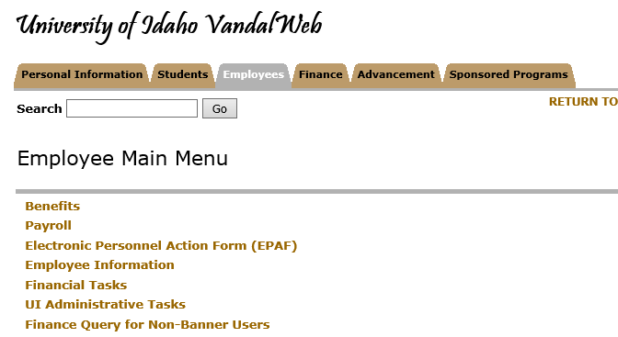

- There are three options available for viewing your financial information.
Budget Availability: This is the most basic report, which gives you the available funds as of today in budget-pooled categories. This query works best for grants and contracts that have not split the funds into more than one index/fund and you will need to know your fund code to access the information. Note that in almost all cases where there is only one index/fund that you can translate your grant code to a fund code easily by taking off the two letters at the beginning of the grant code and substituting “22” in their place. For example grant code CB1014 would have a fund code of 221014.
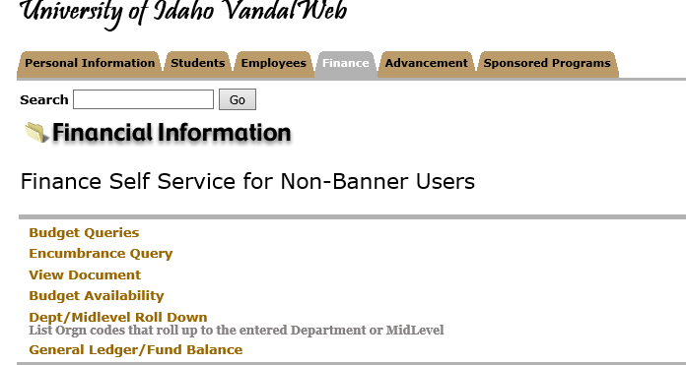

Once you have clicked on “Budget Availability” the following screen will display. You will need to enter the “Chart” of “V”, the fiscal year that you are interested in viewing, your “Orgn,” which is your department code (the first three digits of your index), and the “Fund” and click “Submit Query.”
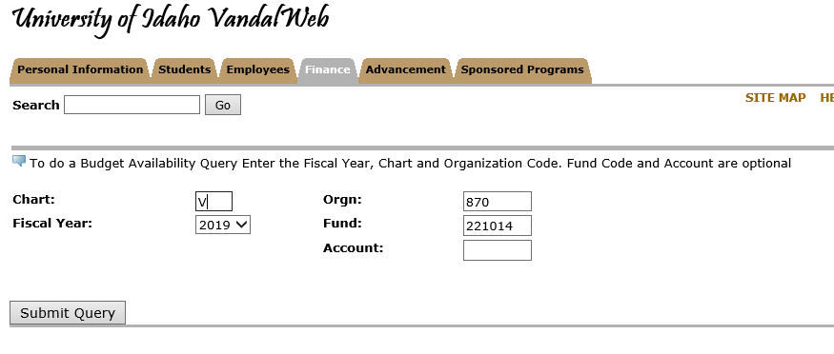
The report produced gives you the total budget at the start of the fiscal year, the year-to-date activity, any encumbrances such as purchase orders, and the available balance. Note that the University has moved to a budget-pool system that ‘rolls up’ all personnel costs (salaries, wages, fringe benefits) to a single category of “PERS.” The other categories are “NONPER” (all other direct categories except subcontracts and overhead), “SUBCTR” (sub-awards) and “OVERHD” (F&A).
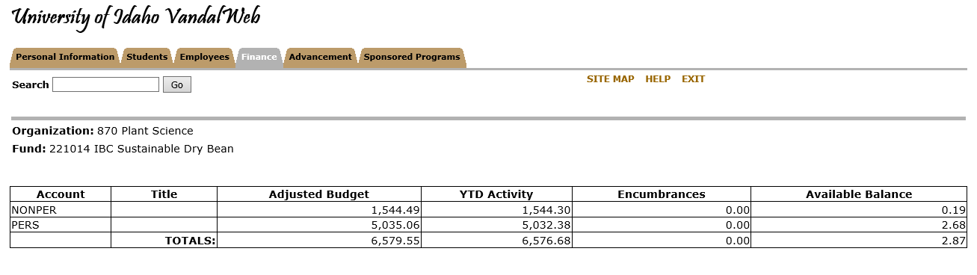
- The other reporting tools are under the “Budget Queries” menu item.
Budget Quick Query – This report gives you more detailed financial information on items posted to Banner, and also includes information on “Pending Documents” which are documents in the system but that have not yet been processed all the way through approvals.
- Select “Budget Quick Query” from the dropdown menu and then “Create Query” to start the process.
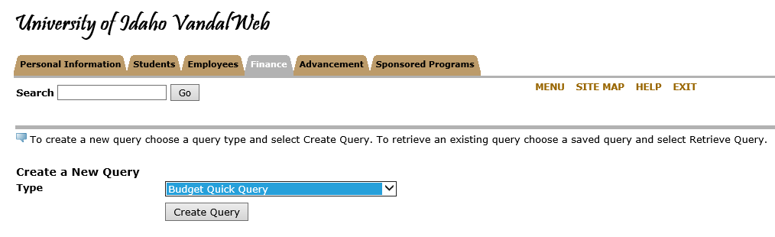
- Select the fiscal year and chart of accounts (V) and enter your index code or your grant code in the appropriate fields and click “Submit Query.”
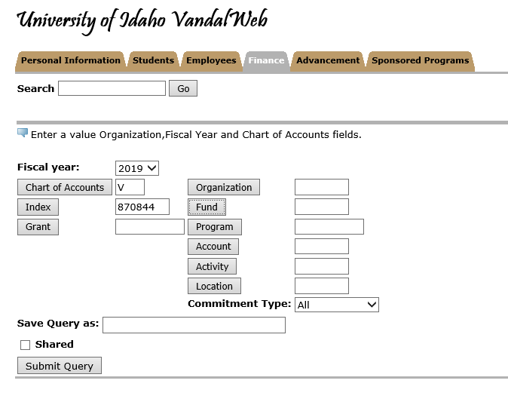
- If you used an index then the “Submit Query” button will first bring up all of the FOAPAL details of that index (fund, program code, etc) and you will need to click it again to get the actual report. Below is the result of clicking the Submit Query button after entering an index. The report will be filtering your data based on the information in the right hand column. If you find that you are not getting the expected data we suggest that you remove all of the filters except the Fund.
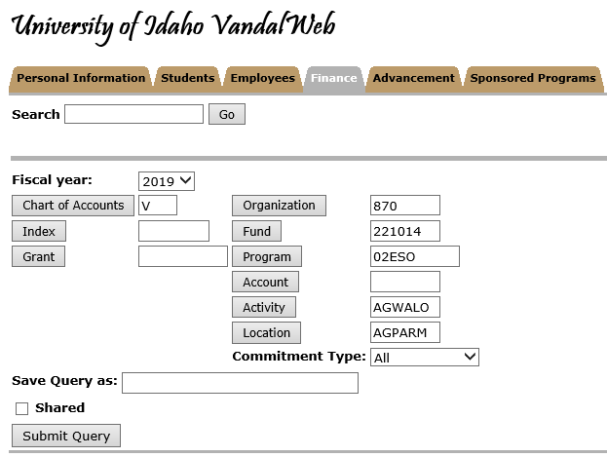
- Note the “View Pending Documents” button. The budget data displayed when you use an index is the balance at the beginning of the fiscal year. If you are using this report for grants then please note that the Revenue code (last item on the report and starts with “R”) is irrelevant. Also, the “Report Total” displays in the opposite direction. In the example below the available funds at the beginning of the fiscal year were a positive $6,579.55 and the expenditures (those account codes starting with “E”) total $6,576.68, leaving a balance of the $2.87 shown in the Budget Availability Report above.
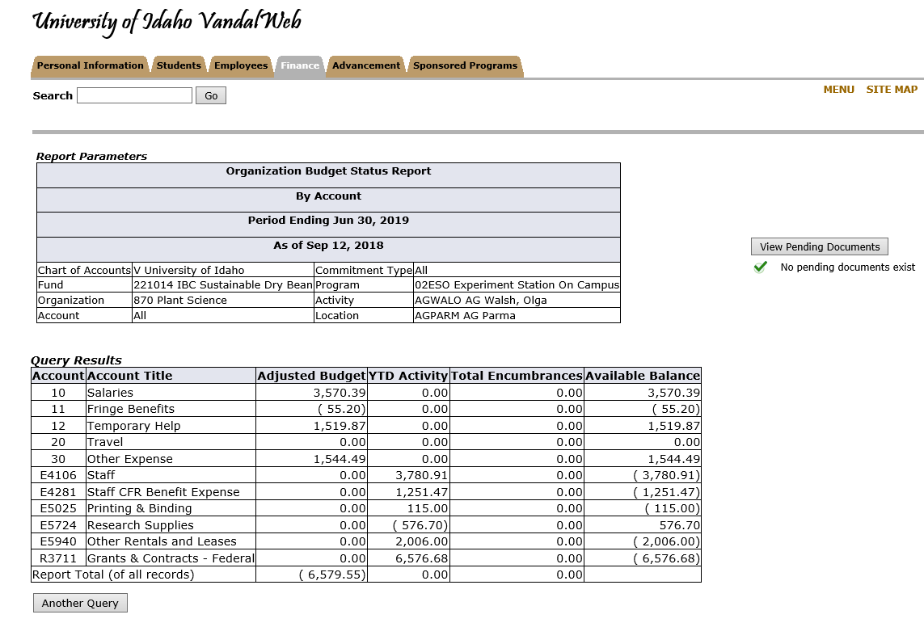
The other way to use this report for grants is to enter your grant code rather than the index. Using the grant code allows you to see “Grant Inception to Date” which is all transactions since the start of the award period. This report does not show Pending Documents.
- Enter your grant code in the appropriate field and click “Submit Query.”
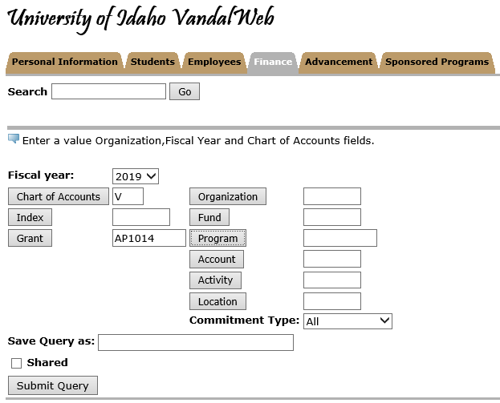
- The report will be in the same format as before, but include all data since the beginning of the award. A partial view of the report is below.
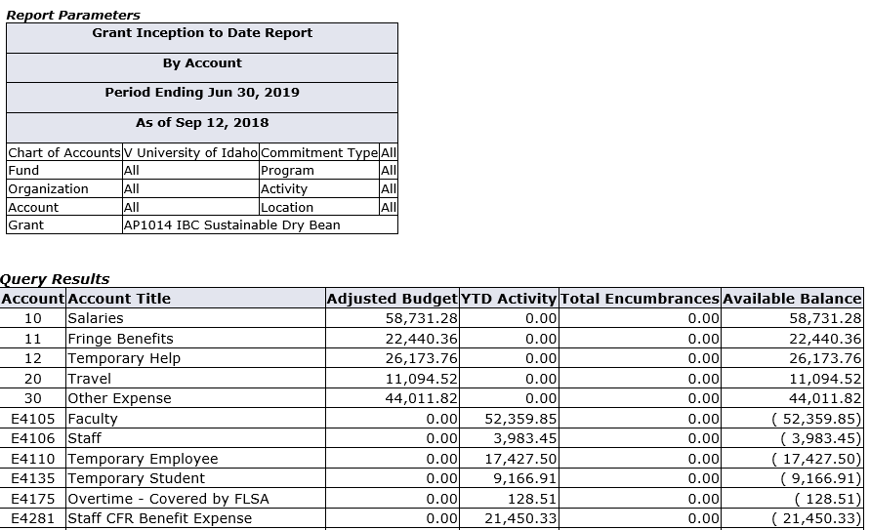
Budget Status by Account – This report allows you to ‘drill-down’ to see details.
- Select “Budget Status by Account” from the dropdown and then click “Create Query.”
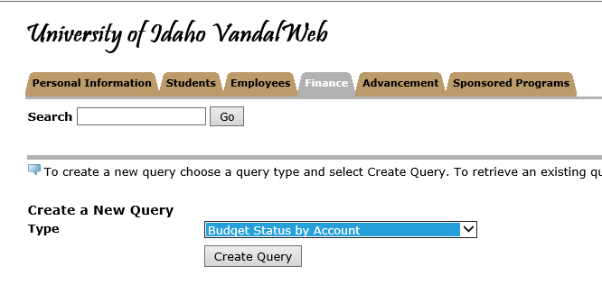
- The fields listed below are your options for report columns. We are selecting only a few of the columns for demonstration purposes. Choose your selected report columns and click “Continue.”
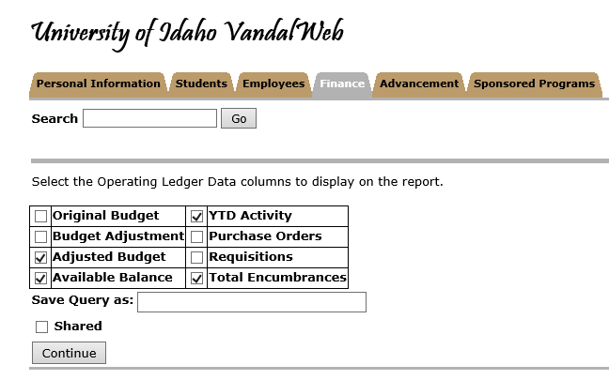
- Again, you will have the option to use index or grant code to pull the data and the same basic pattern as the “Budget Quick Query” will be in effect. In the case of this report you are allowed to include or not include Revenue accounts. For grant purposes you should uncheck the box below. Note also that you will need to select the “Fiscal Period” that you are looking for. The University’s fiscal year starts in July, so July would be period 01. Grant codes will again bring information that is inception to date. Index will only show you the current fiscal year.
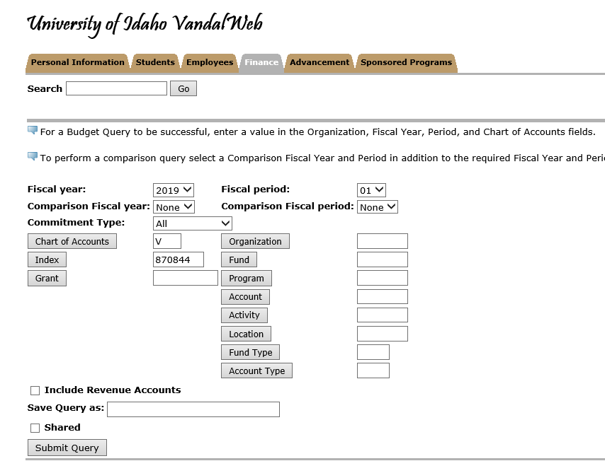
- You will notice that in this report the YTD Activity is highlighted. Clicking on any of these lines will allow you to see the transactional detail behind them. Note that if you click on the dollar amount for a payroll category the information is not very informative, but if you instead click on the expense code (e.g. E4105) you will see the detail of who was paid and for how many hours.
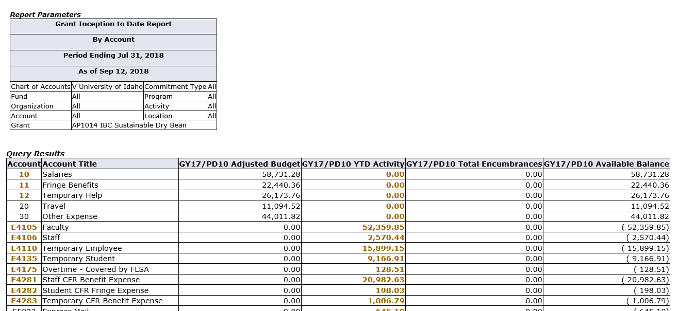

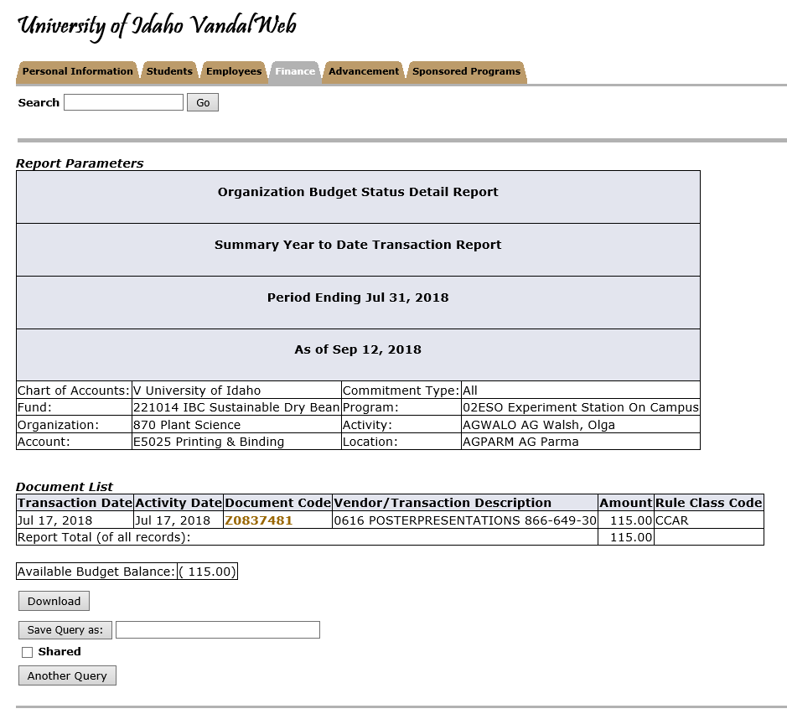
One caveat on this detail is that all expenses that posted prior to 7/1/18 is in the prior chart of accounts (chart 9) and under your old index. Any pre-7/1/18 data will simply show as “cumulative monthly transaction.”
Budget Status by Organizational Heirarchy Report
- Select the above from the dropdown list and click Create Query:
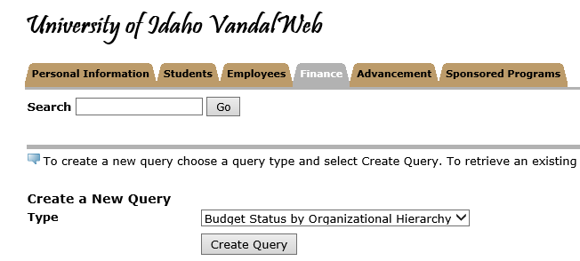

- Select the columns for the report similarly to the other reports and click Continue.
- Select the Fiscal Year, Fiscal Period, Chart of Accounts and enter your index and click twice just like the other reports.
- First level:
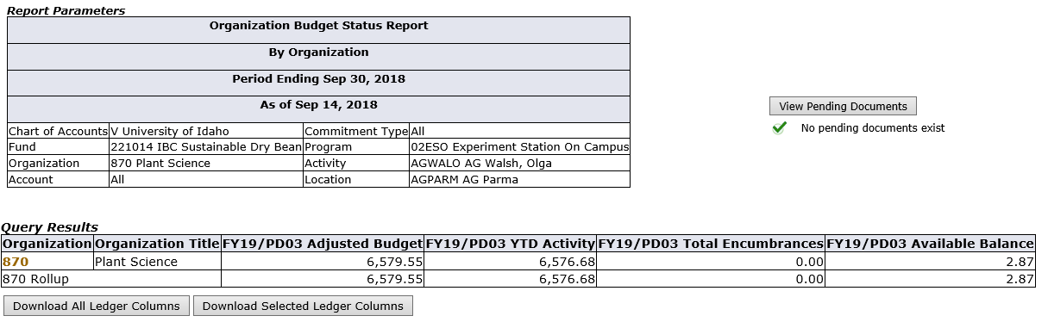
- Second level (clicked on highlighted Organization field):
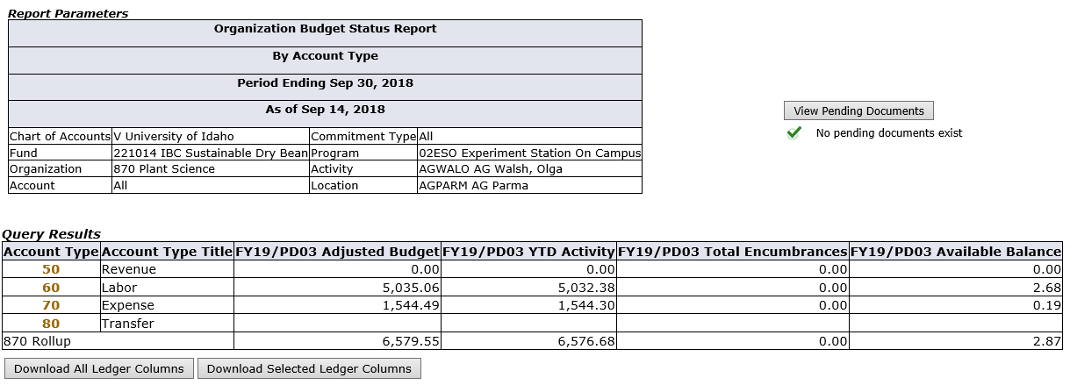
- Third level (clicked on Account Type 70 to see expense detail)
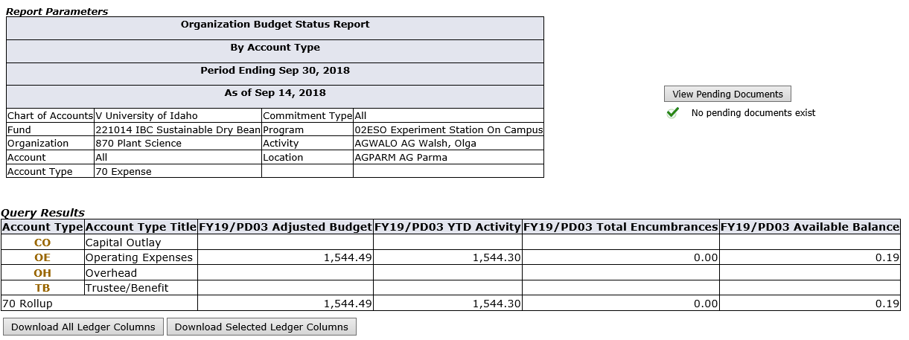
- Fourth level (clicked on Account Type OE)
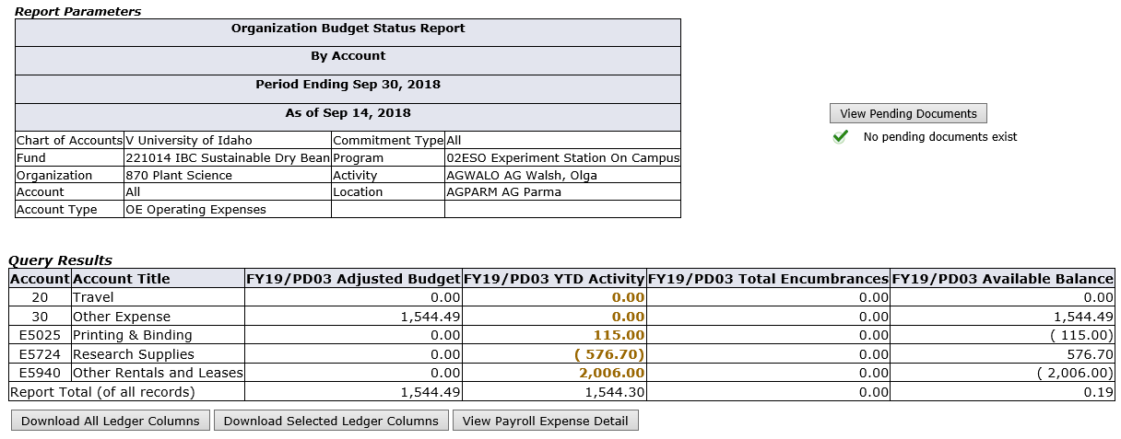
- Fifth level (clicked on $115.00 highlighted under E5025)
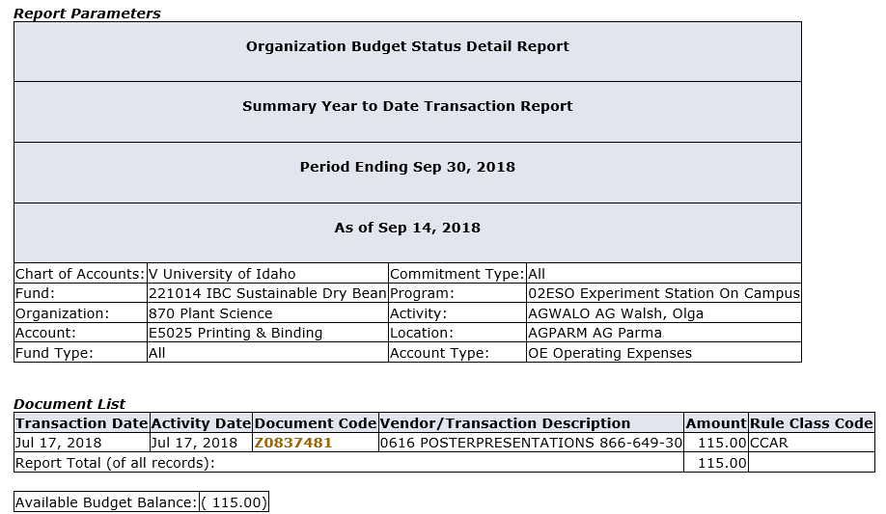
- You can continue clicking on highlighted items to get all the way down to the document itself and the descriptive text (if any) associated with the specific document.

VandalWeb Financial Reports (Instructions for all funds)
VandalWeb has a number of report options to view your financial balances as they are posted to the Banner financial system. Note that the information included is for receipts and payroll that have been fully processed and posted.
- Log into the VandalWeb portal and select the “Employees” tab and the menu item “Finance Query for Non-Banner Users.” If you do not see this menu item or get an “access denied” when you run reports please request access to the reports tool from finaccess@uidaho.edu.

- There are three options available for viewing your financial information.
Budget Availability: This is the most basic report, which gives you the available funds as of today in budget-pooled categories (PER, NON-PER, etc.).

Once you have clicked on “Budget Availability” the following screen will display. You will need to enter the “Chart” of “V”, the fiscal year that you are interested in viewing, your “Orgn,” which is your department code, and the “Fund” and click “Submit Query.”
The report produced gives you the total budget at the start of the fiscal year, the year-to-date activity, any encumbrances such as purchase orders, and the available balance. Note that the University has moved to a budget-pool system that ‘rolls up’ all personnel costs (salaries, wages, fringe benefits) to a single category of “PERS.” The other categories are “NONPER” (all other direct categories except subcontracts and overhead), “SUBCTR” (sub-awards) and “OVERHD” (F&A).
- The other reporting tools are under the “Budget Queries” menu item.
Budget Quick Query – This report gives you more detailed financial information on items posted to Banner, and also includes information on “Pending Documents” which are documents in the system but that have not yet been processed all the way through approvals.
- Select “Budget Quick Query” from the dropdown menu and then “Create Query” to start the process.
- Select the fiscal year and chart of accounts (V) and enter your index code in the appropriate fields and click “Submit Query.”
- If you used an index then the “Submit Query” button will first fill in the FOAPAL details of that index (fund, program code, etc) and you will need to click it again to get the actual report. Below is the result of clicking the Submit Query button after entering an index. The report will be filtering your data based on the information in the right hand column. If you find that you are not getting the expected data we suggest that you remove filters as appropriate (all but Org and/or Fund).
- Note the “View Pending Documents” button. The budget data displayed when you use an index is the balance at the beginning of the fiscal year. The “Report Total” displays in the opposite direction. In the example below the available funds at the beginning of the fiscal year were a positive $6,579.55 and the expenditures (those account codes starting with “E”) total $6,576.68, leaving a balance of the $2.87 shown in the Budget Availability Report above.

Budget Status by Account – This report allows you to ‘drill-down’ to see details.
- From the same main menu item of “Budget Queries”, select “Budget Status by Account” from the dropdown and then click “Create Query.”
- The fields listed below are your options for report columns. We are selecting only a few of the columns for demonstration purposes. Choose your selected report columns and click “Continue.”
- Again, you will have the option to use index or grant code to pull the data and the same basic pattern as the “Budget Quick Query” will be in effect. In the case of this report you are allowed to include or not include Revenue accounts. For grant purposes you should uncheck the box below. Note also that you will need to select the “Fiscal Period” that you are looking for. The University’s fiscal year starts in July, so July would be period 01.
- You will notice that in this report the YTD Activity is highlighted (in gold). Clicking on any of these lines will allow you to see the transactional detail behind them. Note that if you click on the dollar amount for a payroll category the information is not very informative, but if you instead click on the expense code (e.g. E4105) you will see the detail of who was paid and for how many hours.

Budget Status by Organizational Hierarchy Report
- Select the above from the dropdown list and click Create Query:

- Select the columns for the report similarly to the other reports and click Continue.
- Select the Fiscal Year, Fiscal Period, Chart of Accounts and enter your index and click twice just like the other reports.
- First level:
- Second level (clicked on highlighted Organization field):
- Third level (clicked on Account Type 70 to see expense detail)
- Fourth level (clicked on Account Type OE)
- Fifth level (clicked on $115.00 highlighted under E5025)
- You can continue clicking on highlighted items to get all the way down to the document itself and the descriptive text (if any) associated with the specific document.

