Payment Works Vendor Registration Process

Onboarding Tracker - Steps

Steps to Onboarding New Vendors (Corp/LLC/Individual)
There are six general steps in the payee onboarding process:
- Invitation Initiation

- Invitation Approval

- Invitation Receipt

- Registration Submission

- Registration Approval

- Onboarding Completion

Onboarding Tracker – Possible Status Outcomes

Invitation Initiation
- Invitation Initiated = Initiator sent an invitation.
- Invitation Rejected = Invitation was rejected by the initiator’s organization.
- Invitation Cancelled = Invitation was cancelled by the initiator or another payer user.

Invitation Approval
- Invitation Pending Approval = Invitation is awaiting approval from another payer user.
- Invitation Approved & Sent = Invitation was approved by the initiator’s organization or does not require approval from the initiator’s organization and was emailed to the payee.

Invitation Receipt
- Invitation Email Opened = Payee opened the email invitation.
- Invitation Link Clicked = Payee clicked on the link in the email invitation to register with PaymentWorks.
- Email Verified - Invitation Received = Payee set up an account with PaymentWorks and verified their email address.

Registration Submission
- Registration in Progress (no NVR yet) = Payee began to fill out an NVR.
- Registration Returned - Pending Resubmission = Payee’s NVR was returned and the payee needs to make changes and resubmit the NVR.
- Registration Submitted = Payee completed and submitted their registration form and this registration form is no longer pending review (the registration form was reviewed and approved or rejected by the initiator’s organization).

Registration Approval
- Registration Submitted - Pending PaymentWorks Review = Payee completed and submitted their registration form. PaymentWorks is reviewing the payee’s banking information.
- Registration Submitted - Pending Payee Response = Payee completed and submitted their registration form. PaymentWorks called the payee and left a message, and the payee needs to return the phone call.
- Registration Submitted - Pending Internal Review = Payee completed and submitted their registration form. PaymentWorks reviewed the bank account, and the registration is now waiting for internal review from the initiator’s organization.
- Registration Resubmitted - Pending PaymentWorks Review = Payee completed and resubmitted their registration form. PaymentWorks is reviewing the payee’s banking information.
- Registration Resubmitted - Pending Payee Response = Payee completed and resubmitted their registration form. PaymentWorks called the payee and left a message, and the payee needs to return the phone call.
- Registration Resubmitted - Pending Internal Review = Payee completed and resubmitted their registration form. PaymentWorks reviewed the bank account, and the registration is now waiting for internal review from the initiator’s organization.
- Registration Rejected = New vendor registration form was reviewed and rejected by the initiator’s organization.
- Registration Approved = New vendor registration form was reviewed and approved by the initiator’s organization.

Onboarding Completion
- Registration Processed = Information from the new vendor registration form was exported for integration into the organization’s ERP.
- Onboarding Complete = Payee is set up for payment. The new vendor registration is in the organization’s ERP and connected (linked) to the PaymentWorks application. The payee can view their invoice data in PaymentWorks.

Payment Works does NOT support a live help center. Submitting a support ticket is necessary to get technical issues resolved. AP cannot help with technical and submission issues during application processes.

Contacting Payment Works Customer Service

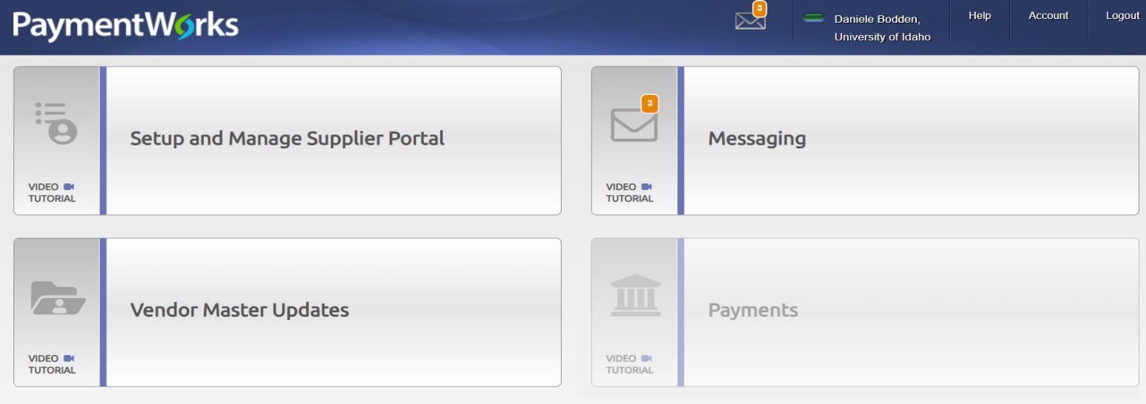
Payment Works Main Page- Help Tab

Payment Works Help Page- Blue Contact Support to Open Ticket

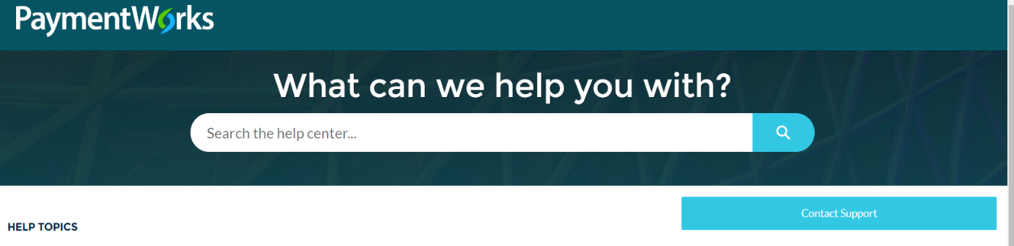
Payment Works does NOT support a live help center. Submitting a support ticket is necessary to get technical issues resolved. AP cannot help with technical and submission issues during application processes.
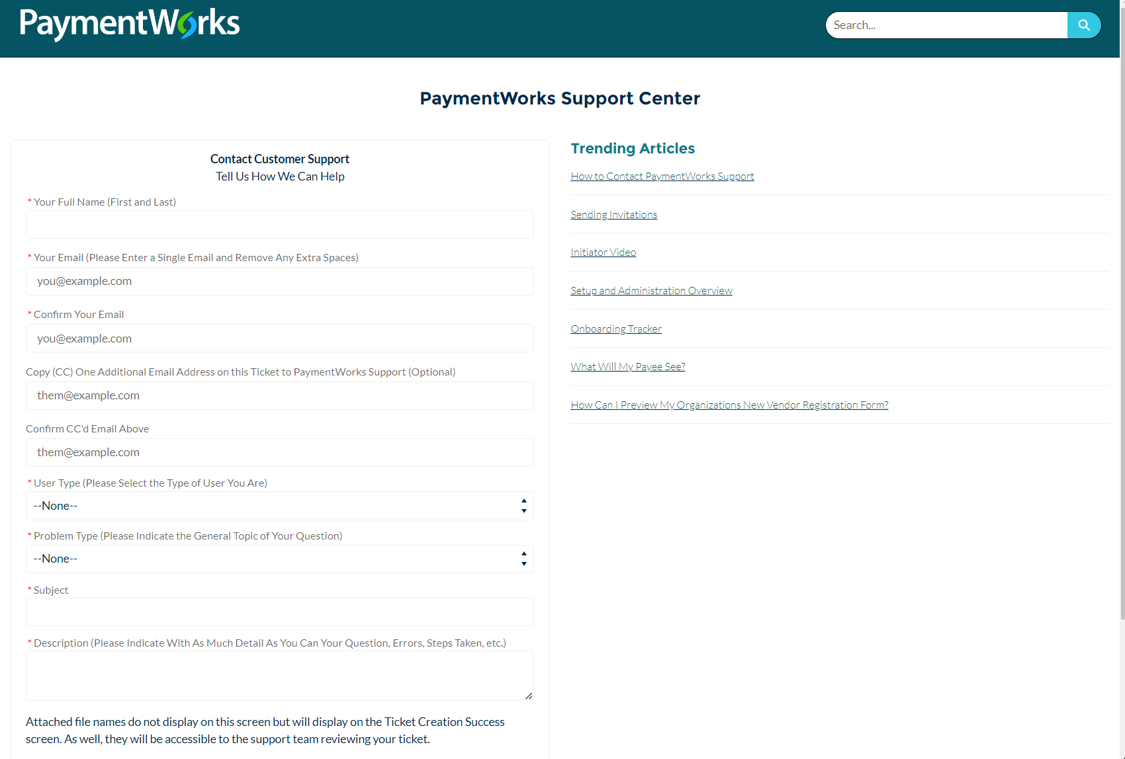

Payment Works Help Page- Training and Tutorials for Vendors and Initiators

