Product Name: Sulfuric Acid  Hazard Statement(s): Causes severe skin burns and eye damage; May cause respiratory irritation; May cause damage to organs through prolonged or repeated exposure  Signal Word: Danger  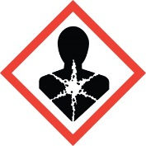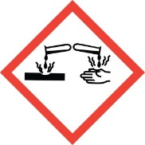 |  | Product Name:  Hazard Statement(s):  Signal Word:
Product Name:  Hazard Statement(s):  Signal Word: |  | Product Name:  Hazard Statement(s):  Signal Word:
Product Name:  Hazard Statement(s):  Signal Word: |  | Product Name:  Hazard Statement(s):  Signal Word:
Product Name:  Hazard Statement(s):  Signal Word: |  | Product Name:  Hazard Statement(s):  Signal Word:
Product Name:  Hazard Statement(s):  Signal Word: |  | Product Name:  Hazard Statement(s):  Signal Word:

