Stress Management Worksheet

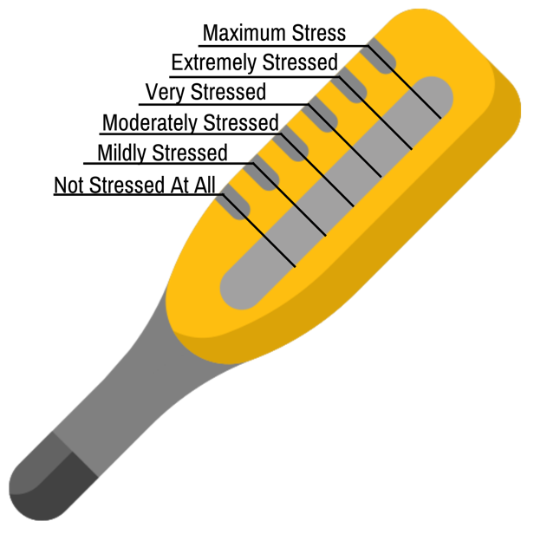
Rate Your Stress

Assessing Your Stress

What is Stress?

My Stress Management Plan

1. Recognize the Signs
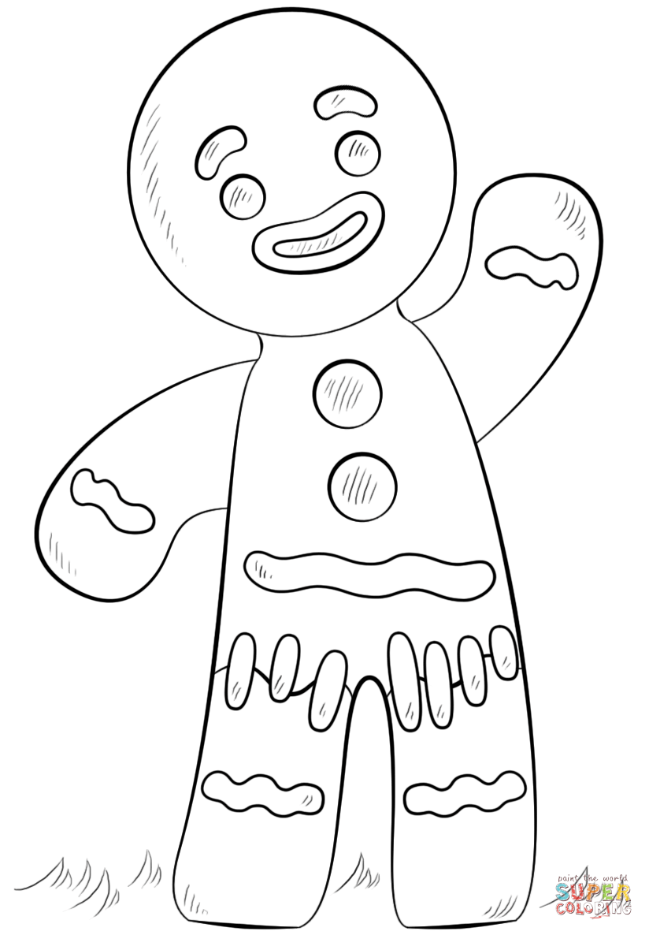
When I am stressed, my mood is:
When I am stressed, a behavior I do is:

I recognize stress in my body here

2. Identify the Sources

My top three sources of stress are:

- ___________________________________________________________________
- ___________________________________________________________________
- ___________________________________________________________________

3. Manage Controllable Stressors
When I recognize a stressors, strategies I will use are:
- ___ , ___ , ___ breathing
  - Inhale for ___ seconds, hold for ___ seconds, exhale for ___ seconds
- ___ , ___ , ___ , ___ , ___ grounding
  - Acknowledge ___ things you see around you.
  - Acknowledge ___ things you can touch around you.
  - Acknowledge ___ things you hear.
  - Acknowledge ___ things you can smell.
  - Acknowledge ___ thing you can taste.
- Mantras
  - ____________________________________________________________________________________________________________________________________
- Gratitude
  - I am grateful for ____________________________________________________
__________________________________________________________________
- PMR: Progressive Muscle Relaxation
- ________________________________________________________________________
- ________________________________________________________________________

4. Accept the Stress I Can’t Control
I recognize that not all stress is within my control. I will:
- Ask: Can I __________ this?
- ___________ my perspective
- Check-in with my ________________.

Rate Your Stress

