There is currently a proposal in the EIPRS queue to a PHS entity or that is PHS flow-through funding on which you were identified as an investigator. Please read through the following information and follow the subsequent instructions.

Each PHS funded investigator is required to submit a financial disclosure form for each SFI (Significant Financial Interest) or sponsored travel, including any SFI held by their dependent child or children, spouse, and any financially interdependent adult living with them. Each investigator that does not have an SFI is still required to fill out the financial disclosure form and select the “I DO NOT have an SFI…” option.

Financial disclosure is mandatory and must be completed before the proposal can be approved via EIPRS and submitted to the funding agency. There is also a training component required for PHS funded proposals. The training component is not required at the pre-award stage but we feel that this training will assist you with disclosing SFIs and sponsored travel per the PHS FCOI policy. If you choose not to do the training at this time and the project is awarded, the training must be completed prior to expenditure of funds. If University of Idaho FCOI training has been completed after August 15, 2012 and your NIH FCOI certificate and video code have been emailed to UIFCOI@uidaho.edu this training is good for four years from the date of the training. Training can be found at www.uidaho.edu/osp/financial-conflicts-of-interest. All investigators must complete training prior to expenditure of funds.

The following steps provide instructions for the financial disclosure process:

- Use Firefox or Google Chrome to visit https://www.sites.uidaho.edu/osp-portal/

- If you are on campus you will login using your University of Idaho username with ‘AD\’ in front of it and your UI password in a pop-up similar to the following screen.

  - Username example: AD\jvandal

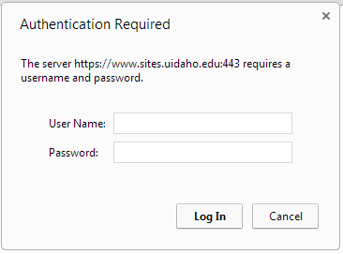

- If you are logging in from an external location, such as your home computer, you will see the following screen and will use your UI username and either your assigned temporary external password or, if you have logged in and reset your password previously, the external password that you provided.

If you have previously reset your password and cannot remember the password please click “Forgot Your Password?” as shown below and a new password will be emailed to you.
Your temporary password should have been emailed to you from osp@uidaho.edu or your Sponsored Programs Administrator (SPA).

If this is the first time you have used the OSP Portal and you did not receive an email with your temporary external password please contact your SPA directly or email uifcoi@uidaho.edu. After logging in please change your password by selecting “My account” from the top right corner of the screen.

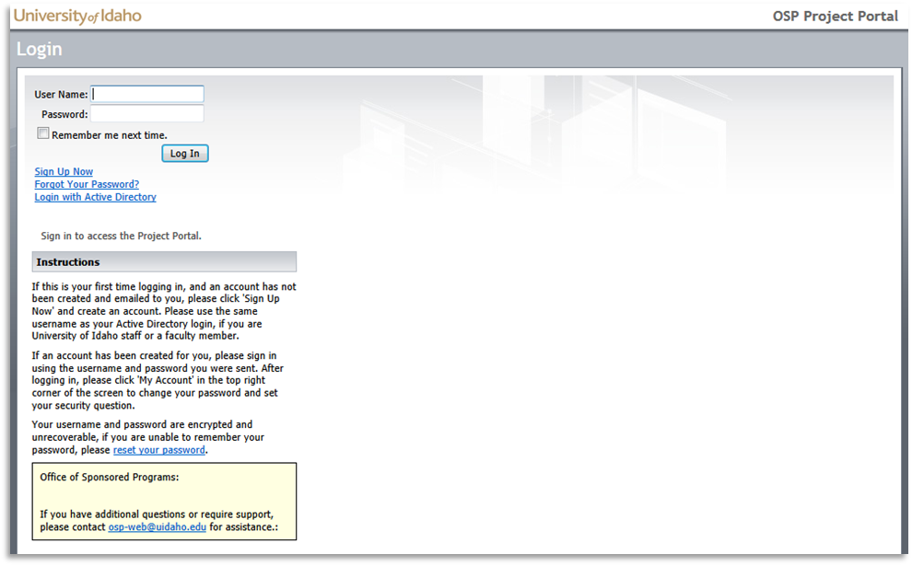

- Once you log in, click ‘Disclosures’ from the top or side navigation areas.

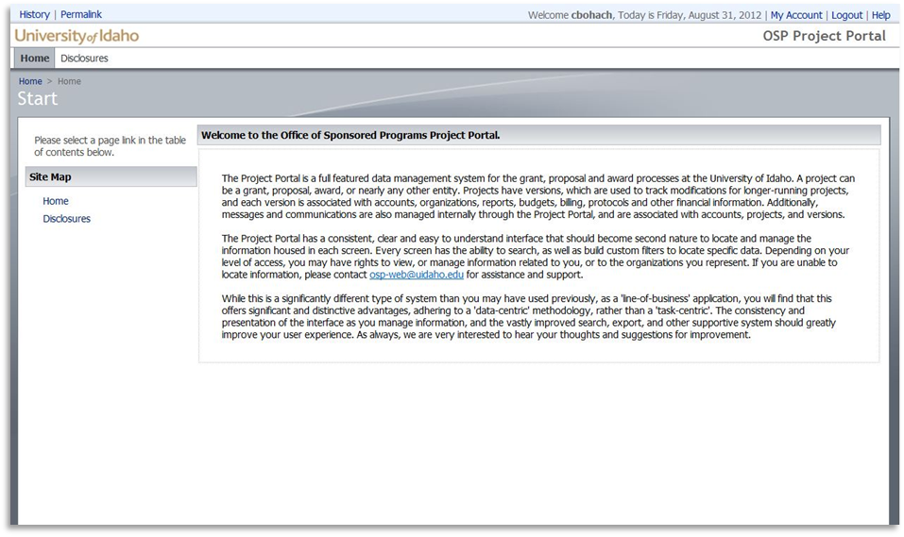

- Click ‘New Disclosures’ from the action bar at the top of the page area.

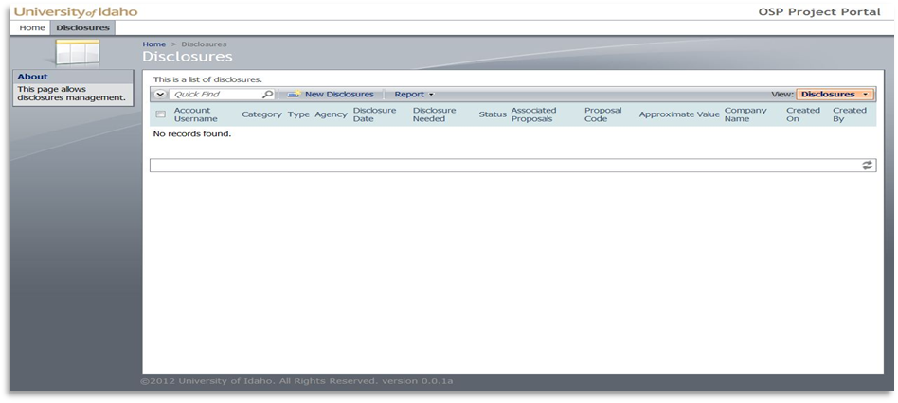

- If you have multiple PHS agency proposals, you will have multiple proposals to select from in the drop down menu. Select the proposal number that you are submitting the disclosure for.

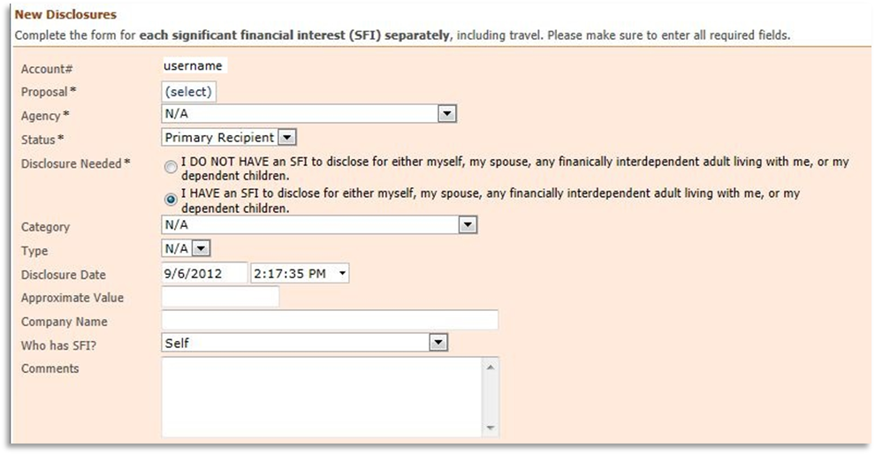

- Select the disclosure category from the “Agency’ drop-down menu. Please note the text in red regarding PHS disclosure requirements. For PHS there are two disclosure fields, “Public Health Service” and “PHS Travel Disclosure (no minimum)”. If you select “I DO NOT” for your disclosure you only need to select “Public Health Service” as the agency.

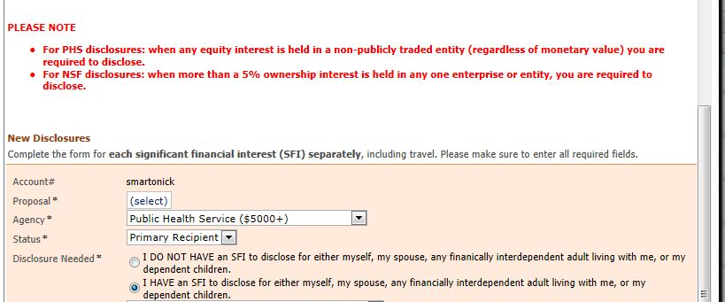

- Next select your status on the proposal. Your choices are Primary Recipient and Subrecipient. All University of Idaho faculty and staff should choose Primary Recipient and all parties external to UI should choose Subrecipient.

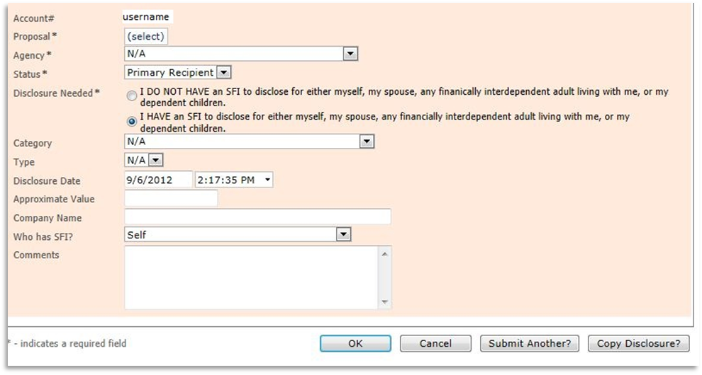

- You are required to complete the form that loads whether or not you have a significant financial interest (SFI) to disclose. Please note that the significant financial interest could be held by yourself, your spouse, any dependent children or any financially interdependent adult living with you. If you do not have an SFI to disclose select “I DO NOT HAVE an SFI…” and then click the ‘OK’ button.
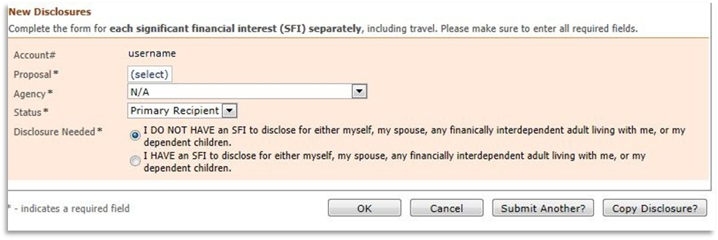

- If you have one or more SFIs to disclose select the “I HAVE an SFI to disclose…” This will open up the secondary part of the disclosure form.
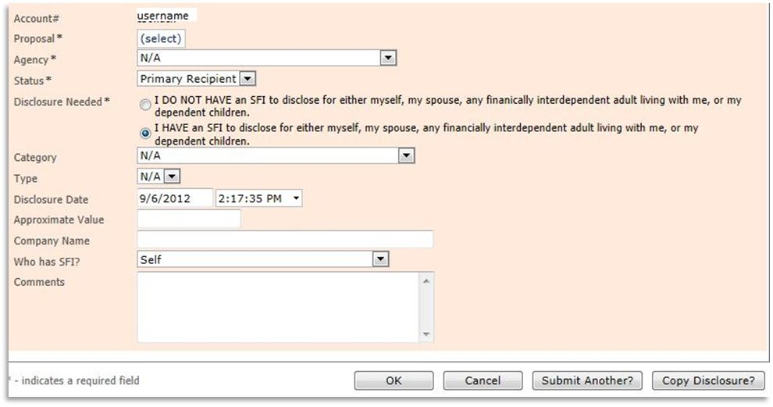

- For Each SFI that you are disclosing you will select the category (Income, Equity, Intellectual Property, Positions / Relationships – (compensated or not), and Travel) from the drop down menu.

- Next you will select the corresponding Type to further define the Category (with the exception of Travel).

- Fill in the approximate value of your SFI or travel, the company name, select the person with the SFI from the dropdown and then enter in the required information in the comments. See the UI FCOI policy and FAQs at http://www.uidaho.edu/osp/financial-conflicts-of-interest for information on the required notes to include in the comments box.

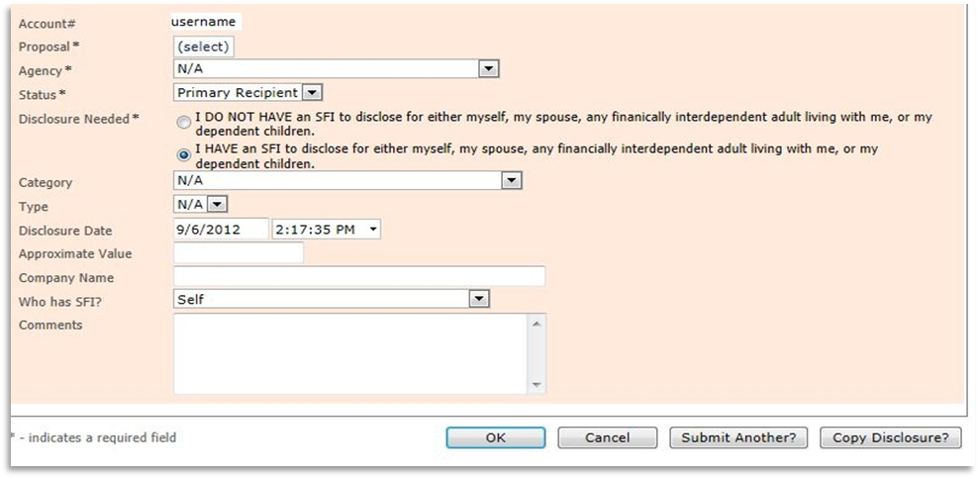

- You are required to disclose each SFI separately, including travel as defined in the University of Idaho (UI) Financial Conflict of Interest (FCOI) policy. To submit another SFI or sponsored travel disclosure click “Submit Another”.

- When you have clicked the “Submit Another” button, the following certification will appear. Please read and click “OK” to acknowledge your acceptance. Repeat steps 6-15 for each SFI or sponsored travel disclosure.

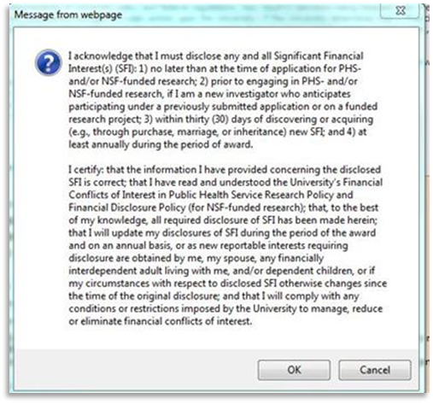

- If you have multiple PHS funded proposals you need to disclose each SFI and sponsored travel per proposal. Click the “Copy Disclosure” button. This will bring up the certification in Step 15; you will need to click ‘OK’ after reading the certification to submit the disclosure form for the proposal you were previously disclosing for.
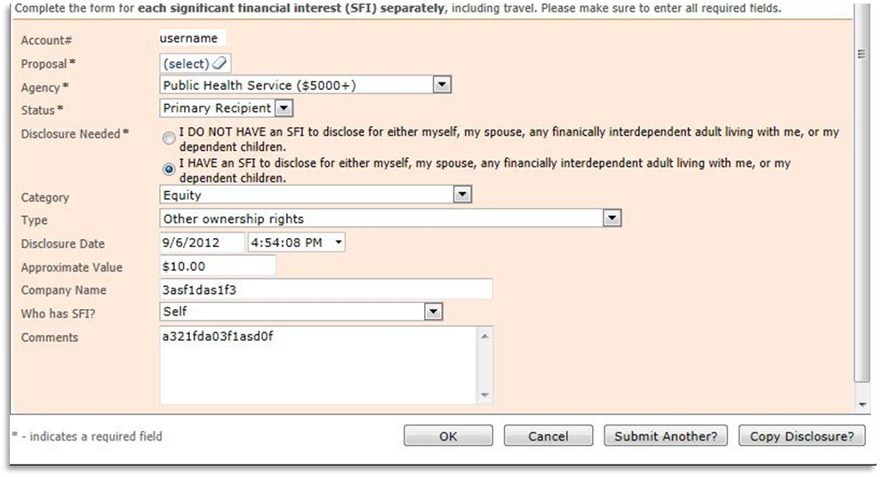
- The disclosure form will remain on the screen but will have saved for the previous proposal. To submit this disclosure on a different proposal, select the proposal number in the drop down and click either ‘OK’, ‘Submit Another’, or ‘Copy Disclosure’. Clicking one of these three buttons will bring up the certification in Step 15. Clicking ‘OK’ on the certification will save the financial disclosure form. If you click ‘Submit Another’ or ‘Copy Disclosure’ please see steps 15 and 16.
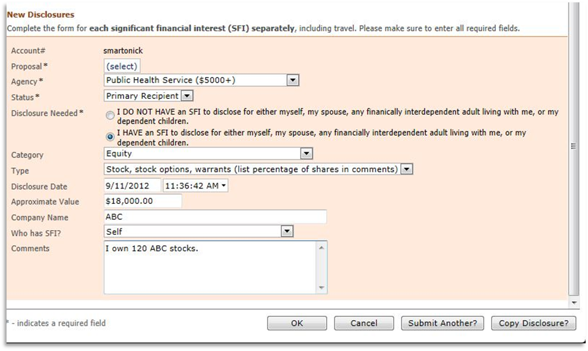

- When you have finished disclosing all SFIs and sponsored travel for each PHS funded proposal, click ‘OK’ on the financial disclosure form and the certification in Step 15 to complete the process.

- To print your disclosure(s) see the following steps:
  - Click on “Disclosures”
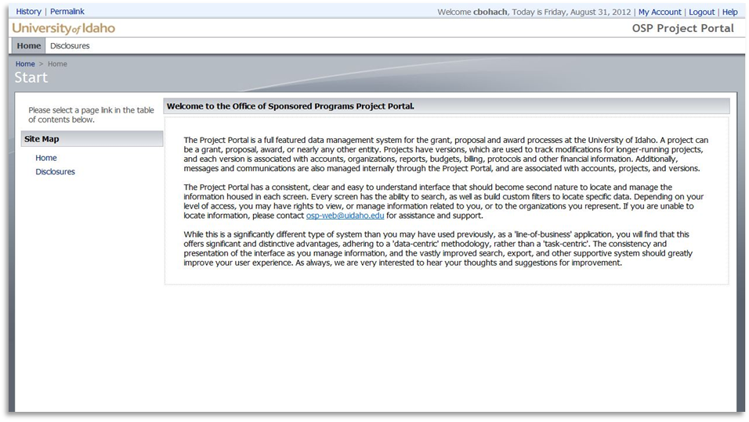
  - This will bring up a list of your disclosures that looks similar to the screenshot below:
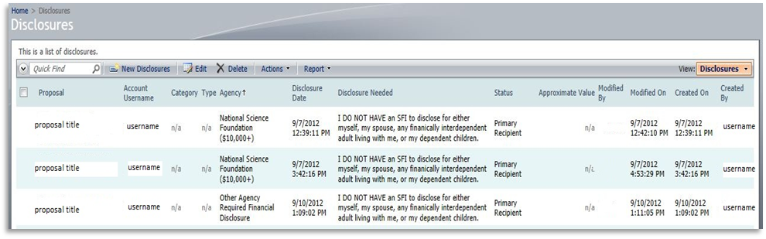
  - Click the report button and then “PDF Document” to create a PDF that you can save and print for your records.
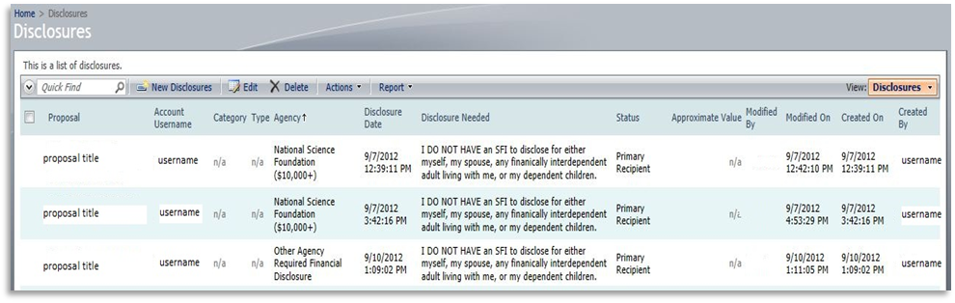

Please contact UIFCOI@uidaho.edu or call 208-885-6651 with any questions.

