The following steps provide instructions for logging into the OSP Portal:

- Use Firefox or Google Chrome to visit https://www.sites.uidaho.edu/osp-portal/

- If you are on campus you will login using your University of Idaho username with ‘AD\’ in front of it and your UI password in a pop-up similar to the following screen.

  - Username example: AD\jvandal

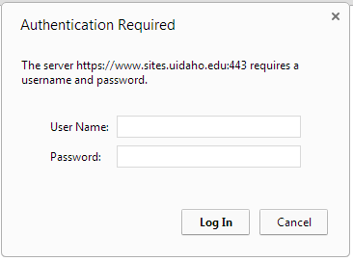

- If you are logging in from an external location, such as your home computer, you will see the following screen and will use your UI username and either your assigned temporary external password or, if you have logged in and reset your password previously, the password that you provided.

If you have previously reset your password and cannot remember the password please click “Forgot Your Password?” as shown below and a new password will be emailed to you. Your temporary external password should have been emailed to you from osp@uidaho.edu or your Sponsored Programs Administrator (SPA).

If this is the first time you have used the OSP Portal and you did not receive an email with your temporary external password please contact your SPA directly or email uifcoi@uidaho.edu. After logging in please change your password by selecting “My account” from the top right corner of the screen.

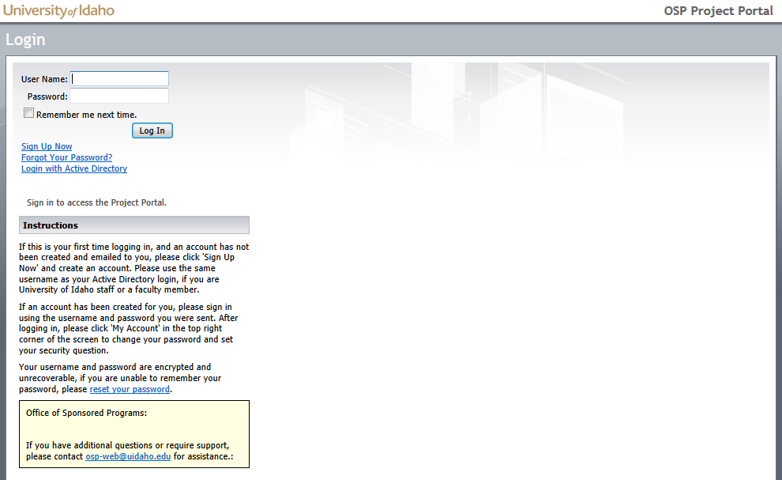

- After you have logged into the OSP Portal you will need to consult the instructions sent to you by your SPA. Instructions for submitting a disclosure are specific to the agency (ex: NSF or NIH).

