CITI Program Registration Instructions
To create a new account (If you already have an account with CITI, see page 2):
- Go to www.citiprogram.org.
- Click on the Register button on the home screen (see below).

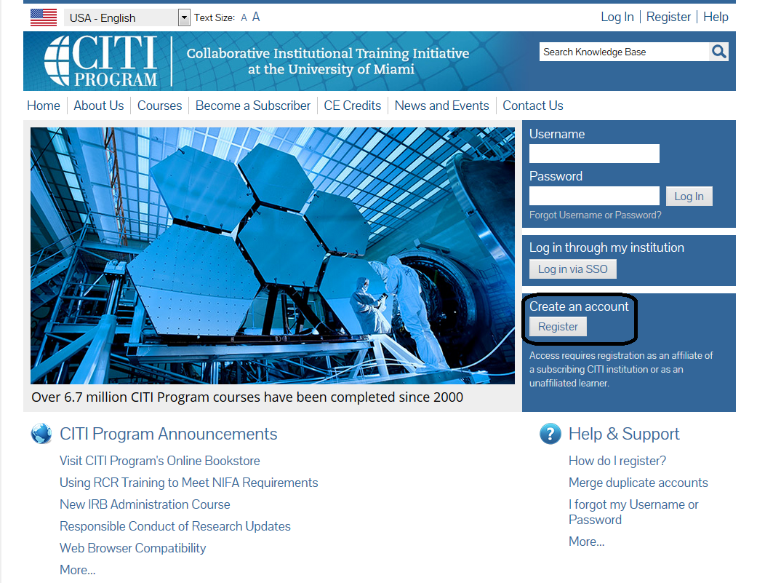

- Type University of Idaho in the text box to affiliate yourself with our institution then press Continue to Step 2.
- Step 2 requests that you enter your first and last name along with your email address.
  - Enter your name as you would like it to appear on your completion report received at the end of the course.
  - While not required, they do encourage entering a secondary email address. It will assist in the recovery of your account if you forget your username or password and no longer have access to your primary email address.
- At step 3 you will choose a username and password for your account. Please follow the on screen instructions. Passwords are case sensitive.
  - During this step you will also select and answer a security question. This question will be used to assist in the recovery of your account if you have forgotten your username or password. Please select a question that is applicable to you and you can comfortably answer for the tech support team.
- Step 4 collects demographic information. All information provided is voluntary. Use the blue information question marks for more information on specific categories.
- Professionals seeking credit for CITI Program courses can make their selection for Continuing Education (CE) credits during Step 5. Please note that CE credit is not required for completion of courses for University of Idaho purposes.
- Step 6 is institution-specific. The Institutional email address is your UI email address. Please specify if you are an undergraduate, graduate, or postdoctoral student under the Job Title field.
- The questions in Step 7 enroll you in CITI Program courses. The University of Idaho currently offers CITI courses for a variety of topics (see a-e below). Please read each question carefully and check the box(es) under the appropriate course topic that matches your “learner group”. Check “not at this time” if the topic does not apply to you or leave it blank. You are only required to check the box for the course topic that you are interested in. For example, if you are only required to take the Responsible Conduct of Research course then only check a box for question 3.
  - Human Subjects Research (IRB) (Question 1)
  - Export Controls (Question 2)
  - Responsible Conduct of Research (Question 3)
    - Choose the appropriate group.
      - SBE – Social, Behavioral, Educational Research
      - Biomed – This would be appropriate if doing more biomedical research
  - Conflict of Interest (Question 4)
  - Biosafety (Question 5)
- If your registration is complete, click on Finalize Registration.
  - Your learner account registration is complete.
On the Main Menu, click on the course name to begin the course. If you need to change your course registration, click on “Add a Course or Update Learner Group.”
If you have an existing CITI account:
- Go to www.citiprogram.org and log in with your username and password.
- Ensure you are affiliated with the University of Idaho. If you are not, go to the Main Menu and click on “Click here to affiliate with another institution”
- Type University of Idaho in the text box
- Once affiliated, enroll in CITI Program courses. Please read each question carefully and check the box(es) that match your applicable “learner group.” The University of Idaho currently offers learner groups within the following training topics:
  - Human Subjects Research (IRB) (Question 1)
  - Export Controls (Question 2)
  - Responsible Conduct of Research (Question 3)
    - Choose the appropriate RCR group.
      - SBE – Social, Behavioral, Educational Research
      - Biomed – This would be appropriate if doing more biomedical research
  - Conflict of Interest (Question 4)
  - Biosafety (Question 5)
- Click Submit
- On the Main Menu, select “University of Idaho Courses” and click on the course name to begin.
  - If you need to change your course registration, click on “Add a Course or Update Learner Group.”
Questions?
- IRB/Human Subjects Research coordinator at 208-885-6340 or irb@uidaho.edu
- IACUC, IBC or Shipping Regulated Biological Materials at 208-885-7258 or ibc@uidaho.edu / iacuc@uidaho.edu.
- RCR at 208-885-2142 or RCR@uidaho.edu.
- FCOI at 208-885-2142 or uifcoi@uidaho.edu
- For all other questions, contact the Office of Research Assurances at 208-885-6162

