How to submit an IRB amendment request in VERAS including changes in personnel

- Use the My Workspaces Menu to choose Study Assistant, then click on View My Studies to view all of your IRB protocols.
- Scroll down to All Studies.
- Click on the pad and pencil to open the protocol that you would like to modify.
- Click on IRB Amendment – Protocol Modification to the lower left.
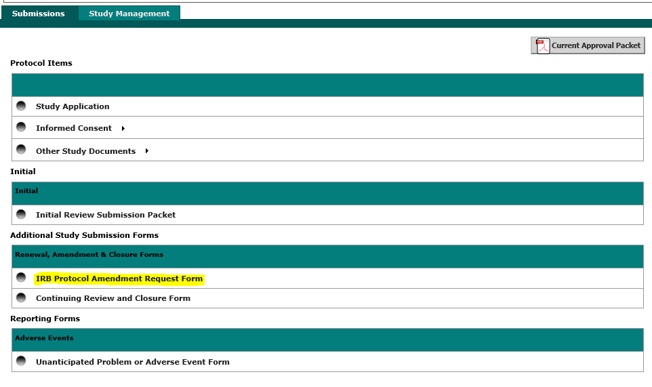
- Click on Add a New Form in the upper right to access the form. This page will store a history of all amendment request submissions.
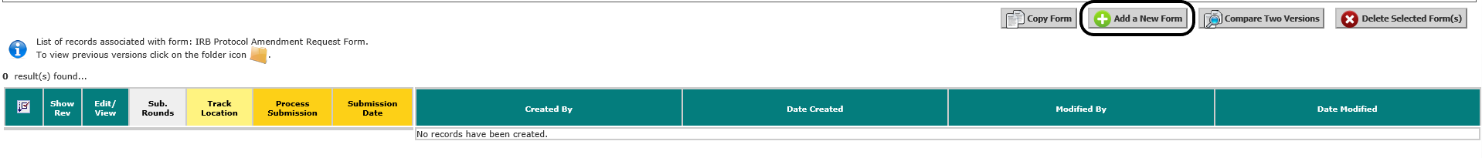

- There are three sections to the amendment request form and you can access each section by clicking Save and Continue to Next Section in the upper right.

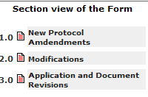

Section 1.0 has a checklist to indicate the type of amendment you are requesting.
Section 2.0 has a text box where you can provide a brief explanation of the proposed changes. You will be asked to modify the original application in the next section with a more detailed description.
Section 3.0 allows you to make changes to the original application (3.1) and upload any new or revised study documents (3.2 and 3.3). More details on revising the application are listed in this section and below.

- Click on the gray bar in section 3.1 to create a revised version of the application that is editable.
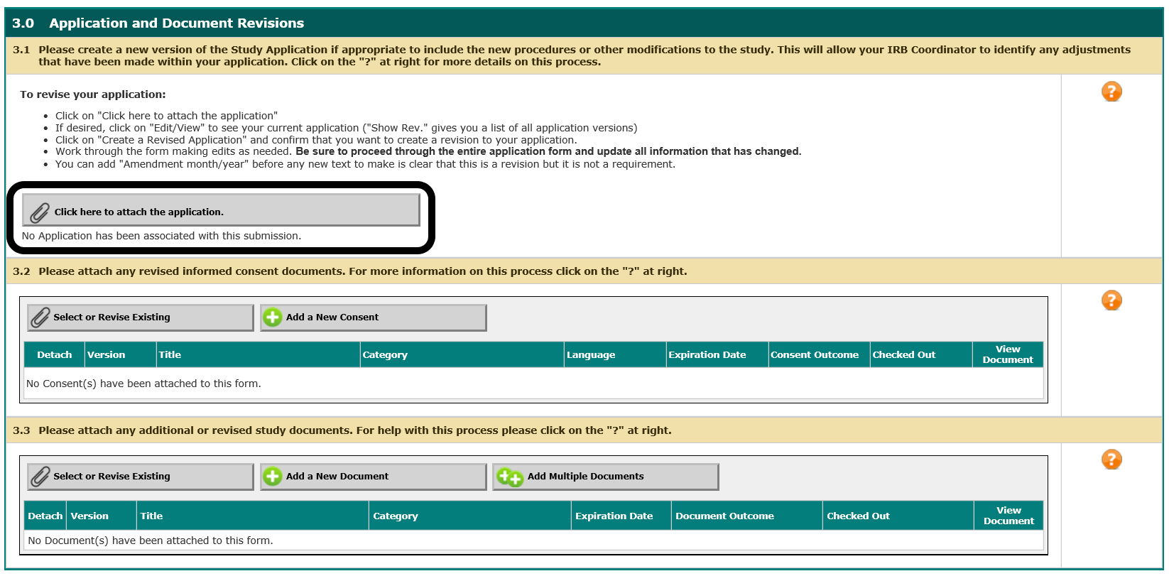

Click on Add Revision to the far right to create a revised version of the application. This will ask you to confirm that you are adding a revision and the application will have a new version number (1.0 to 1.1).

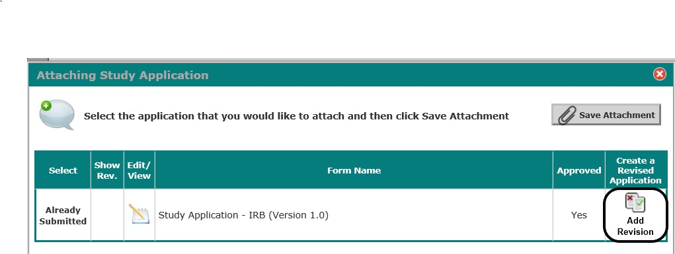

The new version of the application is editable. Please add any new information to the appropriate section. You should leave the original information there and add new information to make the application complete and accurate. You can just add a new paragraph or put a note/date to indicate when the new additions were added.

When you are finished with the revisions then you should see the new version where the gray bar was in section 3.1.

- Click Signoff and Submit when you are finished with the three sections of the form. There is one last page that provides a table with your submission components. Click the option next to Approve then Save Signoff to send the request to the IRB. Please note that the submission will not be sent if you do not complete this last step!
