Cost Share Information
Cost share grant codes are the same as the grant with a “C” on the end (e.g. AN3527’s cost share is in located in AN3527C)
Grant – note that the total cost share required is in the Total Recipient Share box.
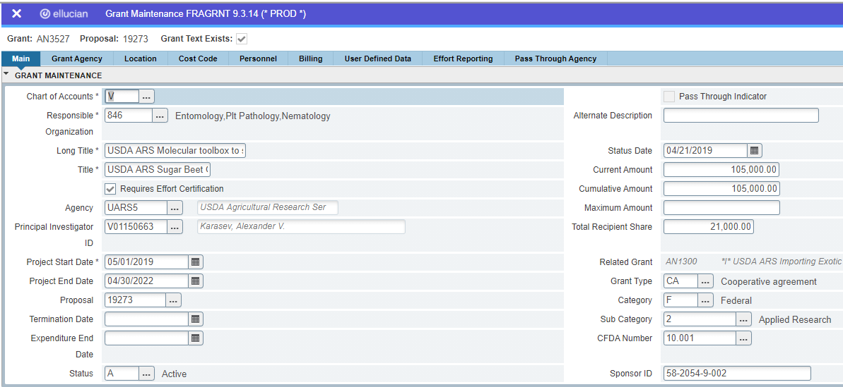
Cost share – note that the Cumulate Amount will reflect the UI cost share budgeted in Banner. The difference between the Total Recipient Share (in this case $10,500) and the Cumulative Amount ($21,000) is waived F&A which we track in a different system.
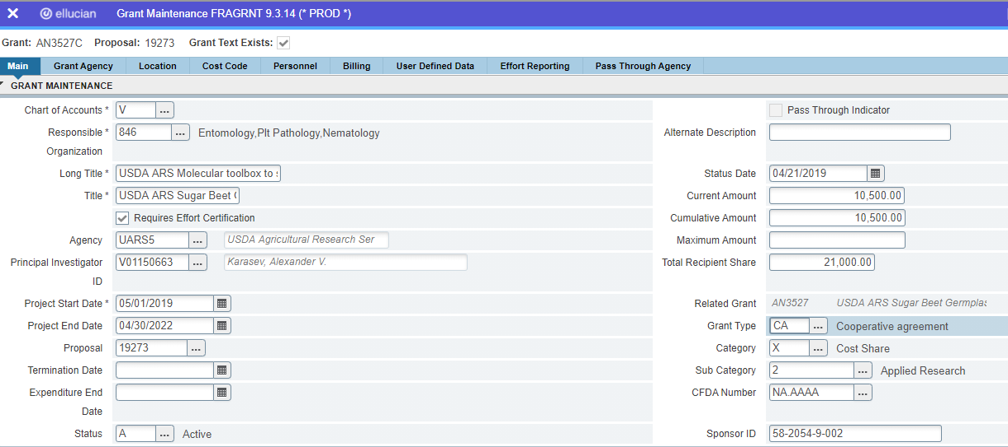
OSP ties the cost share Fund to the providing cost share index in the Banner form FRMFUND. This tie allows cost share expenses to be directly charged to the cost share Fund with a behind the scenes posting to credit E5991 to the cost share Fund and a debit to E5995 on the providing index. This way the expenses on the cost share Fund equal $0 since we won’t be reimbursed for those expenses.
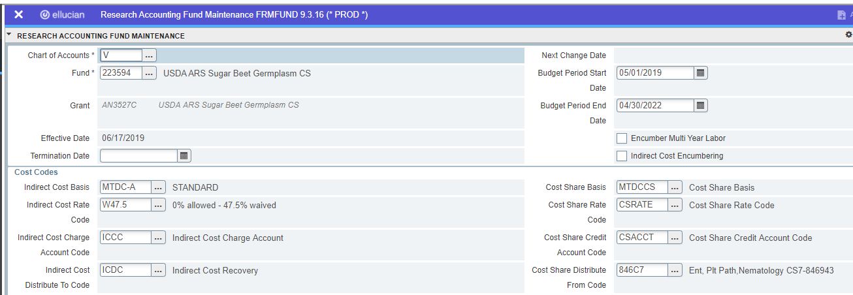

This is what the cost share Fund will look like in FRIGITD. The goal is to get all the amounts listed in the Sponsor Account Codes except 60 Adjusted Budgets column to match the Activity amounts. Please be aware if there are restrictions in revising the budget, this also applies to the cost share budget and will be noted in FOATEXT on line 126 (Type is GRT, Code is Grant code).
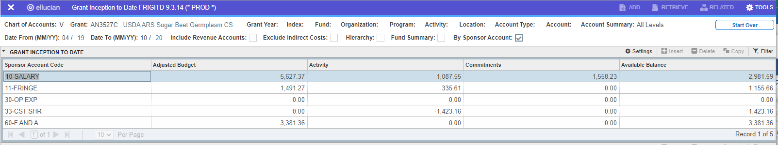

Reports in Argos for Cost Share:
Finance.Production.OSP.Cost Share Report – separate handout
Finance.Production.Departmental Financial Reporting.Salary and Fringe on Cost Share – this is to see what salaries are being used for cost share and what is the providing Cost Share Index and Cost Share Fund are. Can run by Orgn, Grant Code, or just dates.

