DGA Roundtable Minutes – March 4, 2019
1:30 – 2:30 pm, IRIC 305 (above the Atrium)

1. Greetings and Introductions.

- Cost Share:
  - Cathy Knock provided information on how she handles/d cost share for CNR. She walked through the different tabs of the workbook that she created, discussing the usefulness of each tab and what information it can track. She noted that the workbook currently has PAR period, but can be updated to use the new effort reporting schedule periods. She also noted that the Chart V changes to cost share require a whole different mind-set in thinking about cost share. Previously, with effort report (PARS) the cost share was already incurred when it was reported as cost share on the PAR (certified). Now, with Chart V, the department and PI need to understand how to plan and allocate the cost share to a Chart V index (under a cost share grant code) to accurately capture the planned cost share expenses as they post.

  - Wendy Kerr noted that she appreciates feedback on the below report, and answered questions on the ‘how’ cost share works in Banner. See the attached “cost share talking points’ handout. Please test the new cost share report in Argos (below). Nancy Morrison pointed out that the report doesn’t currently show pay period by person, which Wendy will ask to have added.

    - Note that in FRIGITD, the ‘activity’ column doesn’t work the same with cost share indexes as it does with non-cost share indexes. See the example below for the ‘contra expense’ line example.
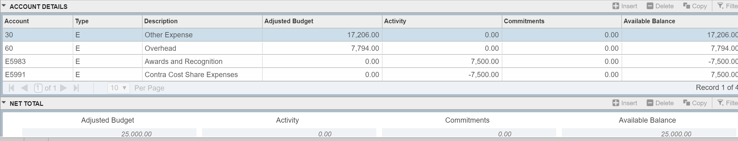
An Argos report has been created which is called: Finance.Test.Cost Share.Salary and Fringe on Cost Share
This report will generate a list of employees paid on cost share grants (column D) and cost share funds (column F). The report is run by Fiscal Year and all cost share expenses will be pulled for all OSP cost share funds. You will need to filter the data to find information just for your cost share grants/funds. The Cost Share Index (column G) will be the one that the cost is being charged back to using E5995. By using this spreadsheet, you can see the payroll detail on your charges to non-OSP indexes.
Based on input from the meeting, Ron Town has added the Grant Index, the Trans Date and the PayNum to the report so you can now tell which pay period the pay is for.
Please test this report and let Wendy Kerr know if you find it helpful or if any changes are needed.

  - Sarah Martonick provided details on what Post Award will request and when, for cost share setups.
    - Post Award will be asking the department (DGAs) to complete and return a cost share allocation form for all new projects that include cost share as part of the project requirements. This needs completed and returned only when the proposal did not include the correct cost share breakdown per providing index (not old Chart 9 budget #s) or when multiple cost indexes are needed under multiple ORGNs and that was not detailed in the proposal and ESF breakdowns for cost share. A cost share allocation form is also needed for modifications that are adding cost share to existing cost share indexes, based on incremental funding. In the latter situation, the DGA can add both the cost share index and fund, as well as the providing index to the allocation form.
    - Please provide the breakdown PER the index providing cost share and include each providing index on the form, as well as the ORGN that you want the cost share index setup under and a suggested title descriptor as needed. The cost share form needs to total the amount required by the sponsoring agency (either based on the total allocation or increment, whatever is awarded at that time).
    - Third party cost share can be shown on the form but will not receive an index under the cost share grant code, because those expenses cannot be tracked in Banner. Gift accounts used as cost share also do not need a cost share receiving index setup in OSP. Work with Wendy on reporting the latter two.
    - We request a quick response time with the cost share allocation form, so that we can ensure the cost share grant code and indexes are setup with the grant code for the sponsored funds. This is important because cost share PCTs are an audit risk, just as other PCTs are an audit risk on grant funds.
    - See the cost share allocation form (thank you to Cathy for creating it). We will get it posted to the website soon with instructions.
- We did not discuss the following due to time constraints:
DGA Roundtable changes
  - DGA Roundtable Committee: Michele Mattoon, Mikayla Frey, John Brabb, Theresa Albright, Eric Everett, Ann-Marie Bilderback, Vicki Russell, Sarah Martonick.
  - Upcoming schedule:
    - April: Payroll/Onboarding/Hiring Process/IPO and J1 Visas/Summer Salary and EPAFs (if not a duplication of the EPAF trainings).
    - May: Budget Monitoring/Projections, Excel Pivot and Argos, Banner reports and E-code usage.
    - If these are items that you voted for in the survey or need training on, please send details on what you want to learn within these topics so that we can best arrange presenters and content.

