Germ City

Clean Hands—Healthy People

Clean Hands — Healthy Children — Healthy People

It’s happening in schools, on cruise ships, in restaurants, in health care settings and in your home. Every year, thousands of Americans become ill — severe vomiting, diarrhea, headache, fever, abdominal pain and nausea. It seems to spread like a wildfire through schools with symptoms lasting several days. Often called the “24-hour” flu, this illness is the second most likely infection in America after the common cold.

It’s called norovirus (previously called Norwalk-like Virus). Humans are the only known hosts. People get norovirus infection by swallowing food or water that has been contaminated with microscopic viral particles from the stool of an infected person. That’s how the virus is most commonly spread from one person to another.

This illness spreads rapidly from person to person when hands are not washed after toileting. Any surface the ill person touches like doorknobs, faucet handles or computer keyboards may be contaminated. When a healthy person touches the same surface, they can easily carry the virus to the food and water they consume. This is especially true when people don’t take time to wash their hands prior to preparing food or eating.

One of the best ways to stay healthy is to wash your hands frequently and well: Especially before preparing food, eating meals and snacks. This simple step will make a difference in your health and the health of your family and friends. Clean Hands means Healthy Children and Healthy People!

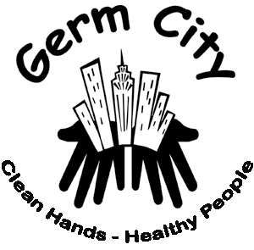

Germ City Visits Schools, Fairs and Festivals

University of Idaho Extension educators and volunteers are sharing the handwashing message of Germ City with children in schools and during fairs and festivals.

Here’s how Germ City works: Children and adults apply a black light sensitive lotion to their hands and enter a tunnel equipped with black lights, seeing pretend germs. After initial observation, participants wash their hands normally, revisit Germ City and assess their effectiveness. It’s “hands-on.” Everyone has an opportunity to learn about the importance of frequent handwashing and see results.

The Cost of Hand Hygiene

It’s a $9 billion dollar problem in the United States. According to the Centers for Disease Control in Atlanta Georgia, that’s the annual cost for the treatment of foodborne illness caused by personal control hygiene factors including poor handwashing practices. The Centers for Disease Control link poor hand sanitation to 34% of the documented cases of foodborne illness in the U.S. That’s 9.3 million illnesses each and every year in the United States that could be prevented with frequent, effective handwashing.
Handwashing is a key, often overlooked behavior that is important for food safety, disease prevention and personal health. Yet, many of us underestimate the potential seriousness of illness and its’ correlation with handwashing practices. In a study by the Food and Drug Administration, only 2/3rd of those questioned reported they used safe food practice that included hand washing, cross contamination prevention, and thorough cooking of meat and poultry.
Most people—including children and adults do not wash their hands as often or as well as needed.

When asked “Why” they don’t take time to wash when they know it is important, adults and children say similar things:
- It takes too long
- Doesn’t make a difference
- My hands are clean
- My hands aren’t dirty
- I’m too busy
- There are more important things to do

It’s a Little Dirty Secret

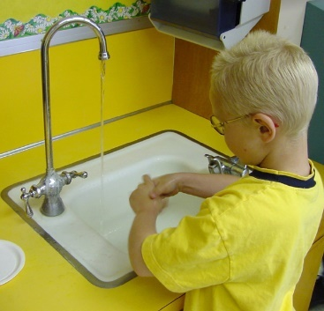
Several studies have shown that adults fail to wash their hands frequently and effectively. In 2000, the American Society for Microbiology asked 1,021 people, “Do you always wash your hands after using the bathroom?” 95 percent responded they did. When 7,836 adults were observed in a subsequent follow-up study in public restrooms in five major metropolitan areas, only 68% even placed their hands under running water prior to leaving the restroom.

A 1999 study conducted in 82 cities in North America by Audits International showed at least one critical violation that could lead to foodborne illness occurred in 69% of the households. The most frequently observed violations were cross contamination (31%), improper cooling of leftovers (29%) and neglected hand washing (29%).

Take time today and make plans to encourage good handwashing in your home.

Children’s Health Improved with Hand Washing

Children stay healthy when they wash their hands effectively and frequently. In a study done in a Detroit, Michigan school, children heard about the importance of handwashing. Half of the students (305) were asked to wash their hands four times each school day at planned times. Children
washing at scheduled times
had 24% fewer sick days due to respiratory Illness and 51% fewer days lost because of stomach upset than did children in the classroom without the scheduled washing.

Encourage your children to wash their hands frequently during the school day and at home.

For More Information:
Name
Phone
Email

