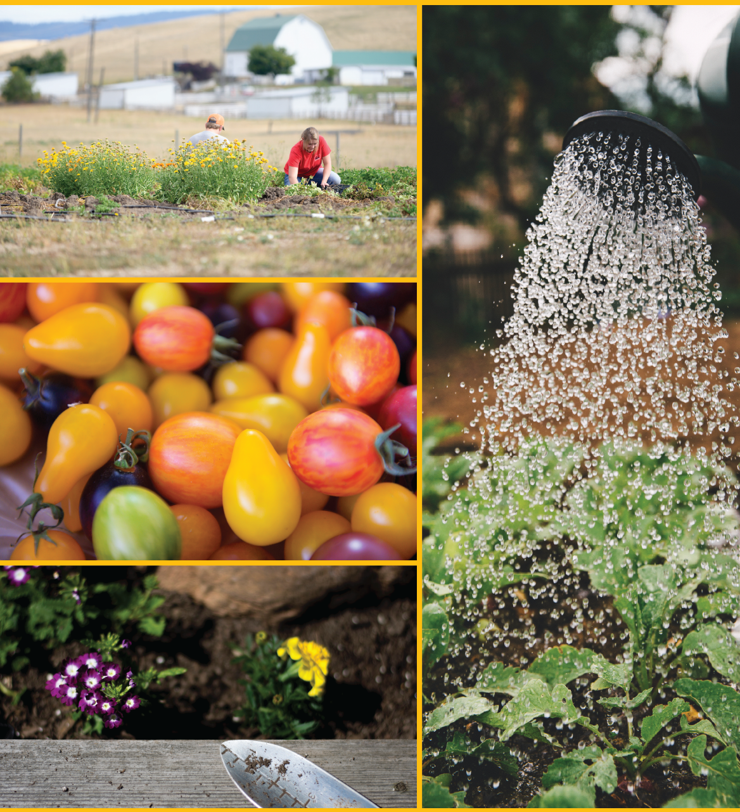­

Classes cover topics such as:

* Botany
* Composting
* Entomology
* Fertility
* Fruit production
* Fruit tree care
* Herbaceous Plants
* Insect pest control
* Landscape design
* Landscaping
* Market Gardens
* Organics
* Pathology
* Plant anatomy and physiology
* Propagation
* Pruning
* Season extension
* Soils/soil health
* Vegetable Production
* Woody plant selection and care

2024

Master Gardener Class

February 14- May 1

Wednesdays, 7:00pm

Classes and coursework online

Classes also include several hands on labs on topics such as pruning, grafting, and propagation

Following classes, there are many opportunities for hands-on volunteer training during the summer months. Master Gardeners must complete all of their classes, quizzes, MG final, and 40 hrs of volunteer service to achieve Master Gardener status.

Class fee $180, $155 refunded upon completion of coursework and associated hands-on volunteer training.

\*\*those in other counties are welcome to join our class if one is not offered in their county

It is U of I policy to prohibit and eliminate discrimination on the basis of race, color, national origin, religion, sex, sexual orientation and gender identity/expression, age, disability, or status as a Vietnam-era veteran. This policy applies to all programs, services, and facilities, and includes, but is not limited to, applications, admissions, access to programs and services, and employment.

UI Extension, Bonneville County

For More Information:

208-529-1390

lallen@uidaho.edu