University of Idaho 4-H Club Charter Request Packet
{4-H Family groups, affiliates, councils, etc. must instead file a “4-H Name & Emblem Use Authorization Request”}

To be completed by 4-H Club Volunteer/Representative:

Club/Group Name: _________________________________________________________________________

County: _____________________________ What is this club’s/group’s EIN #: ________________________

Type of Group: (check one) ___ 4-H Community Club ___ 4-H Afterschool Club

___ Other type of 4-H Club (specify): ________________________________________________
Briefly describe what this group will be doing (purpose): ____________________________________________

__________________________________________________________________________________________

__________________________________________________________________________________________

Was this club/group previously chartered? __ Yes / __ No If yes, what was the EIN #: __________________

I have read the 4-H Name and Emblem User Guide ( https://nifa.usda.gov/sites/default/files/resource/fy-2019-4-h-name-emblem-use-guide-20191108.pdf ) and attest that this group will insure proper use of the 4-H Name and Emblem in accordance with Federal regulation. Furthermore, we will operate in compliance with all federal, state and local 4-H policies, procedures and other requirements.

Volunteer/Representative submitting request: Name: (print) ________________________________________

Signature: ___________________________________________ Date: ________________________

Copies of these documents must be submitted with this request form:
__ Actual IRS Employer Identification Number (EIN) notification (see SS-4 application template, next page)
__ University of Idaho Affiliation Agreement
__ University of Idaho Articles of Affiliation
__ University of Idaho Authorization to Include Club for Group Exemption

I have reviewed the required documentation attached to this request form. Furthermore, based on the acknowledgement and purpose(s) set forth above, this group is authorized to use the 4-H Name and Emblem in connection with its program and activities and is considered an official 4-H unit of the University of Idaho Extension 4-H Youth Development Program.

_________________________________________________________ __________________
(County 4-H Youth Development Personnel) (Date)

_________________________________________________________ __________________
(State 4-H Director) (Date)

To submit this request, county personnel will need to insure all documents are signed, then scan all four documents into one file and email it to fourh@uidaho.edu .

State Office Use Only
Required Materials | Processed at the State Office | Date Completed
__ Affiliation Agreement  __ Articles of Association  __ Authorization … Group Exemption  __ EIN Number | __ Charter sent to County  __ Club/Group Tax Exempt Forms processed | Date: _________________  Date: _________________

(Revised 1/22)
Template for Idaho 4-H Clubs/Groups in Completing their IRS Form SS-4 – To Obtain Their EIN
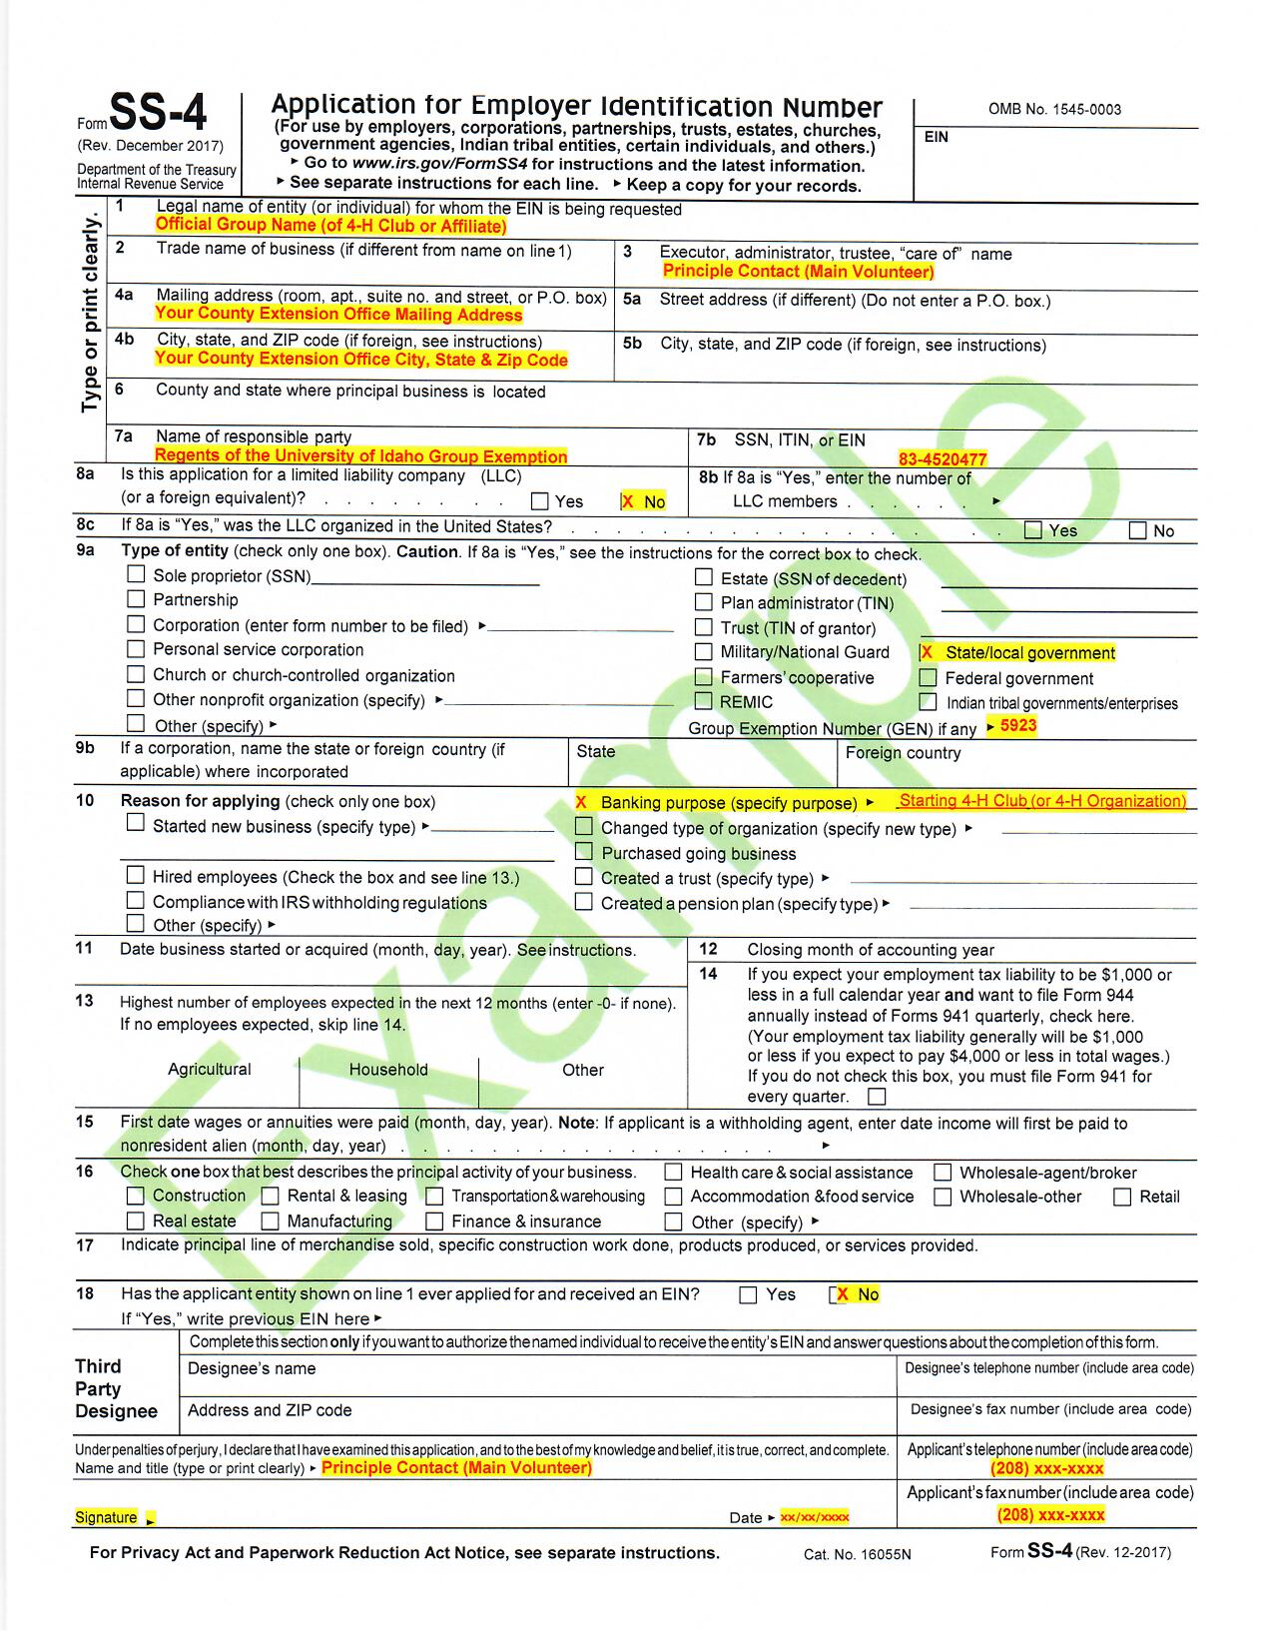
Once Form SS-4 is completed, FAX this form to (855) 641-6935. Allow 2-3 weeks for processing.
{Access to a fillable PDF can be found at https://www.irs.gov/pub/irs-pdf/fss4.pdf }

{Important: include this statement on the FAX cover page “Per IRS rules, box 7a and 7b can list an entity (rather than an individual) because of the state government affiliation, as marked in box 9a.”

ARTICLES OF ASSOCIATION
[NAME OF 4-H CLUB]

The undersigned, a majority of whom are citizens of the United States, desiring to form an Association to carry on the not-for-profit activities and business of [name of club] under the laws of the state of Idaho, do hereby certify:

First: The name of the Association shall be [name of club]

Second: The place in this state where the principal office of the Association is to be located is the City of _______________, ____________ County.

Third: The Association is organized exclusively for charitable, educational, and scientific purposes, including, for such purposes, the making of distributions to organizations that qualify as exempt organizations under section 501(c)(3) of the Internal Revenue Code, or the corresponding section of any future federal tax code.

Fourth: The name[s] and address[es] of the person[s] who [is/are] the leader[s] of the Association [is/are]:

[list name(s) and addresses of club adult leader(s)]

Fifth: No part of the net earnings of the Association shall inure to the benefit of, or be distributable to its members, trustees, officers, or other private persons, except that the Association shall be authorized and empowered to pay reasonable compensation for services rendered and to make payments and distributions in furtherance of the purposes set forth in Article Third hereof. No substantial part of the activities of the Association shall be the carrying on of propaganda, or otherwise attempting to influence legislation, and the Association shall not participate in, or intervene in (including the publishing or distribution of statements) any political campaign on behalf of or in opposition to any candidate for public office. Notwithstanding any other provision of these articles, the Association shall not carry on any other activities not permitted to be carried on (a) by a Association exempt from federal income tax under section 501(c)(3) of the Internal Revenue Code, or the corresponding section of any future federal tax code, or (b) by a Association, contributions to which are deductible under section 170(c)(2) of the Internal Revenue Code, or the corresponding section of any future federal tax code.

Notwithstanding any other provision of these articles, this Association shall not, except to an insubstantial degree, engage in any activities or exercise any powers that are not in furtherance of the purposes of this Association.

Sixth: Upon the dissolution of the Association, assets (including all funds) shall be distributed for one or more exempt purposes within the meaning of section 501(c)(3) of the Internal Revenue Code, or the corresponding section of any future federal tax code, or shall be distributed to the federal government, or to a state or local government, for a public purpose. Consistent with this requirement, assets and funds of the Association should be distributed for the benefit of 4-H. Disbursement among the members and/or leaders of the club is not acceptable, nor is transfer of the assets or funds to a non-4-H group. Appropriate options include: donate to County 4-H council; donate to District 4-H council; donate to Idaho Friends of 4-H. Any assets or funds not so disposed of shall be disposed of by a Court of Competent Jurisdiction of the county in which the principal office of the Association is then located, exclusively for such purposes or to such organization or organizations, as said Court shall determine, which are organized and operated exclusively for such purposes.

In witness whereof, we have hereunto subscribed our names this day of , 20___.

, [title]

, [title]

, [title]

, [title]

[Adult leader(s) must sign. Delete extra signature blanks.]

AFFILIATION AGREEMENT

This Affiliation Agreement (“Agreement”) is made and entered into by and between [name of club as stated in Articles of Association], an unincorporated nonprofit association located in [city and county], Idaho, (“Club”), and the Regents of the University of Idaho, a public corporation, educational institution, and a body politic and corporate organized and existing under the Constitution and laws of the state of Idaho ("University"), through University of Idaho Extension.

Recitals:

  - University is a land grant institution responsible for developing and implementing Cooperative Extension System programs in Idaho. It conducts 4-H Youth Development Programs through the University of Idaho Extension.

  - Club is a 4-H Youth Development Program that meets the minimum criteria for a 4-H Charter Club and is chartered through its local extension office in [county] County.

  - Club desires to be affiliated with University and to operate as a recognized subordinate organization under University’s group exemption for tax purposes (“GEN”).

In consideration of the following commitments and undertakings, the parties agree as follows:

- University shall recognize and accept Club as a subordinate organization under University’s GEN.

- Club shall be subject to University’s general supervision and control, and shall comply with and conduct its business according to the University of Idaho Extension 4-H Youth Development Policies and Procedures as now written or as they may hereafter be amended.

- Club shall limit its purpose and activities to those charitable, educational, and scientific purposes recognized as exempt under § 501(c)(3) of the Internal Revenue Code, shall not engage in activities that attempt to influence legislation, participate or intervene in a political campaign, or otherwise engage in activities that do not further its exempt purposes, and shall dedicate its assets to tax exempt purposes upon dissolution.

- Club shall provide University with a copy of its organizational document, promptly advise University of any changes in Club’s name or address, timely provide University with such financial reports as may be required for tax reporting or other purposes, and otherwise cooperate with University to maintain Club’s status as a qualified subordinate organization under University’s GEN.

The individuals executing this Agreement below certify that they have authority to sign the Agreement on behalf of their respective entities, and that the parties consent to be bound by the terms and conditions of the Agreement.

__________________________________  [Name of club] | Board of Regents of the University of Idaho
By: Name: Title: Date: | By:  Name: Brian Foisy  Title: Vice President for Finance and Administration Date:
 | 4-H Youth Development Programs, State Office:
By:

Name: Angela Freel
Title: Director, 4-H Youth Development Programs

Date:

Authorization to Include 4-H Club In Application for Group Exemption

[Name of club], by its duly authorized officer, authorizes the University of Idaho, through its Director of Cooperative Extension Service or other authorized agent, to include the Club in the University of Idaho’s Application for Group Exemption Letter under Rev. Proc. 80-27.

The undersigned affirms, on behalf of the Club, that the Club will engage only in such activities that qualify it for exemption as an educational organization under Section 501(c)(3) of the Internal Revenue Code, and that it will abide by its charter and the University of Idaho Extension 4-H Youth Development Policies and Procedures, as they now exist or may hereafter be amended.

Club  Name of Authorized Officer and Title (type or print)  Signature | (xx-xxxxxxxx)  EIN #
 | Date

