**Dissertation (or Thesis) Template: These Pages are Correctly Formatted, and you can Change Highlighted Items to Suit Your Degree and Research**

A Dissertation

Presented in Partial Fulfillment of the Requirements for the

Degree of Doctor of Philosophy

with a

Major in Dissertation Writing

in the

College of Graduate Studies

University of Idaho

by

Lou P. Student

Approved by:

Major Professor: John Lennon, Ph.D.

Committee Members: Paul McCartney, Ph.D.; George Harrison, Ph.D.; Ringo Starr, Ph.D.

Department Administrator: Brian Epstein, Ph.D.

December 2023

Abstract

This handbook will guide you through the formatting standards instituted by the University of Idaho Graduate Faculty for submitting your thesis or dissertation. All documents, no matter the discipline or degree level, need to have:

1. a title page.
2. an abstract
3. a table of contents (TOC)
4. chapters or sections with consistent formatting

**If you have looked at previous students’ work, you may notice that the Authorization to Submit Dissertation (or Thesis, if you are a master’s student) is no longer page ii**. Approvals will be initiated and documented on the ETD ProQuest platform. A printed paper copy is no longer required. Your committee and department administrator will **approve your final submission in ETD** with a computer-generated approval process. ***Learn more in Chapter 3: ETD Sounds Greek to me.***

This document is ***pre-set*** with all the formatting requirements. If you do not use this document as your template, **please make sure you read the requirements carefully**

After formatting the Abstract page, you will use the same style for headings, indentation, and spacing throughout the document. Abstracts have no word limit. Take note of the heading style used in the first few pages of the style guide and text style (normal) for the content provided here so that you select these same styles on the subsequent pages and sections. Click the expand box on the bottom right of the Styles Guide on the tool bar above to make it easier to see and then modify your document. Also, opening the Navigation Pane will help you visualize your entire document’s outline by seeing the selected section headings as they correspond with the correct style.

A final tool that is most helpful, especially when checking your margins, is your Gridlines. Turn on Gridlines by going to “View”, finding the “Show” section, and selecting the box next to “Gridlines”. Gridlines can be very helpful to check that your content does not go over the margins and is spaced consistently.

This handbook is formatted to be used as a template for your research document. Appendix B has more in-depth formatting information if your document is more elaborate, or you broke the provided template. Best advice: **Do not break the template!** Good luck.

Acknowledgments

Acknowledgments are used to convey your appreciation to those who were instrumental to your academic career, including faculty, grant and scholarship agencies, internships, research facilities, and others who assisted and supported your academic pursuits.

(Instead of mentioning family, friends, or pets here, use a dedication page.)

Dedication

This is where you thank the people who have been important to you personally rather than professionally. This is not a required page, but it is nice to thank those who took the brunt of your frustrations while completing this document. Give kudos to loved ones who hopefully still love you after this! The dedication page is centered vertically and horizontally, just like this example, to make it extra special.

Table of Contents

Abstract ii

Acknowledgments iii

Dedication iv

List of Tables vii

List of Figures viii

Statement of Contribution ix

Chapter 1: Introduction to Preparing Your Dissertation (or Thesis) 1

Contact Information 1

Document Standards 1

Document Format 2

Responsibilities for the Student, Major Professor and ETD Administrator 3

Document Deadlines 4

Chapter 2: Organization 5

The document components consist of the following sections and pages. The key three are preliminary pages, main pages, and appendices. 5

Chapter 3: ETD Sounds Greek to Me. 9

ETD Set-up 9

Traditional or Open Access: 9

Search Engines: 9

Delaying the Digital Release of Your Work, aka Embargo: 9

ETD Checklist 11

Steps for Student Submission for ETD Committee Review/Authorization to Submit 12

ETD Committee Review Overview for Faculty 13

Chapter 4: Conclusion 14

Appendix A: Checklists 15

Check These out for Quick Guides to Document Success! 15

Formatting Checklist 15

Document Components Checklist 16

Appendix B: Examples and Tips 17

Use the Headings and Subheading to Organize! 17

Figure, Table, Etc. Captions 17

Styles 18

References or Bibliography 19

Appendices 19

Landscape Pages 20

Literature Cited 21

List of Tables

Table 2.1 This table reflects the number of times a student will revise and submit a thesis or dissertation in comparison to the times they consult this handbook. The data are fictitious and for illustration purposes only. 6

Table B.1 This is a table to provide another entry for the List of Tables 18

List of Figures

Figure 1.1 is an example of Arabic and Roman Numerals. You will use the Roman numerals (ii, iii, iv…) for the preliminary pages and the Arabic ones (1, 2,3…) to begin Chapter 1. 2

Figure 1.2 Identical Titles and Capitalizing all Words Four Letters or More. 3

Figure 2.1 explains the difference between autogenerating and manually labeling your tables and figures. Both have their issues. What are yours? 8

Figure 3.1 shows the ETD Checklist for the requirements to successfully submit your thesis or dissertation to graduate. You will find this on your ProQuest ETD Submission Account on the left-hand menu. Watch the video or read the rest of this chapter on ETD account set-up and publishing to get started. 11

Figure 3.2 Image of ETD Committee Review Workflow once the ETD Committee Review feature is activated. Please use the temporary Authorization to Submit Form found in the Administrative Documents if you submit before its launch. 12

Figure 3.3 Adapted from proquestmeetings.webex.com/recording/ETDCommitteeReview 12

Figure 3.4 Committee Review Decision Page Image 13

Figure B.1 shows how to create a label for your table and figure captions. Let’s hope it autogenerates your Lists of Figures and/or Tables when using this function. Good luck! Watch the Tutorial linked on page 8 if you have trouble. 18

Statement of Contribution

If submitting collaborative work through multi-authored articles in the dissertation or thesis, the student must demonstrate primary responsibility and authorship, and include a clear statement of the student’s specific contribution to the collaborative work. This contribution statement must be approved by the thesis/dissertation committee. The contribution statement should clearly and specifically articulate the attributions of any co-authors included in the dissertation/thesis articles.

Please delete this page if this does not apply to you.

# Introduction to Preparing Your Dissertation (or Thesis)

*Below is an example of how to cite a chapter already submitted or published:*

**Smith, J., Thompson, S., “Introduction, Getting Ready, and Formatting.” *The Graduate Handbook for Preparing and Submitting Theses and Dissertations,* vol. 15, no. 1, 2021, pp. 12-19**

Remember: Only chapters ALREADY SUBMITTED to a journal are allowable for inclusion. If the publication allows permission to use your published work with them for the purpose of completing your dissertation or thesis, a copyright letter in your appendices is not required. Many journals that do require permission have an easy access form on their websites. Check with the publisher for details.

(The above citation styles is an example only; use the reference style guide (APA, IEEE, MLA…) you have used for the rest of your document and consult your committee for best practices in your field.)

### Contact Information

For all issues preparing, defending, or submitting your thesis or dissertation, contact Molly Patterson via email at mpatterson@uidaho.edu, on, or in-person at Morrill 104 on Tuesday and Thursday afternoons. She will do her best to make this process a painless and happy one. If there are any specific formatting questions that are not addressed in this handbook, contact Molly. All administrative matters like registration and study plan issues will be deflected to Taylor Brady because they drew the shortest straw and must handle all items that make students very unhappy. Contact Taylor at [cogs-forms@uidaho.edu](mailto:cogs-forms@uidaho.edu) or 208-885-6243.

### Document Standards

Starting August 23, 2021, all theses and dissertations will be digital format and electronic submission only although comply to the same consistency and layout rules as demonstrated and expressed in this handbook. If you or your committee would like a printed copy, the required format allows for that, and the UI Print and Copy Center can assist you. Visit <https://printonline.uidaho.edu> to order your personal copy. *(****Please note that active weblinks are NOT allowed in your real document. We are breaking the rules by providing them here. Do as we say and not as we just did****.)* Also, ProQuest offers a bound copy service as well. That is the digital platform where students submit their work. **Lastly and once again, a paper copy is not required for students registered and graduating Fall 2021 and beyond!**

### Document Format

#### Margins and Line Spacing

All pages, just as shown in this handbook, must have **margins set at 1.25” on the left, 1” on the right, 1” on the top and bottom, and formatted to 8.5”x11’ paper-size**. The 1” bottom margin must be maintained even if footnotes are used. The top margin will be set in the correct position if you use automatic page numbering function; this will position your **portrait page number about .75” from the top of the page and 1” from the right**, and the first line of text or the page title will automatically begin to appear in the correct place—about 1” from the top of the page.

The text of the entire document (including the preliminary pages) should have its line spacing set at 1.5 like in this document because it looks the best. References (and captions) may be single-spaced with an extra blank line between each entry or entirely spaced at 1.5, since otherwise, they are difficult to read. Spacing after titles and headings must be consistent throughout.

#### Page Numbers

All page numbers in ALL sections of the document must be placed so that, no matter if the page is portrait or landscape oriented, all page numbers are aligned should the pages be printed out. (See Landscape page 19 for example).The only page that should not have a page number is the Title Page. Lower case Roman numerals are used for ALL preliminary pages. Arabic numbers must be used for every page in the rest of the document, beginning with 1 on the first page of Chapter 1 (or on the first page of an introduction, if used). Examples of each type of number follow:

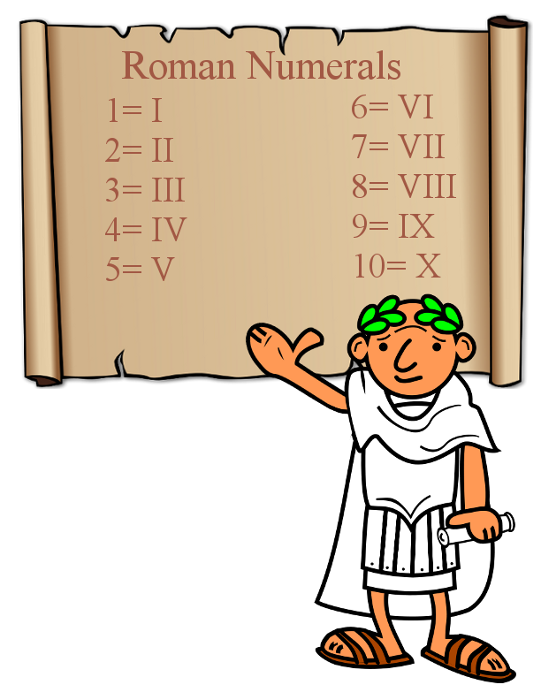

Figure 1.1 is an example of Arabic and Roman Numerals. You will use the Roman numerals (ii, iii, iv…) for the preliminary pages and the Arabic ones (1, 2,3…) to begin Chapter 1.

#### Fonts and Text Size

Use only one style/type of font throughout and black text color only unless illustrating text within images, figures, etc. Color is allowed there. This one style/type of font is to be used for text, page numbers, captions, appendices, references, footnotes, and everything else. The main text size must be 10 – 12-point text. For example, this font is 11-point Times New Roman. Chapter/section titles may be larger than the main font size. This template uses 14-point. For space reasons, a 9-point type may be used for captions with figures, tables, and other graphics.

Consistency is the key to ensuring your document appears polished and professional. For example, just as the font for your tables and figures descriptions should be consistent, so should be the placement. Choosing to put them below or above the graphic may depend on your discipline’s style guide. Whichever you use, make sure they stay in the same place throughout your document.

Figure 1.2 Identical Titles and Capitalizing all Words Four Letters or More.

Title of Your Thesis or Dissertation

Your Title Should be the Same on the Title Page, the ETD Title Field, and Your Repository Agreement. All Words Four Letters or More Should be Capitalized Like in This Textbox Example. You may use Your Discipline’s Style for Titles on the Other Pages not Mentioned Above.

### Responsibilities for the Student, Major Professor and ETD Administrator

#### Student

• Manages all aspects of completing their thesis or dissertation. This includes ensuring that their defense meets the semester deadline and does NOT occur in the final 3 weeks of a semester.

• Takes the lead by WRITING to the Major Professor and committee members to convey all important dates, expectations, and other important aspects of completing their work and meeting deadlines. This includes acquiring all necessary signatures.

• Organizes all materials in the approved manner outlined in this Handbook and follows all formatting guidelines and submits a neat and clean document free of misspellings, typos, improper punctuation, and poor grammar. Your major professor may or may not edit your work for correct English usage; they will, however, read for errors in your subject content.

• Submits all forms and materials by the deadlines on the COGS Dates & Deadlines website at http://www.uidaho.edu/cogs/student-resources/graduate-deadlines.

• Takes responsibility for adhering to deadlines, thesis or dissertation formatting, and other forms pertaining to your degree. If you find your major professor or committee member are not very communicative to the extent that you are in peril of finishing up on time, contact COGS. Make sure you have written proof of your communication efforts so we can be well informed.

#### Major Professor

• Does not set any final defenses during the final 3 weeks of a semester.

• Is responsible for content accuracy and completeness of all aspects of the document.

• Informs the student of the style guide s/he should use for references and citations, and ensures student submits properly composed references.

• Makes certain that the student has complied with any necessary Protocol Approvals and works with the student to ensure that sensitive materials are treated properly.

#### ETD Administrator

* Reviews all versions, from the preliminary draft to the final submission, to ensure all format, organization, and appearance standards have been met.
* Will point out typographical errors or inconsistencies if in titles or main preliminary pages; however, avoids basic copy-editing duties such as spelling, punctuation, syntax suggestions, citation repairs, references list, and other aspects of grammar throughout the document.
* Conveys to the student and Major Professor (in writing) the elements that need to be revised prior to the next submission.

### Document Deadlines

Visit our [webpage](https://www.uidaho.edu/cogs/deadlines/thesis-dissertations) for specific dates associated with the thesis and dissertation deadlines for each term.

* Request to Proceed with final defense five weeks before the end of the term.
* Defense and Qualifying Paper format **check three weeks prior to end of term**
* Final version to ETD **two weeks prior to the end of the semester**
* Complete the ETD Checklist and receive final approvals of your document in ETD including Department Administrator and the COGS ETD Administrator by end of day on the last day of the term. Not providing adequate time for approvals, meaning not meeting the first three deadlines, could delay your graduation term.

**CAUTION: Summer has tight deadlines, and many people are unavailable for defenses and approvals. Communicate well and plan accordingly if you are considering a summer defense and degree conferral!**

# Organization

### The document components consist of the following sections and pages. The key three are preliminary pages, main pages, and appendices.

1. These are the Preliminary Pages, in order. Each of these pages must begin on a new page.
2. Title Page (**required**)
   1. Does not have a page number.
   2. Doctoral students prepare a “dissertation;” Master’s students prepare a “thesis.”
   3. Your degree and major must match your university records; do NOT include a minor, emphasis, focus, or area of specialization.
   4. Keep the full name and highest terminal degree of the faculty member all on the same line. Certificates and professional notations are NOT considered terminal degrees and are, therefore, not allowed. (e.g. Jane G. Smith, Ph.D.)
   5. At the very bottom, put the month and year in which you plan to graduate, not the month and year that you wrote your thesis or dissertation. The only options are December, May, and August.
3. Abstract (**required**)
   1. The abstract is a short summary of the entire document, written in narrative style, and numbered *ii*.
   2. Although each chapter may have its own abstract or introduction, an “umbrella” abstract that encompasses the entire document is REQUIRED.
4. Vita (optional) This is a summary (maximum 2 pages) of your academic background; it should not be autobiographical.
5. Acknowledgments (recommended)
   1. This section thanks specific individuals for their guidance and assistance, and the agencies from which you may have received grant support.
   2. Think of this page as the “Academic and professional thanks” page.
6. Dedication (optional, but nice)
   1. The title and content it must be both vertically and horizontally centered in the middle of the page.
   2. Make sure the title is just 2 lines above the beginning of the text.
   3. Dedications are more personal than professional in nature. Usually, they convey thanks and appreciation to family members, close friends, pets that went hungry, etc.
7. Table of Contents (**required**)
   1. This table lists the title of each of the document components.
   2. An entry for each preliminary page used (except for the Title page)
   3. Each chapter/section number and title
   4. 1st order subsections (and 2nd order if you wish)
   5. References (if only one list of sources is used)
   6. Each individual appendix number and title
   7. Use dot leaders to line up the final digit of your page numbers up at the right margin.
   8. Apply 1.5 spacing to ensure easier readability.

Table 2.1 This table reflects the number of times a student will revise and submit a thesis or dissertation in comparison to the times they consult this handbook. The data are fictitious and for illustration purposes only.



1. List(s) of Graphic Materials (figures, tables, charts, etc.) and/or Explanatory Materials (glossary, codes, terms, abbreviations, symbols, equations) if used Body of chapter. Use scripts heading 2 – 5 for subheadings and normal for body text.
   1. Create a separate list for each different type of graphic material (tables, figures, photographs, etc.) or explanatory material (nomenclature, glossary, abbreviations, symbols, etc.)
   2. Use dot leaders to line the final digit of each of your page number entries up with the right margin (just as you did with the Table of Contents)
   3. Use 1.5 spacing to ensure easier readability.

**The Authorization to Submit is not a page in your formatted document. Your committee and department administrator authorize your submission in an electronic approval process on the ETD platform. Learn more in Chapter 3!**

1. These are required in the Main Content Pages.
2. Chapters/Sections (required)
   1. You must be the primary author of each chapter in your document regardless of whether you intend to submit your work for publication or not.
   2. Your work needs to be divided into sections entitled “Chapters” accompanied by a number (Chapter 1, chapter 2, etc.) and a short verbal description of what the chapter will discuss OR sections (if your major professor does not want you to title these sections as “chapters”)
   3. Both chapters and sections need to be numbered and have a descriptive title
   4. Each new chapter or section must begin on a new page.
   5. Chapters you intend to publish need to be composed using the same formatting rules as the chapters you do not intend to publish.
   6. Submitted chapters need to also include the current publishing status directly below the chapter title.

“Theses and Dissertations Graduate Handbook: Preparing and Submitting Your Document to the University of Idaho.” College of Graduate Studies Literature, vol. 28, no. 1, 2021, pp. ii-34.

* 1. Examples of the most recent publishing status can include “published in” or “forthcoming in”. **If the paper has not been accepted for publication, do not include a note regarding its status.** We cannot predict whether your paper will be accepted in the future.

1. References/Works Cited (required)
   * May be placed at the end of each chapter, or all together immediately after the chapters and before any appendices. Please remove all active web hyper-links in your document.
2. Appendices (may be used only if the material in question is one or more of the following items)
   * Copyright letters, surveys, protocol approvals, oversize and other auxiliary materials, extensive data sets, and other material referred to in the chapters that enhances the content of the document.

Protocol Approvals:

* Prior to beginning any research projects, approval must be granted by one or more of the following groups if it applies to the research that you are undertaking.
* A letter from the appropriate committee approving the protocol must be included in the appendices.
* Visit the Before Starting Your Research webpage to ensure you are following all the necessary protocols. Should your research methodology or source funding change, notify the appropriate group.

Sensitive Materials

* We urge students not to include classified or confidential material as a part of the dissertation or thesis that would impair the ability to have the documents available in the university library or appear in digital format on the Internet. If you feel you need to include such material, you must receive permission from the Dean of the College of Graduate Studies before you begin your research.
* Talk to your Major Professor about using pseudonyms for privacy purposes. If classified material is being used or there is any other reason you think your material needs to be treated with sensitivity, talk to your Major Professor about ways to protect the information.

Figure 2.1 explains the difference between autogenerating and manually labeling your tables and figures. Both have their issues. What are yours?

(This document is set-up to automatically create your List of Figures and Tables, but Word, like many humans, can be finnicky sometimes and resistant to change. Some students choose to manually add the chapter number, because it adds more freedom in how they want to label their chapters but can create more work in creating their List of Figures and Tables. Additional tips are given in the appendices of this handbook. If you break the template, you are sentenced to misery or to watching the videos linked below to give you tips on how to fix it. By the way, providing an active hyperlink to webpages is against the formatting rules. We are being naughty here! Forgive us. See [Erin Wright Writing Tutorial](https://www.youtube.com/watch?v=MpoE6CCadlw) on how to insert figure and table captions in Word and [Chapter-Based Figure Numbering](https://www.youtube.com/watch?v=UrcAmAQWSK0) if you have lots of figures and want to use the auto-create function.

* + In Appendix A, you will find format and document checklists for quick guides to the rules explained in this chapter.
  + In Appendix B, you will find more in-depth tips and examples if you are having trouble with a specific format or organization item.

# ETD Sounds Greek to Me.

### ETD Set-up

When you are certain your document meets all the formatting, component, and standards for the First Format Review, you are ready to create an ETD account. **LOOK HERE:** **Best tip!! You should convert your Word document to a PDF *PRIOR* to uploading.**

1. Create an ETD account at <https://www.etdadmin.com/main/home?siteId=126> Fill in the fields and upload your document. You will need to enter email addresses for your committee members and department administrator.
2. Click SUBMIT. If you don’t, the ETD administrator does not get notified and is unaware it exists.
3. Don’t worry! It’s OK! Just click SUBMIT. The paper will ONLY go to the ETD Administrator, not your committee. You will have as many opportunities as you need or are requested to make revisions on your document.
4. ALWAYS resubmit on your original ETD Account/Submission ID. Do not create a new account, please.

During set-up, you must answer publishing questions before you can move on. For that reason, review the Publishing Options below to help make your selections.

### Traditional or Open Access:

Students must choose between either Traditional or Open Access publishing. Most select Traditional Publishing (it is free) as they do not see the need to purchase Open Access Publishing ($95) from ProQuest. Selecting the Open Access Publishing option from ProQuest makes your work fully available through their website, but since it will already be fully publicly available through the University of Idaho library, this payment is unnecessary.

### Search Engines:

There is nothing wrong with allowing major search engines to discover your work through ProQuest. This will make your work more accessible to other scholars.

### Delaying the Digital Release of Your Work, aka Embargo:

1. Delaying the release of academic work is often referred to as “embargoing” your work. This is the amount of time that you want to delay the DIGITAL distribution of your document.
2. It is RARE to embargo. If you do, your institutional repository agreement found in the Administrative Documents tab on your ETD account’s left-hand margin **must match the selection** you made with ProQuest.
3. Unless there is a very specific reason why you would need to delay electronic access to your document, such as a patent pending, we recommend that you make your work accessible immediately. As a publicly funded university, your work should be made readily available to the State of Idaho as well as the larger scholarly community.
4. Embargoing your thesis or dissertation does not affect the publication of current or future articles arising from your work.
5. If you need to delay the digital release of your work, your document will not be available until the end of the embargo period.
6. The same amount of time must be reflected in both the ETD account and on the UI Repository Agreement. Both yours and your major professor’s signatures must appear on the Repository Form which you upload to administrative documents in ETD.
7. It is the responsibility of the student to inform ProQuest, COGS and the UI Library if they wish to request an embargo renewal or extension beyond what he/she originally selected.

If you still have questions about publishing, contact the University’s Digital Infrastructure Librarian, Evan Williamson, at ewilliamson@uidaho.edu or 208-885-6260. You can also read the Intellectual Property, Copyright, Publishing Guides and ETD Publishing Information.

### ETD Checklist

If you can check all the boxes on your ETD account, you are ready to finish! The figure below is a screenshot of the ProQuest ETD Submission Account page found on the left-hand menu in *Manage your ETD*.

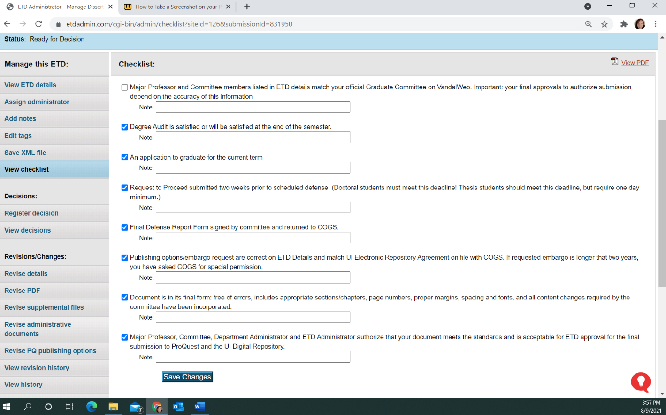

Figure 3.1 shows the ETD Checklist for the requirements to successfully submit your thesis or dissertation to graduate. You will find this on your ProQuest ETD Submission Account on the left-hand menu. Watch the video or read the rest of this chapter on ETD account set-up and publishing to get started.

### Steps for Student Submission for ETD Committee Review/Authorization to Submit

*To modernize and simplify the Authorization to Submit Thesis/Dissertation step and to be compatible with electronic-only document submission starting Fall 2021,* ***final approvals will be done in ETD.***

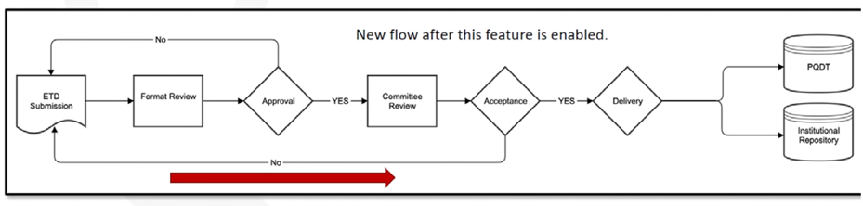

Figure 3.2 Image of ETD Committee Review Workflow once the ETD Committee Review feature is activated. Please use the temporary Authorization to Submit Form found in the Administrative Documents if you submit before its launch.

Here is what to do to get final committee and department administrator authorization to submit:

1. During your submission to ETD, you will provide details about your committee chair (major professor), committee members and department administrator. At this time, you should check that your committee listed in VandalWeb matches the names and email addresses you enter here. You will enter your department administrator as your final committee member. If addresses are incorrect or missing, neither you nor the administrator will be able to complete or accept the submission. Your committee is blocked from making a decision until the fixes are made and then approvals start over.
2. After the format review by the ETD Administrator, email notifications with a direct ETD login link are sent to your committee members to approve your thesis or dissertation.
3. If all committee members approve, you will not receive an email. If a committee member rejects your submission, you will receive details on what to fix for resubmission.
4. When all final documents are received including the final defense report form (to [cogs-forms@uidaho.edu](mailto:cogs-forms@uidaho.edu)) and institutional repository agreement (uploaded in ETD), the ETD Administrator will approve your submission and send your document to ProQuest and the Institutional Repository for publishing.



Figure 3.3 Adapted from proquestmeetings.webex.com/recording/ETDCommitteeReview

### ETD Committee Review Overview for Faculty

*To modernize and simplify the Authorization to Submit Thesis/Dissertation step and to be compatible with electronic only document submission in Fall 2021, final approvals will be completed in ETD.*

Here is how committees and department administrators authorize submitted theses and dissertations for final approval:

1. After the format review by the ETD Administrator, email notifications with a direct ETD login link are sent to the committee members and department administrator.
2. In no sequence, committee members and the department administrator verify that the submission is the committee-approved version on the Committee Review: Decision page.
   1. There are radial buttons to register your decision as approve or reject.
   2. If you reject, you must provide comments and action items for the author to fix to receive an approval after resubmission.
3. The major professor confirms embargo/repository selections on ETD details match the Institutional Repository Agreement uploaded in the ETD administrative documents.
4. When all final documents are received including the final defense report form (at cogs-forms@uidaho.edu) and institutional repository agreement (uploaded by student in ETD), the ETD Administrator will approve the submission and send the document to ProQuest and the Institutional Repository for publishing.

*Note: Page ii is now the Abstract because format review and approval are done in ProQuest ETD as explained above.*



Figure 3.4 Committee Review Decision Page Image

# Conclusion

(The End in Summary)

# Appendix A: Checklists

## Check These out for Quick Guides to Document Success!

### Formatting Checklist

◻ Margins: top and bottom, 1”; left 1.25”; right 1”

◻ Font: 10-12 point; use only ONE type of font

◻ Page and Chapter Titles, Headings: all of these MUST be consistent in terms of:

• case (all uppercase or all major words capitalized)

• emphasis (all bold or none)

• alignment (all centered or all at left margin – with a few exceptions)

• size (may be the same size as text or up to 2 points larger)

◻ Titles, headings, or first line of text: must be about 1” from top of page; no running heads

◻ Page numbers must appear in the upper right corner about ¾” from top margin

◻ Spacing of text and lists: minimum 1.5 (looks best) – maximum 2.0

◻ Spacing after titles and headings, including subtitles, must be consistent throughout

◻ Tables, figures, and other graphic materials: centered horizontally, with single-spaced captions placed consistently above or below the graphic.

◻ Eliminate Widows and Orphans: This term applies to words, short lines, subtitles, headings, or bibliographic references that start at the end of one page and continue onto the next. Keep material such as this together whenever possible.

◻ Keep references that are 2-3 lines together. References of 4 or more lines at the bottom of a page may be split onto 2 pages at approximately the half-way point.

### Document Components Checklist

◻ Preliminary Pages, in order: (use lower case Roman numbers)

◻ Title Page (do not put a number on this page)

◻ Abstract (p. ii) and then continue numbering from here

◻ Vita (optional)

◻ Acknowledgments (recommended)

◻ Dedication (optional) centered vertically and horizontally on the page

◻ Table of Contents

◻ List(s) of Graphic and/or Explanatory Materials (one list per type of material, e.g., tables,

figures, abbreviations, illustrations, equations, and so forth)

◻ Preface (optional)

◻ Introduction (optional)

◻ Chapters: (Begin to use Arabic numbers here)

◻ All subsections within each chapter, such as abstract, introduction, methods, etc. must follow immediately after each other. The only subsection that may start on a separate page is a list of your sources.

◻ References/Works Cited/Bibliography: A separate section listing your sources is required for documents that do not include the sources at the end of each chapter.

◻ Appendices (not all theses and dissertations require appendices)

_________________________________________________________________________________

◻ Make sure your Authorization to Submit Thesis or Dissertation is completed on the ETD platform!

# Appendix B: Examples and Tips

(Delete this before submitting your document)

If the provided template is not working for you, here are additional examples and tips to try. Remember this is just a template that is designed for universal use. You need to adapt it to your needs. The body of each chapter can be divided in whatever subsections needed. Furthermore, you may choose to not write an Introduction or Conclusion and thus, should delete those headings and use Chapter numbers. If you do not have any figures or tables, please delete the List of Figures and/or Tables. On the rare occasion you do not have any citations in your thesis, you should delete the Literature Cited subheadings.

### Use the Headings and Subheading to Organize!

Heading “1st few pages” should be used for headings on roman numeral pages (before your 1st chapter).

Headings 1-5 are for use in the chapters.

Heading format (font, size, type) can all be modified by right clicking on the heading and clicking on ‘modify’. If you modify the heading it will apply to all your pages so your formatting will remain consistent throughout the whole document.

Currently only Headings 1 and 2 are designated to appear in the Table of Contents. If you want more levels to appear, go to:

* In Word: *References* > *Table of Contents* section >, click on the arrow for *Table of Contents* > *Custom Table of Contents* > and change *Show Levels* to the desired number.

### Figure, Table, Etc. Captions

Each figure and table must have a caption/label which must be included in the ‘List of Figures’ or ‘List of Captions’. The easiest way is to insert a caption which lets Word automatically add it to the lists.

* In Word: *References* > *Captions* section > **Insert Caption.**
  + When you insert a caption, a box will open. You can tell it to suppress or add the chapter titles and you can change the label. For figures you want the label to be figure. If you want a different label, you can create your own.
  + If you add additional labels and want additional Table of …. You will need to insert a new Table of … To do this: *References* > *Captions* section > **Insert Table of Figures (and select the appropriate list).**
  + 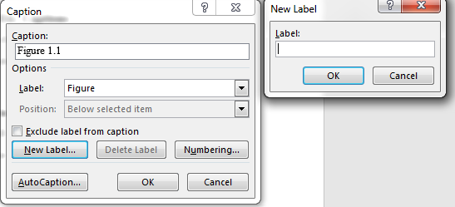

Use dropdown menu to select label (Figure, Table, Equation, or something else)

Figure B.1 shows how to create a label for your table and figure captions. Let’s hope it autogenerates your Lists of Figures and/or Tables when using this function. Good luck! Watch the Tutorial linked on page 8 if you have trouble.

Make sure you use a consistent format for all your captions throughout your document. You can modify the *Caption* style, so all are the same. Do you want your captions to be?

* Single or double spaces? Bold or not? Center or left justified?
* Figures: Should the captions be places above or below the image?
* Tables: Put captions above or below?

For examples, please see Chapter 2. Please note that this template was created to automatically recognize chapter numbers.

### Styles

Learn to use and be comfortable with the styles and use throughout your document. This will ensure that all your Tables of Contents will be correct and your fonts consistent throughout your document.

Table B.1 This is a table to provide another entry for the List of Tables

|  |
| --- |
| 1st few pages = for headings used before your chapters. |
| Normal = for your basic content; currently set at 1.5 spaces with a paragraph indent. |
| Heading 1 = for “Chapter” title in 1, 2, 3 format. |
| Headings 2-5 = for subheadings in chapters. |
| Appendix = for your “Appendix” title in A, B, C format. |
| Caption = for your “Figure” and “Table” captions. |

### References or Bibliography

Choose a consistent format for your References or Bibliography. The use of a program such as Mendeley or Zotero may be helpful in keeping the formatting consistent and to ensure you include all citations. Be sure to double check all your references as these programs occasionally make mistakes. Do not use active weblinks in your citations if your references are from digital sources.

### Appendices

To add more appendices, do the following:

1. Insert a Page Break (*Insert* > **Page Break**), so the next appendix starts on a new page.
2. Type the name of the appendix and apply the Appendix Heading style *(Home* > A**ppendix**)

If your chapter captions are number 1,2,3, etc., that numbering format should continue through your appendix captions. If captions in chapters are numbered 1.1, 1.2, 1.3, etc., your appendix captions must match that format by using A.1, A.2, A.3, etc.

Problems: A common problem with the appendix captions is that Word will label them like they are in a chapter (for example Figure A.1 was originally labeled by Word as Figure 2.1). One solution is to do the following:

1. Wait to fix anything until after you after inserted all your captions.
2. Starting in Appendix A, carefully delete the chapter number in each appendix caption and type in the appendix identifier (A, B, C, etc.)
3. Be careful to not delete the Word automated number in each caption.

Another solution is to follow these directions provided by Shauna Kelley: <https://shaunakelly.com/word/numbering/numberingappendixes.html>

### Landscape Pages

Landscape Pages are troublesome and should be avoided at all costs! If you must, the easiest solution is to duplicate this page. The following webpage provided by the University of Wisconsin; Green Bay is helpful too. Thanks to the Rising Phoenix for their landscape page number knowhow!

<https://uknowit.uwgb.edu/page.php?id=26346>

20

### Literature Cited

Introduction, Getting Ready, and Formatting.” *The Graduate Handbook for Preparing and Submitting Theses and Dissertations,* vol. 15, no. 1, 2021, pp. 12-19

Kelley, S. (2010, April). *How to number headings and figures in Appendixes in Microsoft Word.* Shauna Kelly-Making the Most of Word in Your Business. https://shaunakelly.com/word/numbering/numberingappendixes.html

ProQuest Education (2020, September). *ETD Committee Review with Jeffrey Cutler.* ProQuest Meetings. https://proquestmeetings.webex.com/recordingservice/sites/proquestmeetings/recording/0721daf40a35487383ad74b04aa30d11/

University of Green Bay, Wisconsin (2020, June) *Rotate Landscape Page Numbers to Match Portrait Layout*. IT Help Desk Services. https://uknowit.uwgb.edu/page.php?id=26346