PI Banner Access User’s Manual

Welcome to Banner access for Principal Investigators. Once you have completed your Banner Navigation training online you are eligible to access the following screens and reports in Banner:
- FRIGITD – On screen display of grant inception to date activity, including budgeted amounts, expenses that have posted (and drill-back to individual items), and balances by category.
- FWRITEM – Report of itemized expenditures including payroll by specific time period.
- FRAGRNT – Basic information regarding your grant agreement such as start and end date, award amount, agreement number, etc.

To open Banner 9 follow this link https://support.uidaho.edu/TDClient/Requests/ServiceDet?ID=707
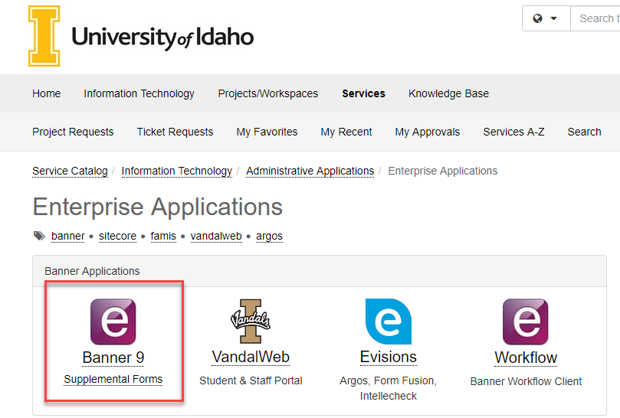

Log in with your DUO single sign-on access.

FRIGITD (Grant Inception to Date)
To access this screen you will type in the acronym (FRIGITD) in the Banner menu field as shown below and hit ENTER.

Then the screen below will display so that you can filter your output.
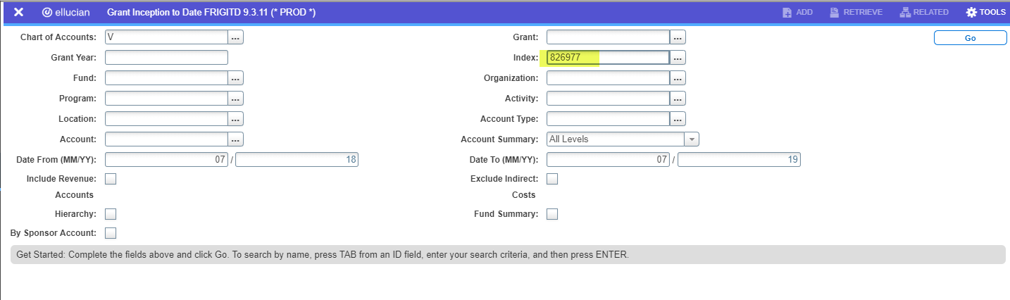

If you do not know your Grant code you can type in the Index and tab twice and the system will display the fund and grant code. If your award has more than one associated index/fund you will want to just search/filter on the grant code field so that you can see your overall award information.

Overall Balance Information
To see your overall award balance you will just need to enter the Grant code or Index and then click Go or use Alt+Page Down to get all of the information from the beginning of the grant through today.
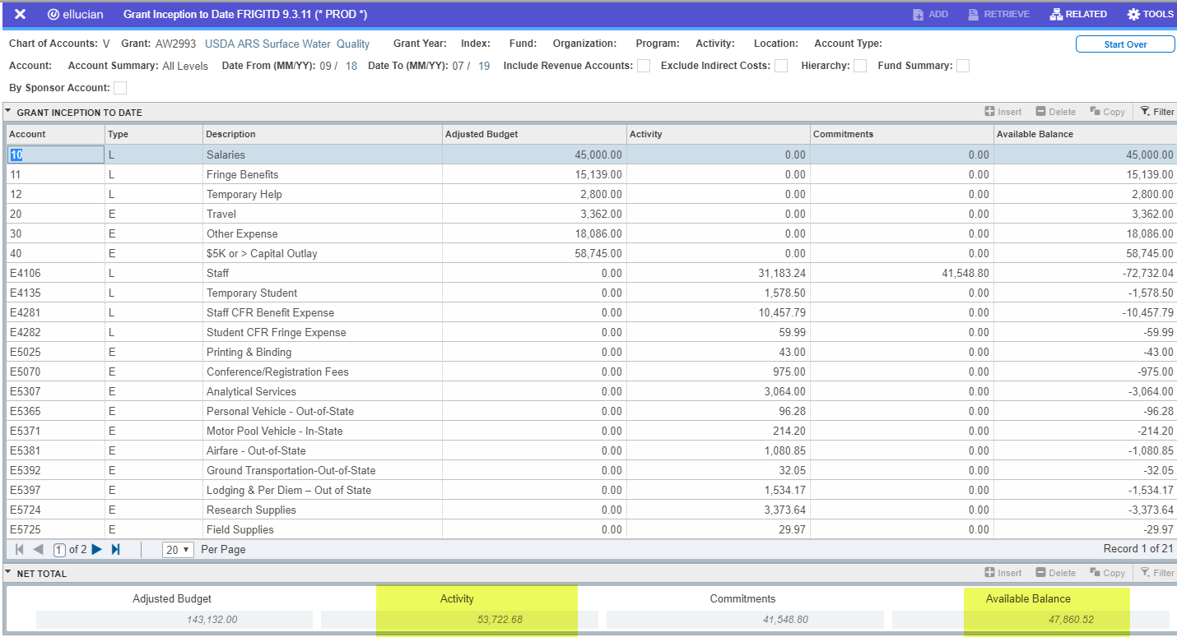
From the above you can see that the sponsor has currently awarded a total of $143,132.00, with $53,722.68 in posted expenditures and $41,548.80 in anticipated salaries through the end of the fiscal year (commitments). The commitments column will also show any purchase orders committed but not yet fully expended. The balance available for spending is $47,860.52, or if you don’t anticipate fully spending the commitments total then those monies might be available to you as well.

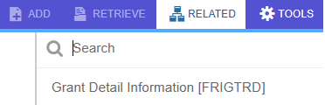
To see what makes up individual expense categories, you can click on an expense code (e.g. E5025) and then select Grant Detail Information from the Related menu in the upper right corner.

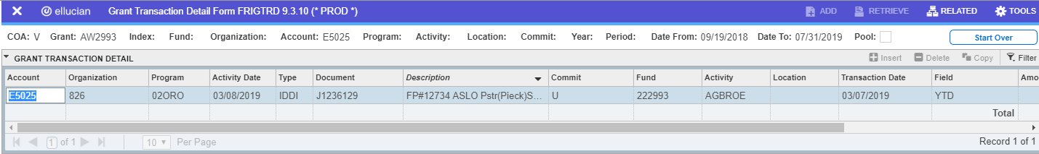

This will display limited information on each transaction under that category so that you can ensure the transaction has been appropriately charged to this project. You may also drill back further by again using the Related menu and Query Document function and yet further within the next Related menu to see Document Text associated with the transaction.
Note regarding transaction history: Detail of the transactions in chart V only goes back to 7/1/18. Items that posted prior to that date will show as “Cumulative Monthly Trans” because they were brought over from the prior chart of accounts. Your old budget number will work as the Grant Code if you wish to review that far back.
Balance by Budget Category
To see your balance by budget category you will need to select the By Sponsor Account checkbox before hitting the Go button.
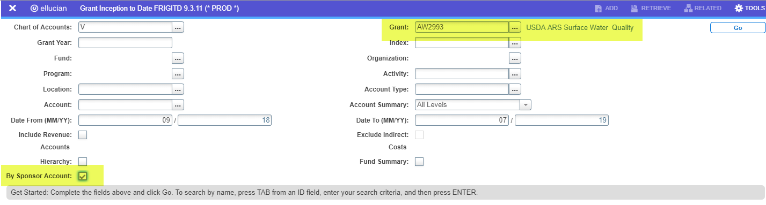
Using this will display the individual expense categories based on the primary expense type (e.g. salaries).
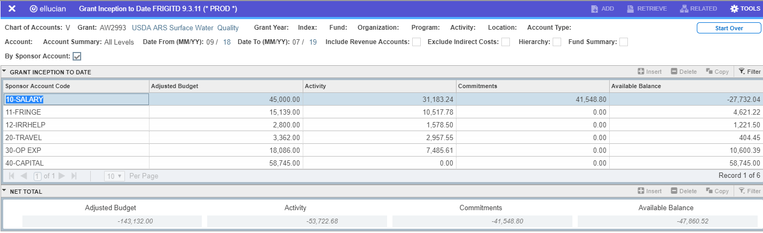
One Banner caveat on this screen is that the totals at the bottom will show in the opposite direction to actuals. This is a Banner bug that has not been addressed. You should pay attention instead to the Available Balance column when viewing using this functionality.

Balance by specific index
When more than one index and fund have been associated with a grant code you may view those balances separately using the Fund Summary checkbox before hitting Go. You may view this either with or without the By Sponsor Account also checked. If you do not click By Sponsor Account you will be able to drill back to see the specific expense detail. If you use the By Sponsor Account you will see the balances by category as shown below.
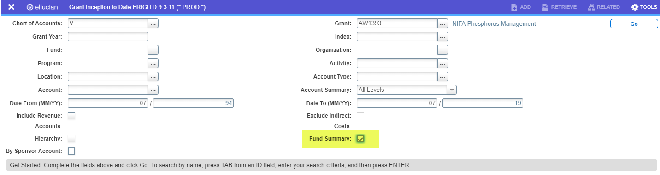
OR
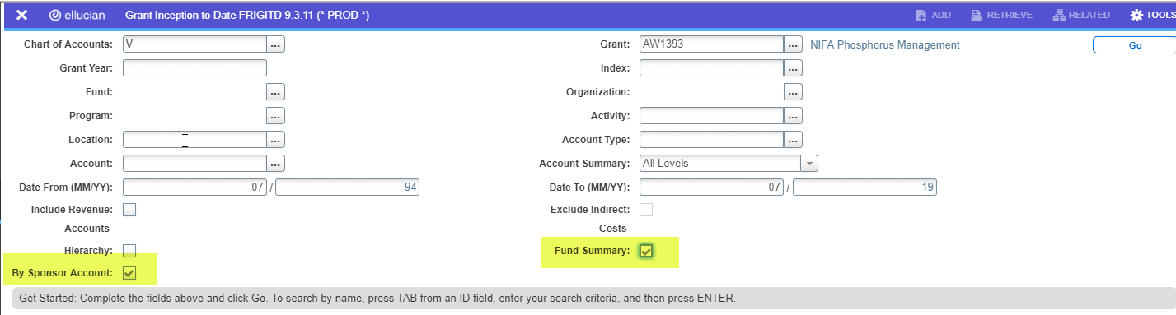
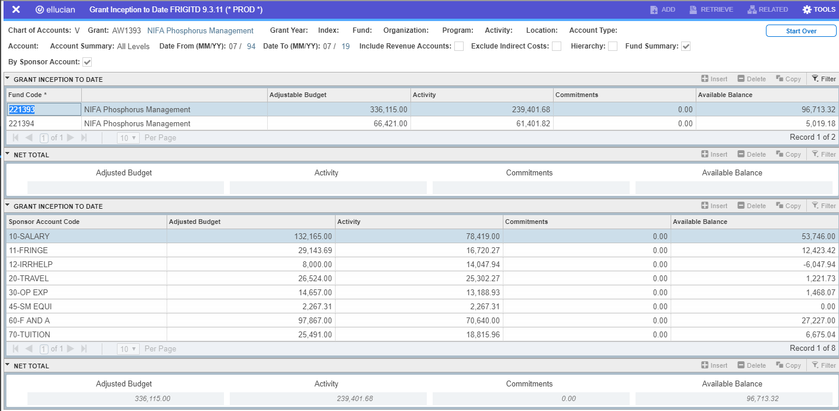

As you arrow between the two funds the information in the lower section will change to show you each account’s information.
Reviewing Data by Date Range
If you would like to see expenses only for a specific range of dates you can use the Date From and Date To fields to narrow your search. This should only be used when you are looking specifically at expenses during that date range. The system filters based on the transaction date and if the budget transactions occurred outside of that range you will get incorrect adjusted budget and balance information.
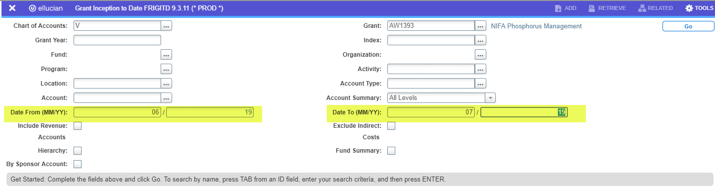
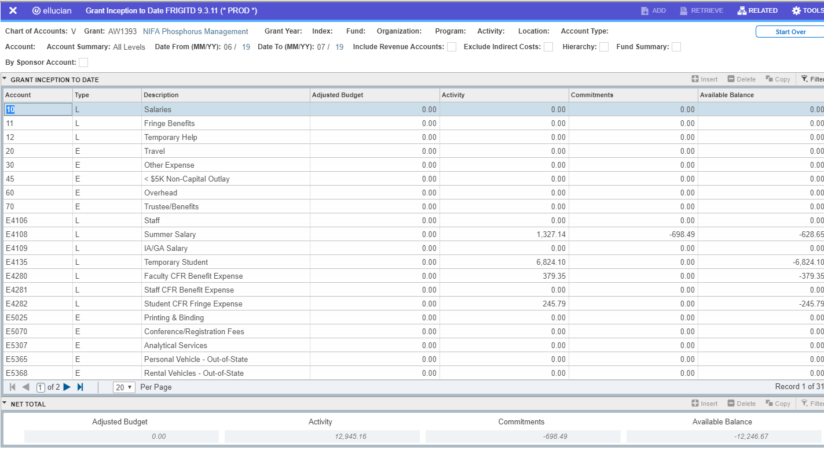

FWRITEM Report of Expenditures
Click HOME button to get back to main page:
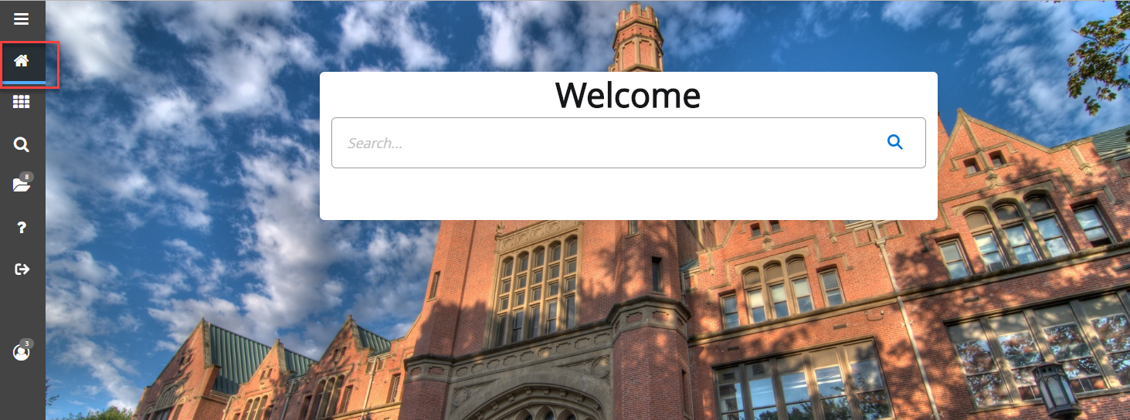

This report, usually run each month and loaded to VandalWeb for review on the 10th, may be run at any time from the Banner system. The recommended parameters are below. The output will be in a .lis file which can be opened in Word. You will have to change the margins to “Narrow” to get it to display correctly.
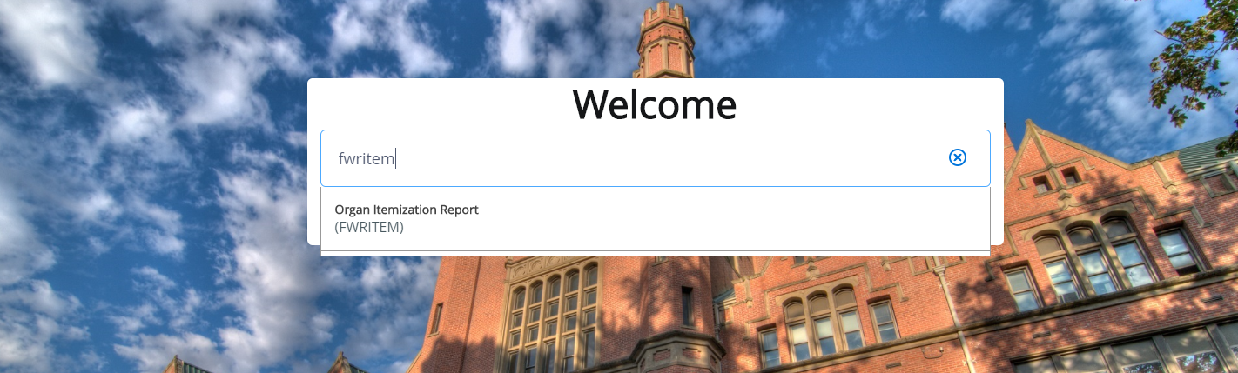
At the screen above hit the Go button.

G
Grant Code
Grant Code
Starting Date Range Desired
Ending Date Range Desired
D
N
Y
%
N
Y
V
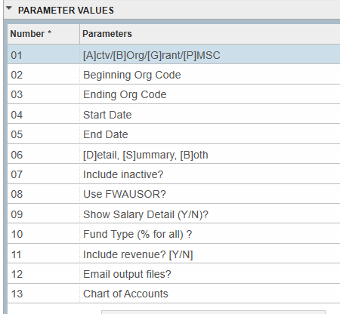

Using “Y” in the Show Salary Detail parameter will display the hours worked by the employee that posted during the time period requested. It is based on pay dates and not earned dates.
Once you have entered the information required you will need to go to the submission block Alt+Page Down and then click F10 to submit the report for processing. Note in the display below that if you choose to Save Parameter Set you can set up reports for each of your awards and only change the dates when you need to rerun a report. The parameter set name would be entered when you start the process.
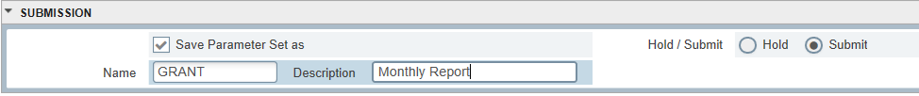

FRAGRNT Basic Award Information
Type

The FRAGRNT screen is a display of the overall award information and contains the following information:
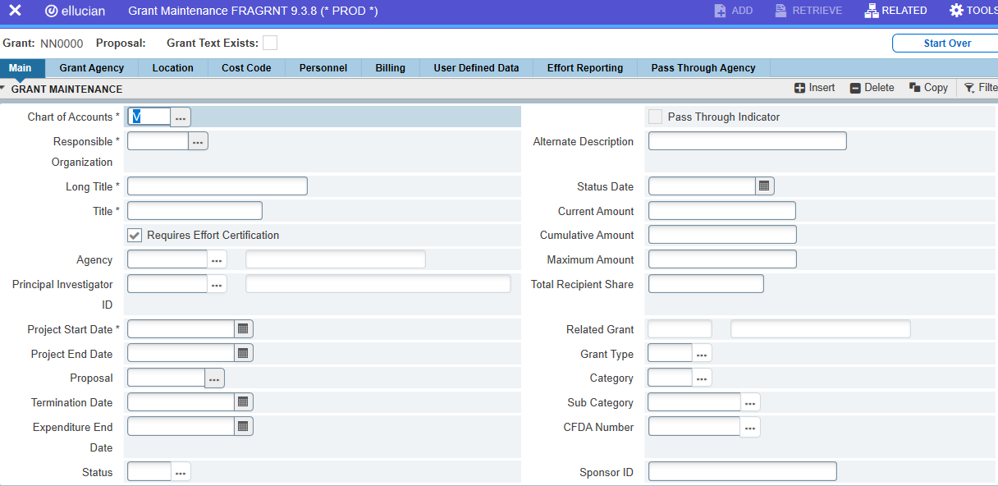
Responsible Organization – Primary department charged with administering the grant
Titles – We usually try to start these with the sponsor acronym for search purposes
Agency – Sponsor
Principal Investigator – Lead PI
Project Start/End Dates – End date will be changed if extensions are requested from and approved by the sponsor
Proposal – Associated Banner proposal number (not necessarily the EIPRS number, but will probably match the VERAS number)
Status – Will be active until we finish the closeout process
Current Amount – Amount of the most recent increment
Cumulative Amount – Total obligated by the sponsor to date
Recipient Share – Cost share obligation (may not be populated yet and that doesn’t mean there is no obligation if one was promised in the proposal)
Sponsor ID – Their award number for reference

