Congratulations on completing your EPR during the last 7-year cycle and thank you for your support of the UI External Program Review (EPR) process mandated by the State Board of Education (SBOE) and recommended by the Northwest Commission on Colleges and Universities (NWCCU).

It is our hope that the EPR process will strengthen programs through the recommendations identified by the external reviewers. Following your self-study and site visit, the recommendations from the reviewers should have been entered in the EPR system so that progress on each is reported annually. I look forward to working with each of you to track our progress so the SBOE sees that we are using this process to build quality, cost-effective programs that support the institution’s fulfillment of its mission.

Please take the following steps to make sure your EPR is progressing as expected. Please note that because I have provided detailed steps, you may need to scroll down a bit to find instructions for your current activity:

- Check your EPR to make sure you have entered the recommendations identified in the review into the EPR system.

- Enter your annual progress for each recommendation. Provide honest feedback on how things are going and what, if any, progress has been made this year regarding the changes previously entered. This is an annual requirement.

(NOTE: The EPR system times out after 45 minutes. It is recommended that you submit your information as you enter it. You can always return and add more. Some people find it helpful to type the information in Word and then cut and paste it into the system because of the time out.)

STEPS for accessing your plan and doing annual reporting:

Go here: https://www.uidaho.edu/provost/iea/accreditation-evaluation/program-review

Page looks like this:

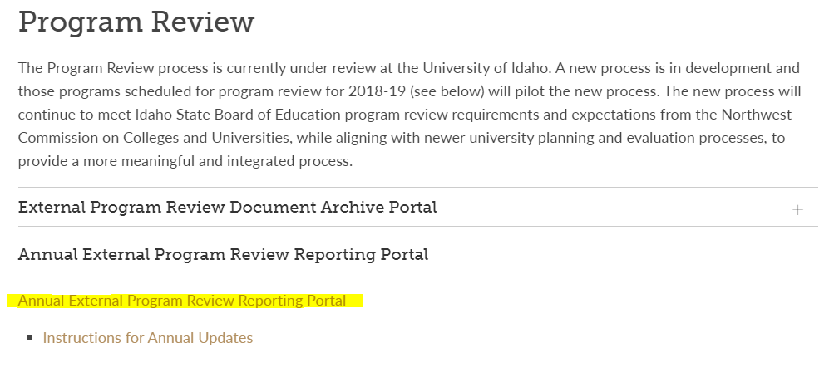

Click on “Annual External Program Review Reporting Portal.”

This will take you to the VandalWeb interface that is the access point to the EPR system.

Login using your UI credentials. Find your college and then click on the “External Program Review” link. This is the same place you will find your student learning outcomes assessment plan.

Select your program from the programs listed. For example, below Food and Science Toxicology is selected:

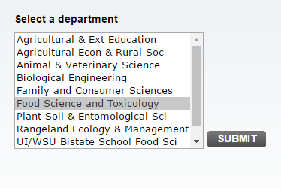

You will now see your program’s EPR information. If you have uploaded your Self-study and final report only, but not entered recommendations, you will only see a blank box like this:

This means you still need to enter the recommendations and your EPR is incomplete. No worries, you can remedy this by clicking on the “Click here” brown link to begin entering your recommendations above the blank box:

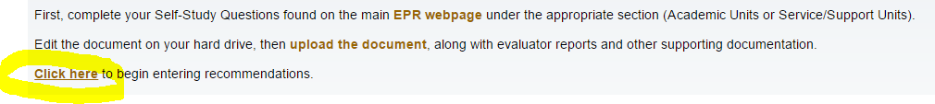

Doing so, will bring you to a screen that looks like the screenshot below:
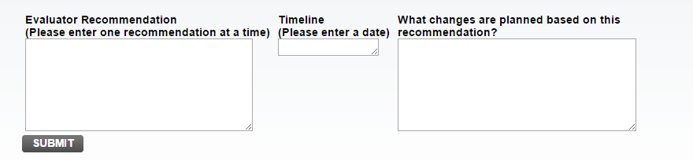

Enter your recommendations in one-by one. For each one, enter the recommendation, the timeline which must be a date of when you expect to implement changes addressing the recommendation in question, and enter the changes you plan. Submit one-by-one.

Some programs may have had someone help them enter in their recommendations, but did not follow up to add the timeline or changes. In such a case, your EPR is still incomplete and will need to be completed before you can do annual progress reporting. If this is the case, you will see something like this:

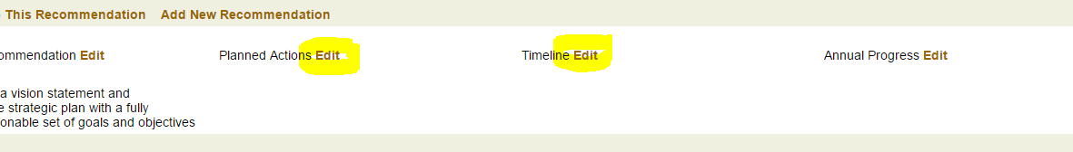

Please choose ‘edit’ and enter your actions and timeline for each recommendation.

If your recommendations, timelines and actions have been entered, you will see them listed below the big blank box when you access your plan. In this case, your EPR is complete! You only need to do annual progress reporting. You will see to the right of the recommendations, planned actions and timeline, the “annual progress” section for that one. Choose ‘edit.”

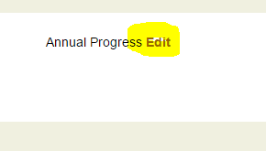

Selecting “edit” will lead you to a screen that looks like below. Here you will type in your annual progress for the recommendation/changes specified.

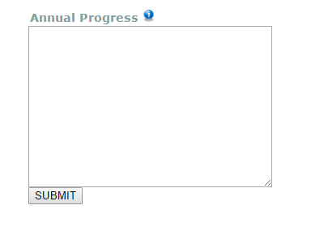

Select “submit” and update progress on each one, one-by-one. When all are entered, annual updating is complete!

The Office of Institutional Effectiveness and Accreditation (IEA) will receive a report that you are done and we will review, and update our records. IEA reports on the information you enter annually to the SBOE.

