**title all caps**

**Final Report**

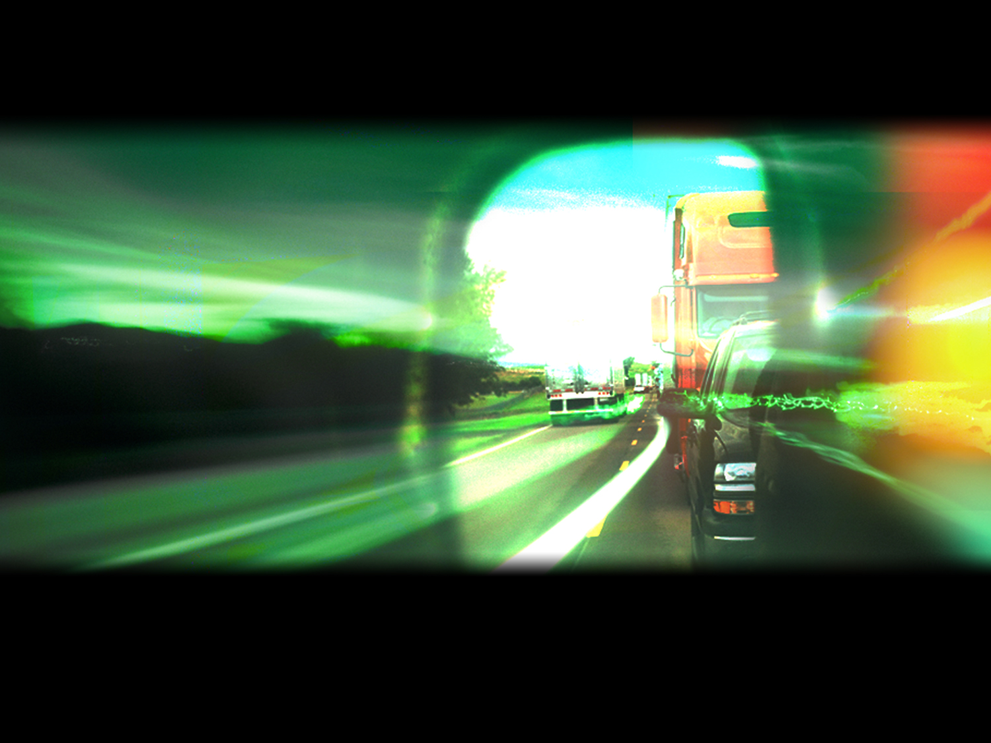

**Author, Author**

**Month Year**

DISCLAIMER

The contents of this report reflect the views of the authors,

who are responsible for the facts and the accuracy of the

information presented herein. This document is disseminated

under the sponsorship of the Department of Transportation,

University Transportation Centers Program, in the interest of

information exchange. The U.S. Government assumes no

liability for the contents or use thereof.

|  |  |  |  |  |  |  |
| --- | --- | --- | --- | --- | --- | --- |
| 1. Report No. | | 1. Government Accession No. | | | 1. Recipient’s Catalog No. | |
| 1. Title and Subtitle  Title | | | | | 1. Report Date  Month Year | |
| 1. Performing Organization Code  Budget | |
| 1. Author(s)   Last, First; Last, Dr. First | | | | | 1. Performing Organization Report No.  NYR-## | |
| 1. Performing Organization Name and Address | | | | | 1. Work Unit No. (TRAIS) | |
| National Institute for Advanced Transportation Technology  University of Idaho  PO Box 440901; 115 Engineering Physics Building  Moscow, ID 83844-0901 | | | | | 1. Contract or Grant No. DTRT12GUTC17 | |
| 1. Sponsoring Agency Name and Address   US Department of Transportation  Research and Special Programs Administration  400 7th Street SW  Washington, DC 20509-0001 | | | | | 1. Type of Report and Period Covered  Final Report: Month Year – Month Year | |
| 1. Sponsoring Agency Code  USDOT/RSPA/DIR-1 | |
| 1. Supplementary Notes: | | | | | | |
| 1. Abstract   Directions for abstract: Include a brief (not to exceed 200 words) factual summary of the most significant information contained in the report. An abstract should state the purpose, methods, results, and conclusions of the work effort. For the purpose, include a statement of goals (objectives, aims). For methods, include experimental techniques or the means by which the results were obtained. Results (findings) are the most important part of the abstract and selection should be based on one, or several of the following: new and verified events, findings of permanent value, significant findings which contradict previous theories, or findings which the author knows are relevant to a practical problem. Conclusions should deal with the implications of the findings and how they tie in with studies in related fields. | | | | | | |
| 1. Key Words TRB key words | | | 1. Distribution Statement   Unrestricted; Document is available to the public through the National Technical Information Service; Springfield, VT. | | | |
| 1. Security Classif. (of this report)   Unclassified | 1. Security Classif. (of this page)   Unclassified | | | 1. No. of Pages # | | 1. Price   … |
| Form DOT F 1700.7 (8-72) Reproduction of completed page authorized | | | | | | |

**TABLE OF CONTENTS**

EXECUTIVE SUMMARY 1

DESCRIPTION OF PROBLEM 2

APPROACH AND METHODOLOGY 3

FINDINGS; CONCLUSIONS; RECOMMENDATIONS 4

REFERENCES 5

APPENDIX 6

# EXECUTIVE SUMMARY

# DESCRIPTION OF PROBLEM

# APPROACH AND METHODOLOGY

# FINDINGS; CONCLUSIONS; RECOMMENDATIONS

# REFERENCES

# APPENDIX