REPORT TITLE
SUBTITLE

FINAL PROJECT REPORT

by

Principal Investigator Name(s)
University Name(s)

for
Pacific Northwest Transportation Consortium (PacTrans)
USDOT University Transportation Center for Federal Region 10
University of Washington
More Hall 112, Box 352700
Seattle, WA 98195-2700

Disclaimer
The contents of this report reflect the views of the authors, who are responsible for the facts and the accuracy of the information presented herein. This document is disseminated under the sponsorship of the U.S. Department of Transportation’s University Transportation Centers Program, in the interest of information exchange. The Pacific Northwest Transportation Consortium and the U.S. Government assumes no liability for the contents or use thereof.

Technical Report Documentation Page
1. Report No. | 2. Government Accession No. |  |  | 3. Recipient’s Catalog No.
4. Title and Subtitle |  |  |  | 5. Report Date
 |  |  |  | 6. Performing Organization Code
7. Author(s) |  |  |  | 8. Performing Organization Report No.
9. Performing Organization Name and Address |  |  |  | 10. Work Unit No. (trais)
 |  |  |  | 11. Contract or Grant No.
12. Sponsoring Agency Name and Address  Pacific Northwest Transportation Consortium (PACTRANS)  University of Washington  More Hall 112, Box 352700  Seattle, WA 98195-2700 |  |  |  | 13. Type of Report and Period Covered
 |  |  |  | 14. Sponsoring Agency Code
15. Supplementary Notes

16. Abstract

17. Key Words |  | 18. Distribution Statement  No restrictions. Copies available from PACTRANS:  www.pactrans.org
19. Security Classification (of this report)  Unclassified | 20. Security Classification (of this page)  Unclassified |  | 21. No. of Pages |  | 22. Price

Table of Contents
Acknowledgments vi
Abstract vii
Executive Summary viii
Chapter 1 Introduction 1
1.1 First Subchapter Should Be Underlined in Document 1
1.1.1 Second Subchapter Should be Italicized in Document 1
Chapter 2 Literature Review 3
2.2 Formatting a Figure 4
Chapter 3 Study Site/Data 5
Chapter 4 Method 7
This section should discuss your research approach, including your approach for collecting data, what type of data was collected if any, and any participants, or apparatus/equipment description you used. 7
4.1 How to layout the headers 7
4.1.1 How to Layout the Second Subchapter 7
Chapter 5 Results 8
This section should discuss the findings of your data analysis, statistical or mathematical modeling. 8
5.1 Subchapter Title 8
5.1.1 Subchapter Title 8
Chapter 6 Discussion 9
This section should discuss the implications of your findings (from Chapter 5), and any study limitations or constraints encountered. 9
6.1 Subchapter Title 9
Chapter 7 Conclusions and Recommendations 10
This section should discuss your what insights your study can provide. What are the implications/recommendations for future research, policies, or education? 10
7.1 Adding References and Appendix 10
References 11
Appendix A Extra Information 12

List of Figures

Figure 2.1 The title is placed below for figures 4
Figure 3.1 This is another example 4

List of Tables

Table 2.1 The title goes above the table 2

List of Abbreviations (optional)
PacTrans: Pacific Northwest Transportation Consortium
WSDOT: Washington State Department of Transportation

Acknowledgments (optional)
This text is left aligned with a standard indent and double spacing. You might use this space to thank researchers or folks who helped with the project in some capacity.

Executive Summary
This text is left aligned with a standard indent and double spacing. An executive summary is required and should briefly summarize the education or technology transfer activity. Your Executive Summary should be no more than 3 pages, and the recommended length is 2. If only an Executive Summary appears (without an abstract), it will be the text used as the abstract text on the Technical Report Documentation Page.
This page should ALWAYS begin on a right hand page (odd)

The Executive Summary should have a few points
- General Background
- Problem Statement
- Key Methodology
- Major findings and their implications
  - Interpretation of Findings
  - Impact on future research and engineering practice

This is an intentionally blank page. Leave a blank page before Chapter 1 if needed in order to ensure that Chapter 1 starts on a right hand page as well. There is no need for more than 1 blank page.

Style guide
For details about cover page formatting, see Cover Pages Specs.
Section Organization
  - Cover page – main
  - Cover page – inner
  - Technical Report Documentation Page
  - Acknowledgements
  - Disclaimer
  - Executive Summary
  - Body of Report
Margins
  - Left/right/bottom = 1 inch
  - Top cover page = 2.5 inch
  - Top chapter heading pages = 1.5 inches
  - Top other pages = 1 inch
Font
- Times New Roman
- Report title/cover pages: see cover page specs
- Chapter headings - 12 pt. bold, centered, all caps, numbering Chapter 1.0 – X.0
- Body text after chapter headings - 12 pt., left justification, single spaced
Page Numbering
- Centered within the footer, ½ inch from the bottom of the page
- 12 pt. Times New Roman
- Front cover page: no page number
- Subsequent title pages: use lower case roman numerals (i.e. i, ii, iii, iv...)
- Body of report (starting with first chapter: use Arabic numerals (i.e. 1,2,3...).
- Chapters: begin on odd numbered pages on the right-facing page
- Make sure the title pages end with an even roman numeral

Introduction

1.1 First Subchapter Should Be Underlined in Document
Use standard indent of 0. 5” and write in “normal” style for text in paragraphs. Everything should be double spaced with “0pt” for “Before” and “After” under Paragraph settings.

1.1.1 Second Subchapter Should be Italicized in Document
Use standard indent of 0.5” and write in “normal” style for text in paragraphs. Each chapter is formatted in this same way, please see the next chapter for instructions on formatting figures and tables. New chapters should always begin at the top of a new page.
Equations are numbered according to chapter. Each equation should be formatted as:

X²=100 (1.1)
where X= the probability of something.

Include punctuation at the end of the equation because it completes the previous sentence. It is not necessary to compile equations in a list at the beginning of the report. They are numbered so that you can reference them easily in text. For example, refer to equation 1.1 and notice that there should be a blank line before and after the equation. The next equation in this chapter would be 1.2, and the next equation after that would be numbered 1.3, and so on.
If something being described needs to be cited, this can be done parenthetically at the end of the sentence using the author’s last name and the publishing year or the number of the reference, if using a numbered reference system (AASHTO 1997). The previous sentence uses an “author-date” citation, and this sentence features a numbered reference (1). Use one system or the other: not both.

Literature Review
Please insert a page break before the beginning of each chapter if needed to make it start as a right side page. You can put introductory text before you begin the subchapters. It should appear with the same formatting as other paragraphs.
2.1 Formatting a Table
Tables and figures are numbered following the Chicago Manual of Style, and the labeling consists of two numbers separated by a decimal point with a text title following. The first number is the same as the chapter number and the second number is sequential for tables or figures, depending on which it is.

Table 2.1 The title goes above the table

Animal | Color | Age (in years)
Dog | Brown | 3
Cat | Black | 4
Fish | Orange | 1

Thus, since this is the first table of Chapter 2, it is table 2.1. Notice that in-text references to figures and tables are lowercase. If they happen to appear in parentheses, abbreviate figure (see fig. 2.1). Notice that on the table, the label appears above, and the table number. The whole label is centered and uses sentence-style capitalization. Notice that there is one whole blank line before and after the table. The same spacing should be applied to figures.
The next table in this chapter would be 2.2 and the following would be 2.3 and so forth. The tables are numbered the same way, but tables and figures are numbered independently of one another. In other words, if I include a figure and then include a table, the figure would be 2.1 and the table would also be 2.1.

2.2 Formatting a Figure
Formatting a figure is essentially the same as formatting a table, but the title goes below the figure (see fig. 2.1).

Figure 2.1 The title is placed below for figures

Notice that the title and numbering for figures is below the figure but, similar to the table, it is centered with only the word “figure” and the figure number are bolded.
As with the table, please leave a full space before and after the figure, then continue the text. Look at the List of Figures in the beginning of the document. Note that the list is single-spaced.

Study Site/Data
3.1 Alternative Text Guidelines
Alternative text is text associated with an image that serves the same purpose and conveys the same essential information as the image. In situations where the image is not available to the reader (perhaps because they have turned off images in their web browser or are using a screen reader due to visual impairment), the alternative text ensures no information or functionality is lost.
The following guidelines should be used when writing alt text:
- Alt text should describe all the important information in the image but not every physical detail: only what is important to its meaning and understanding.
- Alt text should not duplicate information provided in the content of the page or in the caption.
- Alt text should begin with the figure number and a word that describes the type of image, e.g., “Figure 3.1 is a photo of …” or “Figure 5.1 is a graph of …”
- For a simple or decorative image, such as a logo, provide only brief description. If more information would be useful to convey the meaning of the image, this should be included. Purely decorative images, which add no meaningful information to a page, such as bullets or page dividers, do not require alt text.
- Alt text for images that contain detailed information, such as technical diagram, chart, or graph, must include all relevant data, unless already described in the page text.
- Images that are linked must include a description of the destination or the purpose of the link.
- Information that would benefit both sighted viewers and those using screen readers should not be included in alt text but should be included in the image’s caption. The alt text and caption should supplement each other, with the alt text written for screen readers and the captions written for all readers.
Inserting Alt Text:
- Word 2007: Right-click on the image, select Size. Select Alt Text and replace the image file name that automatically appears with appropriate alt text.
- Word 2010: Right-click on the image, select Format Picture. Select Alt Text, then Description and add the appropriate text.
3.2 Figure Example with Alternative Text
Below is another figure example with alternative text.

Figure 3.1 This is another example

Notice the space before and after the figure.

Method

This section should discuss your research approach, including your approach for collecting data, what type of data was collected if any, and any participants, or apparatus/equipment description you used.

4.1 How to layout the headers
The Styles can be found under Home – Styles. Chapter headers will use the “Pactrans Chapter”, Subchapters will use “Pactrans First Subchapter” and have the format of 1.1 or 1.2 for the first two subchapters.

4.1.1 How to Layout the Second Subchapter
Second Subchapters will use the title “Second Subchapters”, will be italicized, and will be numbered 1.1.1 and 1.1.2 if they are within the first Subchapter.

Results

This section should discuss the findings of your data analysis, statistical or mathematical modeling.

5.1 Subchapter Title
Text

5.1.1 Subchapter Title
Text goes here

Discussion

This section should discuss the implications of your findings (from Chapter 5), and any study limitations or constraints encountered.

6.1 Subchapter Title

Conclusions and Recommendations

This section should discuss your what insights your study can provide. What are the implications/recommendations for future research, policies, or education?

7.1 Adding References and Appendix
Use the same headers as before, but highlight the Chapter in the title and delete.

References
American Association of State Highway and Transportation Officials (AASHTO). 1997. “Segregation: causes and cures for hot mix asphalt.” Publication by the Joint Task Force on Segregation of AASHTO Subcommittees on Construction and Materials, and National Asphalt Pavement Association, Washington, D.C.
Amirkhanian, Serji N., and Bradley J. Putman. 2006. “Laboratory and field investigation of temperature differential in HMA mixtures using an infrared camera.” Report No. FHWA-SC-06-06, Clemson University, Clemson, SC.
Brock, J. Don. 1986. “Segregation of Asphaltic mixtures.” Proceedings of the Association of Asphalt Paving Technologists, 55: 269-277.
OR
References
- American Association of State Highway and Transportation Officials (AASHTO). 1997.
“Segregation: causes and cures for hot mix asphalt.” Publication by the Joint Task Force on Segregation of AASHTO Subcommittees on Construction and Materials, and National Asphalt Pavement Association, Washington, D.C.

- Brock, J. Don. 1986. “Segregation of Asphaltic Mixtures.” Proceedings of the Association of
Asphalt Paving Technologists, 55: 269-277.

- Amirkhanian, Serji N., and Bradley J. Putman. 2006. “Laboratory and field investigation of
temperature differential in HMA mixtures using an infrared camera.” Report No. FHWA-SC-06-06, Clemson University, Clemson, SC.

Appendix A Extra Information
Here, you might include extra information that the reader might find useful. It’s also where you could put information that did not warrant the space in the body of the report. Figures and tables may appear in the appendices: they do not need to be listed in the List of Tables or List of Figures, but should be labeled according to appendix and using the same numbering system as the rest of the document, as seen below in figures A.1 and A.2.

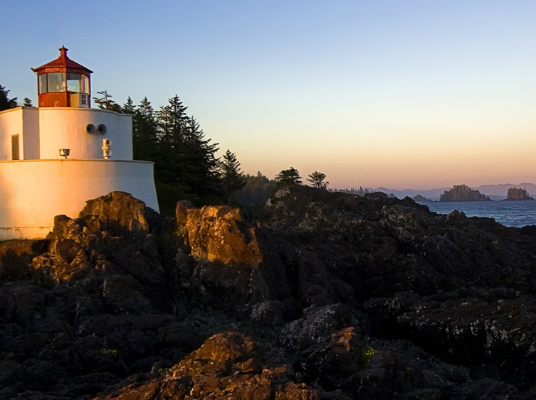
Figure A.1 Figure example

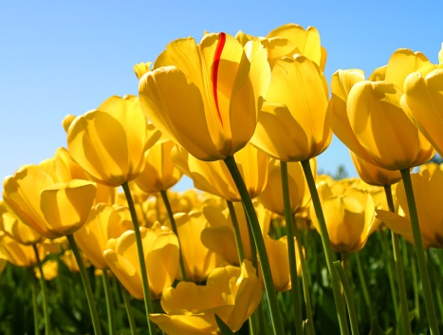
Figure A.2 Here is another figure in the appendix

