Bruce Pitman Center Suite 127
875 Perimeter Dr. MS 4257
Moscow, Idaho 83844-4257
Phone: 208-885-6307
Fax: 208-885-9404
cdar@uidaho.edu
www.uidaho.edu/current-students/cdar

CDAR - Notetaking Policies and Procedures: Students
Student Requirements for Receiving Notetaking as an Accommodation
- All students must be registered with CDAR, for the current semester, in order to
receive Notetaking as an accommodation.
- Students will be required to use Vandal email, the official form of communication of the University of Idaho, in order to receive notetaking accommodations.
- Student’s receiving Notetaking as an accommodation may not share the notes provided with others nor use the notes for anything other than educational purposes
Notetaking as an Accommodation
- Once a student meets with the CDAR Access Consultant and have been given “notetaking” as an in-class accommodation, the CDAR Testing & Notetaking Coordinator will be notified of the accommodation request.
- After the CDAR Testing & Notetaking Coordinator has been notified of the student’s notetaking accommodation request, a Notetaker will be assigned as soon as possible to the class (es) for which the student requires an accommodation.
Procedure for Accessing Class Notes
Once a Notetaker has been assigned, the student will receive an email with a OneDrive ‘shared folder’ invitation. Students will access their notes through OneDrive.
In order to access OneDrive students will need to:
- Go to onedrive.uidaho.edu
- Log in with your Vandal email account

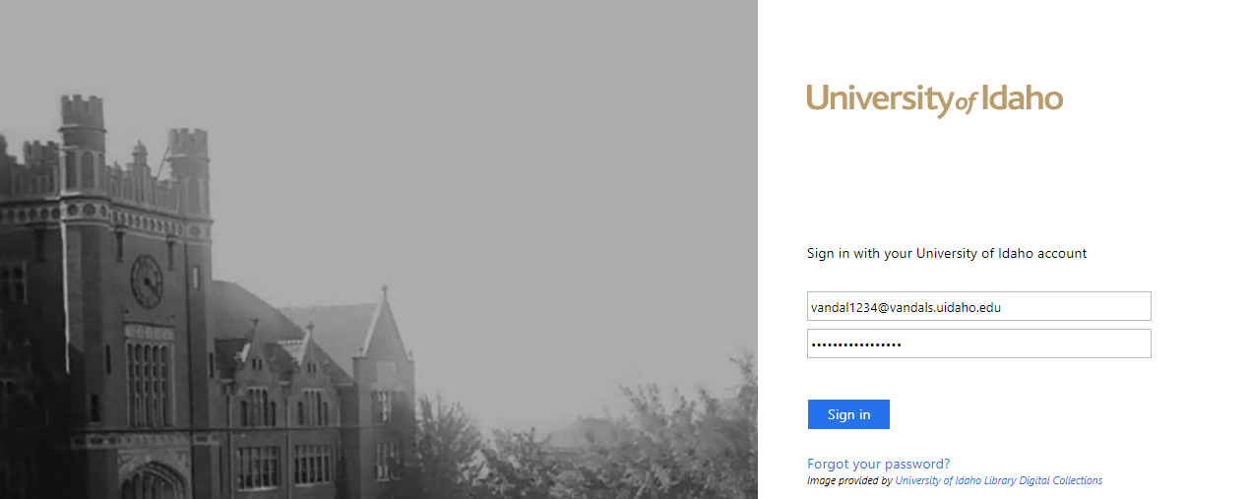

- Click on the ‘Shared with me’ button on the left hand side of the screen (as shown below)

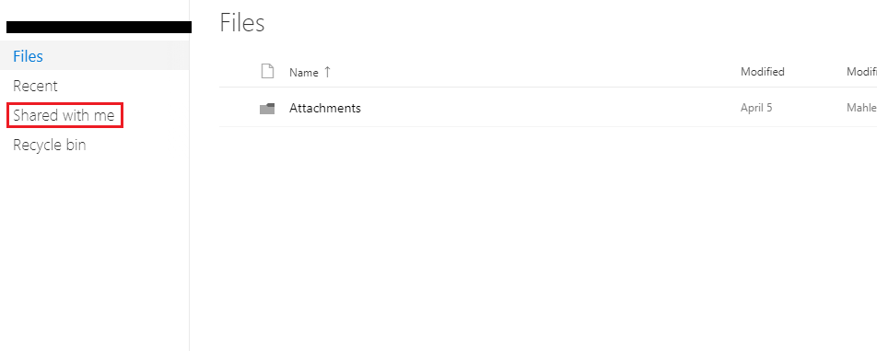
- Once selecting the ‘Shared with me’ file, the classes in which you will be receiving notes will be listed in folder format.
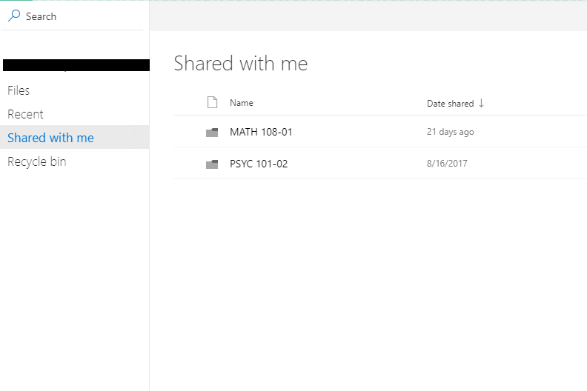

- Select one of the folders in which you would like to view notes.

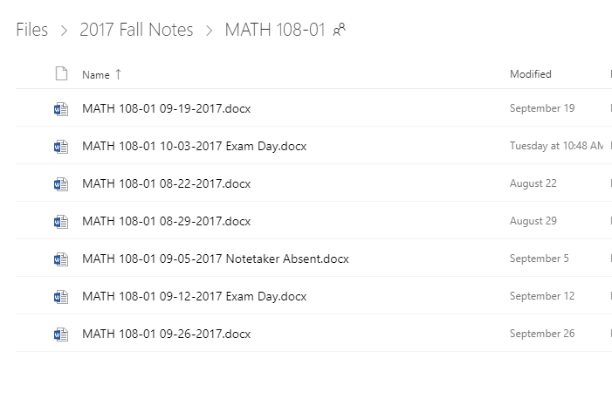

- The folder will be listed corresponding to the date. As shown above, you will be able to see when there were exam days or the Notetaker was absent.

Troubleshooting
- If you are having trouble accessing your notes, try to use the Firefox and Internet Explorer browsers.

- The notes will be submitted for your course by 9am the day after the class occurs.

- Do NOT use the OneDrive app as it crashes often and may present problems with accessing notes.

Notetaking Exceptions
- The course types, listed below, are not available for notetaking accommodations. If you have questions of concerns, please email cdar-notetaking@uidaho.edu
Exceptions are:

  - Labs
  - Seminars
  - English 101
  - Communication 101
  - Online Classes
  - Senior Design Classes

_____________________________________________________________________________________

CDAR Notetaking Policies & Procedures
By signing this form the student agrees not to share notes produced by CDAR with others nor use the notes provided for anything other than educational purposes. In addition, you are acknowledging that you will abide by the Notetaking Policies and Procedures of the CDAR Notetaking Office.
Student Signature: ________________________________________ Date: _______________

Print Name: __________________________________________________________________

CDAR Representative Signature: _____________________________Date: ______________

Print Name: __________________________________________________________________

