Bruce Pitman Center Suite 127
875 Perimeter Dr. MS 4257
Moscow, Idaho 83844-4257
Phone: 208-885-6307
Fax: 208-885-9404
cdar@uidaho.edu
www.uidaho.edu/cdar

CDAR - Notetaking Services
Policies and Procedures - Students
Receiving Notetaking as an Accommodation
- Students are required to register with the Center for Disability Access and Resources for each term in which they intent to receive Notetaking Services as an accommodation.
- Students receiving Notetaking Services as an accommodation will take lecture notes on their own until a Notetaker is assigned to the course.
- Students will use their University of Idaho Vandal email and password in order to log in to OneDrive to access notes produced through Notetaking Services.
- It is the student’s responsibility to notify CDAR Notetaking Services, immediately, if a course is added/withdrawn or if the student has decided to no longer receive lecture notes for a given course.
Notetaking as an Accommodation
- Once a student has been assigned Notetaking Services as an in-class accommodation, a Notetaker will be recruited to scribe instructional material presented during course lectures.
- After a Notetaker has been assigned to a course, the student will receive an email invitation to the course OneDrive ‘shared folder’.
Procedure for Accessing Course Notes
In order to access OneDrive students will need to:
- Go to onedrive.uidaho.edu

- Log in with your Vandal email account username and password.
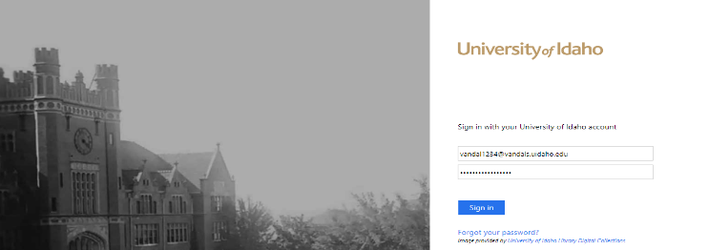

- Click on the ‘Shared with me’ button on the left-hand side of the screen (as shown at the right)

- After selecting the ‘Shared with me’ file, you will see the list of courses for which you have been assigned to receive Notetaking Services.
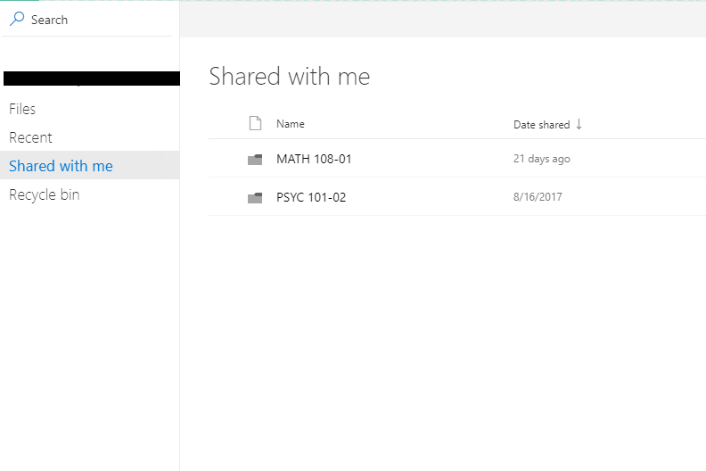

- Select a folder in which you would like to view course notes.
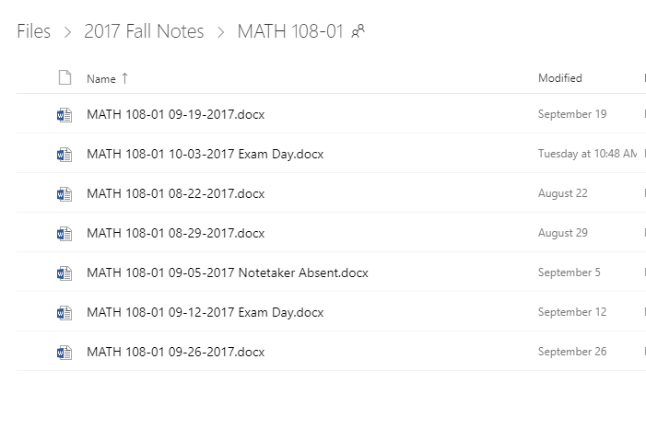

- The course lecture notes will be listed chronologically by date. As shown above, exam dates and Notetaker absences are indicated.

Troubleshooting
- If you are having trouble accessing your notes, try to use the Firefox and Internet Explorer browsers.
- Notes should be available in OneDrive by 9am the next business day.
- Do NOT use the OneDrive

