

**Germ City Hand Washing Program®**

**"Clean Hands, Healthy People"**



**Objectives for Using Germ City at the North Idaho Fair:**

The objectives and project goals of Germ City Hand Washing Program® by the North Idaho Medical Reserve Corps at the North Idaho Fair are to:

* Enhance awareness of the importance of hand washing.
* Improve effectiveness and frequency of hand washing.
* Modify attitudes, enhance personal motivation, and facilitate positive behavior change for hand washing.
* Have fun!

**How Germ City Works:**

Children and adults apply a black light sensitive lotion to their hands and enter a tunnel equipped with black lights, seeing pretend germs. After initial observation, participants wash their hands normally, re-visit Germ City, and assess their effectiveness. It’s “hands-on.” Everyone has an opportunity to learn about the importance of frequent hand washing and see results.

**What Does Germ City Look Like:**

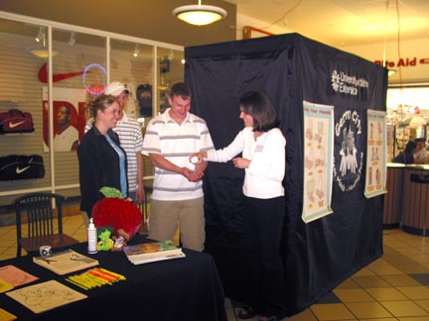

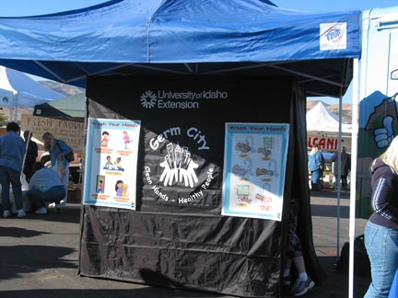

**Inside Germ City:**

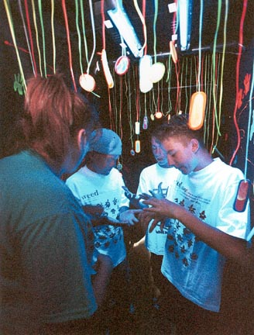

**Note: We will be set up inside the Petting Zoo barn at the fair.**

**Where Will You Be Stationed?:**

There will normally be three volunteers working Germ City at all times.

## Brochure Table

**Black-Light Tunnel**

*Enter here*

**B**

**C**

### Return to enter Germ City

**A**

## Coming from petting zoo

## Go to washing basin

*Get lotion, use view box for hands*

*Hand-washing*

*Basin – outside*

**Volunteer A**

View boxes

Your jobs are to:

* Encourage participants to participate in Germ City® by telling them how it works and asking if they would like to be better hand washers
* Give them a reason to want to enter Germ City® by educating participants about the detrimental health effects of improper hand washing (see What You Need to Know and Background Information)
* Dispense the Glitter Bug Potion Lotion
* Remind children the lotion is only “fake” germs
* Have them put hands in view box to see the “fake” germs
* Instruct them how to wash their hands (see attached flyer)
* Direct everybody to the hand-washing basin
* Have fun!

**Volunteer B**

Your jobs are to:

* Keep order inside Germ City®
* Only allow ~ 4 people inside Germ City® at one time
* Remind children the lotion is only “fake” germs
* Point out to participants the areas of their hands that are still glowing after they have washed and encourage them to pay attention to these parts of their hands the next time they wash (most often missed areas are in between fingers, cuticles, fingernails, the backs of their hands, wrists, and any rough spots)
* Reiterate that these “missed spots” are how germs are transmitted to others
* If they have glow spots on face or clothing, use mirror to show them their face. Explain that this is how germs get inside our mouths and nose
* Have fun!

**Volunteer C**

You are the busiest person! Your jobs are to:

* Observe the hand washing basin, reminding how to wash hands properly (see attached flyer)
* Direct participants who have just washed their hands back to the line to enter Germ City®
* Help participants out of the tunnel
* Encourage participants to wash hands again to remove all “fake” germs
* Have children only place a sticky dot on the hand washing behavior they are willing to try. Encourage behavior changes. (You do not have to have every child do this, so don’t worry if it gets too busy, just try to catch most kids)
* Hand out the “I’m a Super Hand Washer” sticker and the coloring sheet to children and the brochure to adults/parents (Note: We will have a count of stickers. Please use one sticker per child so we can estimate the number of children who went through Germ City® when we are done.
* Point out brochure table for adults – Medical Reserve Corps and Citizen Corps information will be available
* Have fun!

**What You Need to Know to Make Germ City Effective for Participants:**

**1. Stress these points:**

Germs are everywhere

Germs can make you sick

Germs are so small that you cannot see them

You can get rid of germs by washing your hands

**2. Ask the children “Do you know how germs move from one place to another?”**

They will probably suggest by sneezing, by coughing, but remind them their own hands carry germs.

Tell them that all the animals at the petting zoo also have a whole bunch of germs and bacteria on them! If you pet the animals, where have the germs moved? *From the animals – to the children's hands – – to the children's mouth – to inside the children's body.* What might happen?

**3. Identify important times for hand washing:**

Make the connection to Germs/Bacteria and Cross Contamination:

* Before You Eat
* After Using the Restroom
* After Playing with Pets or Visiting the Petting Zoo
* After Coughing or Sneezing. Show children how to cough or sneeze into their sleeve/arm.
* After Playing with Toys or Outside

**4. Show participants how to correctly wash their hands.** You may choose to pantomime the process with small children. As you are demonstrating each activity tell them what you are doing. (see hand-washing flyer)

* Turn On the Water. Get hands wet - with warm, running water.
* Add Soap
* Scrub Hands for 20 seconds
  + First show them how to do it - under and around nails, fingers, front and back side of hands, and wrists.
  + Practice washing while singing a favorite song: Row, Row, Row Your Boat (twice), (use hand washing words)
  + Rinse well under running water.
* Dry with the Paper Towel
* Shut off Water with Paper Towel
* Place the Paper Towel in Waste Basket

**Background Information:**

Hand washing is a key, often-overlooked behavior that is important for food safety, disease prevention, and personal health. Yet, most Americans underestimate the potential seriousness of foodborne illness and its correlation with hand washing practices. Children as well as adults self report hand washing behaviors that scientists fail to observe during observation of food safety related behaviors. There is a clear need to communicate risk and enhance consumer motivation for hand washing and personal hygiene that makes lasting behavior change possible. Most people do not wash their hands as often or as well as needed. Research studies support the need for behavior change, effective hand washing education, research, and improved evaluation.

* Several studies have shown that adults fail to wash their hands frequently and effectively. In a 2000 study from Wirthlin Associates sponsored by the American Society for Microbiology, 1,021 people were asked “Do you always wash your hands after using the bathroom?” 95% responded they did. When 7,836 adults were observed in a subsequent follow-up study in public restrooms in five major metropolitan areas, only 68% washed their hands (6).
* Hand washing is important in the prevention of foodborne illness and transmission of pathogenic bacteria and viruses that include *E.coli* O157,Campylobacter, Salmonella, Shigella, and hepatitis A. In foodborne disease analysis (1994-1998), the Hawaii Department of Health reported 3,590 cases of campylobacteriosis, 507 cases of shigellosis, and 547 cases of hepatitis A*.* Hawaii has the highest rate in the nation for infections with Campylobacter with numbers rising significantly in the past decade (5).
* In a soon to be published analysis of more than 900 outbreaks in Washington State, inadequate hand washing ranked as the leading cause (31.1%) of foodborne illness outbreaks in the 1990’s. Estimates based on data analysis from 1990-1999 indicate 1.5 million foodborne illnesses, 6,500 hospitalizations, and 100 deaths occur each year in Washington State with approximately 500,000 foodborne illnesses linked with inadequate hand washing. A manuscript by David Gifford and Janet Andenburg of the Washington State Department of Health is under development. It will be submitted to the Journal of Food Protection for publication (2).
* The Centers for Disease Control and Prevention (CDC) estimates that there are 78 million cases of food-borne illness with 325,000 hospitalizations and 5,000 deaths each year. The CDC links poor hand sanitation to 34% of the documented cases of foodborne illness (8).
* An estimated 9.3 million cases of foodborne illness at a cost of $8.2 billion are linked to personal control hygiene factors (9).
* In a 1993 study conducted nationally, consumers believed that most foodborne disease was a minor illness and that most illness came from food prepared outside the home (4).
* A 1999 study conducted in 82 cities in North America by Audits International showed at least one critical violation that could lead to foodborne illness occurred in 69% of the households (3). The most frequently observed critical violations were cross contamination (31%), improper cooling of leftovers (29%), and neglected hand washing (29%).
* In a study conducted by the Food and Drug Administration, only 2/3rds of those questioned reported they used safe food practices that included hand washing, cross contamination prevention, and thorough cooking of meat and poultry (1).
* Outbreaks of *E. coli* O157 infections among children have been associated with petting zoos on farms, and at fairs, and festivals. In the spring and fall of 2000, 56 illnesses and 19 hospitalizations were reported among children visiting farms/petting zoos in Pennsylvania and Washington State. Of the 44 state and territorial public health departments responding to a national CDC survey in June 2000, none had laws to control exposure of humans to pathogens from interaction with farm animals during public events (13).
* *E. coli* O157 infections cause an estimated 73,500 cases of illness, 2,000 hospitalizations, and 60 deaths each year in the United States (8).
* Children’s health is adversely affected when they fail to practice effective, frequent hand washing behavior. 305 Detroit school children were asked to wash hands four times each school day at planned times. Hand washing was not supervised. Children washing at scheduled times had 24% fewer sick days due to respiratory illness and 51% fewer days lost because of stomach upset than did children in classrooms without scheduled hand washing (7).
* In a recent Viewpoint article in the Journal of Nutrition Education, authors from several universities suggest that personal hygiene (estimated 10 million cases of foodborne illness/yr) and adequate cooking/avoiding cross contamination (estimated 3.4 million cases of foodborne illness/yr) should receive the most attention in food safety education programs (9).

Outbreaks of foodborne illness including death have also been linked with community events like fairs and festivals (13). During the 1998 Western Washington Fair, there were 3 confirmed cases of *E. coli* O157. The Western Washington Fair attracts 1.2 million visitors each year. While the Centers for Disease Control have not been able to confirm the source of the bacteria, possible connections were suggested to animal exhibits including the petting zoo and food service operations. Large-scale community events like fairs and festivals are being more carefully scrutinized across the United States.

Meaningful cognitive-behavioral changes in hand washing behaviors are vital to community health and the safety and continued success of large-scale public events.

Clearly, failure to wash hands is a significant public health concern and linked with food safety from the farm to the table. Foodborne illness has significant economic as well as social costs in the United States.

**Sources:**

B. Susie Craig – Project Director, Germ City: Clean Hands, Healthy People Program® 2002 by Washington State University Cooperative Extension

**References for Background**

Altekruse SF, Street DA, Fein SB, Levy AS. Consumer knowledge of foodborne microbial hazards and food-handling practices. J. Food Protect 1996;59:287-94.

Andenburg J, Gifford D. Foodborne Disease in Washington State 1990-1999. Manuscript under development for the J Food Protect.

Daniels RW. Audits International Home Food Safety Survey. http://[www.audits.com/Report.html](http://www.audits.com/Report.html).

Fein SB, Lin CTJ, Levy AS. Foodborne illness: perceptions, experience, and preventive behaviors in the United States. J Food Protect 1995;58:1405-11.

Hawaii Department of Health. Campylobacteriosis: A Six-year Review. http://mano.icsd.hawaii.gov/doh/resource/comm_dis/cdrcampy.htm.

Hyde B. America’s Dirty Little Secret – Our Hands. American Society for Microbiology Survey. http://www.washup.org/page03.htm.

Master D, Longe SH, Dickson H. Scheduled Hand Washing in an Elementary School Population. Family Medicine 1997;5:336-339.

Mead PS, Slutsker L, Dietz V, Macaig LD, Bresee JS, Shapior C. Food related illness and death in the United States. Emerg Infect Dis 1999;5:607-25.

Medeiros L, Hillers V, Kendall P, Mason A. Food Safety Education: What Should We Be Teaching to Consumers? J. Nutr Ed 2001;33:108-13.

National Health Education Standards from the American Association for Health Education http://[www.aahperd.org/aahe/natl_health_education_standards.html](http://www.aahperd.org/aahe/natl_health_education_standards.html).

Partnership for Food Safety Education. http://[www.fightbac.org](http://www.fightbac.org).

Presidents Council on Food Safety. http://[www.foodsafety.gov/~fsg/presidentscouncil.html](http://www.foodsafety.gov/~fsg/presidentscouncil.html).

U.S. Centers for Disease Control and Prevention. Outbreaks of *Escherichia coli* O157:H7 Infections Among Children Associated with Farm Visits – Pennsylvania and Washington 2000. Centers for Disease Control MMWR Weekly 2001;50(15);293-7.