How to wash hands.

Wash your hands with soap and warm water scrubbing for 20 seconds. Rinse in warm, running water. Dry with a paper towel. It’s also a good idea to turn the food preparation over to another member of the family if you have a cold, sore throat, diarrhea, or you are vomiting. If you have infected cuts, burns, or sores on your hands, cover with a bandage and wear disposable gloves.

For Parents:

If children wash their hands with soap and water during the time it takes to sing this song then they will have effectively cleaned them well! Sing the song to the tune of “Row, Row, Row, Your Boat.”

The Hand Washing Song

Wash, wash, wash, our hands
Wash those germs away
Scrub, scrub, scrub and rub
Germs go down the drain

Wash, wash, wash, our hands
Wash those germs away
Scrub, scrub, scrub and rub
Healthy everyday

This information brought to you by:

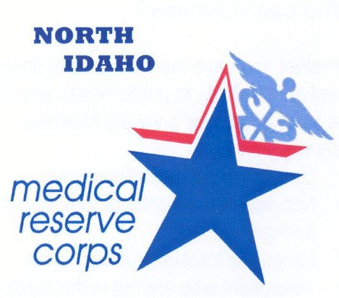

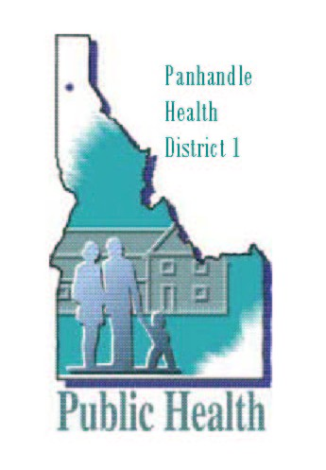







Hand Washing:
A Key to
Personal Health

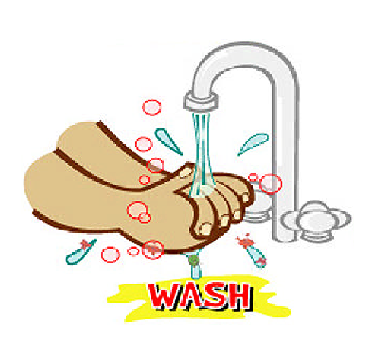

Hand Washing for Your Health

Do you wash your hands?

People like to think that they wash their hands frequently and effectively. However, studies show otherwise. The American Society for Microbiology conducted a nationwide phone survey with 1,000 people in 2000 and asked, “Do you always wash your hands after using a public restroom?” 95% responded that they did. Sounds good, doesn’t it? As a follow-up study, however, 8,000 adults were observed in public restrooms in five cities across America. Only 67% washed their hands. Observers counted as a hand wash anyone who got their hands wet and then dried them with a paper towel or hot air dryer. To keep things in perspective, even when using soap, effective hand washing requires time – about 20 seconds of scrubbing to remove disease-causing microbes like bacteria and viruses.

Why is hand washing so important to health?

The Centers for Disease Control and Prevention (CDC), the lead federal agency for protecting the health and safety of the people of the United States (an agency of the Department of Health and Human Services) studies outbreaks of foodborne illness across the United States. In more than 1/3rd of the outbreaks, hand washing was a significant contributing factor. The skin on our hands, with its natural secretions of oil, forms an ideal environment for microbes to hitch a ride. Hands can easily carry bacteria or viruses from our gastrointestinal tracts after we cough, sneeze, rub our mouths or noses, or use the restroom. You don’t have to be sick to carry disease-causing bacteria in your GI tract, either. Scientists have shown that 40-50% of us carry Staphylococcus, a bacteria that can grow in food to produce a toxin. Therefore, while uncooked food with bacteria can contribute to outbreaks of foodborne illness, people frequently contaminate food during preparation because they fail to wash their hands.

Is there scientific evidence that hand washing works?

A hand washing study with 305 school children in Detroit, Michigan, showed some dramatic results. Children were asked to wash their hands four times each school day: on arrival at school, before lunch, after recess, and before leaving school. Children washing their hands at scheduled times had 24% fewer sick days due to respiratory illness and 51% fewer days lost because of stomach upset than did children in classrooms without scheduled hand washing.

When should I wash my hands? (you can add others to this list)

- Before beginning to prepare food

- Before you touch food that will not be cooked

- Before you eat

- After you work with raw meat, fish, and poultry

- After you handle trash or take out the garbage

- After you go to the bathroom

- After you blow your nose, cough, or sneeze

- After playing with pets or visiting a petting zoo at the Fair. CDC recommends that hand-mouth activities, such as eating and drinking, and carrying toys and pacifiers, should not take place in petting zoo interaction areas.

