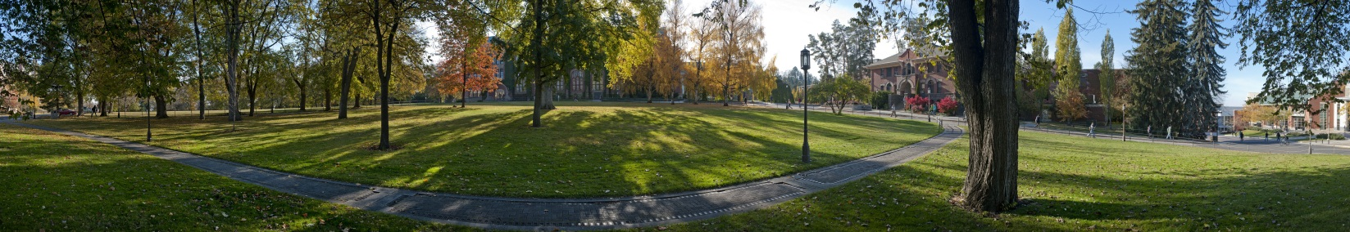
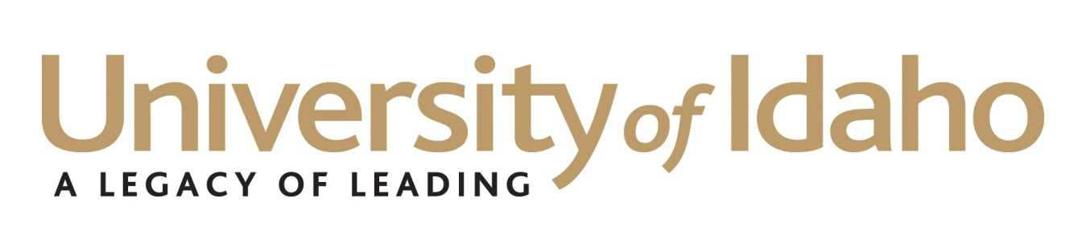

International Programs – Marketing and Recruitment

Greetings from the University of Idaho,
Thank you for your interest in partnering and promoting our university and programs around the globe. We value our partners and work hard to ensure an open and robust relationship based on trust, honesty, and integrity. Back in 2009, the University of Idaho began formally working with recruitment agencies on a commission based model. Currently, we work with more than 30 different companies all over the world, and are constantly looking to expand and broaden our network through qualified partnerships.

This application serves as the first step in the process, following our initial introduction. Below is an illustration of our signing process:

CONTRACT
REFERENCE CHECK
INTERVIEW
APPLICATON

The University of Idaho is a member of the American International Recruitment Council (AIRC), and we prefer working with recruitment agencies that have been certified through this association. The AIRC works to safeguard the interests of both international students and enrolling institutions through the promotion of ethical, standards-based international recruitment strategies. Please note that we will still consider all qualified recruitment agencies who express interest in working with the University of Idaho.

I look forward to learning more about your business and exploring this opportunity of working together. Please don’t hesitate to contact me with any further questions regarding this application or our signing process.

Best regards,

Shawn Greenfield
International Marketing and Recruitment Coordinator
875 Perimeter Drive MS 1250
Moscow, Idaho 83844-1250 USA
Tel: 208.885.4599 Fax: 208.885.2859
http://www.uidaho.edu/internationalstudents
https://www.facebook.com/UI.Shawn

University of Idaho Agent Application

Monday, February 25, 2013

Business Information
Business Name: Click here to enter text.
Business Owner/Manager: Click here to enter text.
Title: Click here to enter text.
Address: Click here to enter text.
City: Click here to enter text.
State/Province: Click here to enter text.
Country: Click here to enter text.
Postal Code: Click here to enter text.
Telephone: Click here to enter text.
Email: Click here to enter text.
Website: Click here to enter text.

Primary Contact for the University of Idaho
Last Name, First Name: Click here to enter text.
Title: Click here to enter text.
Address: Click here to enter text.
City: Click here to enter text.
State/Province: Click here to enter text.
Country: Click here to enter text.
Postal Code: Click here to enter text.
Telephone: Click here to enter text.
Email: Click here to enter text.

Questionnaire
- Please describe how you heard about the University of Idaho and why you are interested in representing us.
Click here to enter text.
- When was the student recruitment division of your organization founded?
Click here to enter text.
- From which country(s) will you recruit students to study at the University of Idaho?
Click here to enter text.
- In addition to your headquarters, do you have any branch offices? If yes, please list.
Click here to enter text.
- How do you promote your services?
Click here to enter text.
- How many students does your agency send to the following programs in the USA:

English language programs: Click here to enter text.
Undergraduate degree programs: Click here to enter text.
Graduate level programs: Click here to enter text.

- What kind of fees, if any, does your agency collect from the students you work with?
Click here to enter text.
- What type of business organization are you? (Corporation, Limited Liability Partnership, Privately Owned Business, etc.) Please provide a copy of your Business Registration.
Click here to enter text.
- Are you a member of any professional organizations, councils, or associations in the United States (i.e. American International Recruitment Council)? Please list.
Click here to enter text.
Are you a member of any other country based professional organizations, councils, or associations? Please list.
Click here to enter text.
- Does your agency recruit for institutions only in the United States? If yes, please list your top five institutions and contact information. If no, please explain which countries you recruit for and list any references.
Click here to enter text.

Reference 1:
Institution: Click here to enter text.
Contact Name: Click here to enter text.
Phone Number: Click here to enter text.
Email: Click here to enter text.
Reference 2:
Institution: Click here to enter text.
Contact Name: Click here to enter text.
Phone Number: Click here to enter text.
Email: Click here to enter text.
Reference 3:
Institution: Click here to enter text.
Contact Name: Click here to enter text.
Phone Number: Click here to enter text.
Email: Click here to enter text.
Reference 4:
Institution: Click here to enter text.
Contact Name: Click here to enter text.
Phone Number: Click here to enter text.
Email: Click here to enter text.
Reference 5:
Institution: Click here to enter text.
Contact Name: Click here to enter text.
Phone Number: Click here to enter text.
Email: Click here to enter text.

- Does your agency recruit for institutions outside of the United States? If yes, please list the name and country of the institution.
Click here to enter text.

Please email this application and attach any of the following to Shawn Greenfield at sgreenfield@uidaho.edu

- Company profile
- Business registration
- Brochures
- Catalogues
- Marketing Material

