You have been named as a subrecipient investigator on a proposal to a Public Health Services (PHS) entity and you have requested and received permission to adopt University of Idaho Financial Conflict of Interest Policy (UI FCOI). You are required to complete the financial disclosure process as outlined below. Per the PHS FCOI policy, each investigator is required to complete this process before the proposal can be submitted.

Each PHS investigator is required to submit a financial disclosure form for each SFI (Significant Financial Interest) or sponsored travel, including any SFI held by their dependent child or children, spouse, and any financially interdependent adult living with them. Each investigator that does not have an SFI is still required to fill out the financial disclosure form and select the “I DO NOT have an SFI…” option.

Financial disclosure is mandatory and must be completed before the proposal can be approved via EIPRS and submitted to the funding agency. There is also a training component required for PHS funded proposals. The training component is not required at the pre-award stage but we feel that this training will assist you with disclosing SFIs and sponsored travel per the PHS FCOI policy. If you choose not to do the training at this time and the project is awarded, the training must be completed prior to expenditure of funds. If University of Idaho FCOI training has been completed after August 15, 2012 and your NIH FCOI certificate and video code have been emailed to UIFCOI@uidaho.edu this training is good for four years from the date of the training. Training can be found at www.uidaho.edu/osp/financial-conflicts-of-interest. All investigators must complete training prior to expenditure of funds.

The following steps provide instructions for the financial disclosure process:

- Visit https://www.sites.uidaho.edu/osp-portal/ using Google Chrome or Firefox

- Login using your assigned username (either the first letter of your first name plus your last name or your email address without @domain.com). Ex: Joe Vandal’s username would be jvandal and if your email address is joev@uidaho.edu your username would be joev. Your initial password was direct emailed to you by either the person who created your account (UI OSP Employee) or osp@uidaho.edu. If you need assistance with your password or username please contact uifcoi@uidaho.edu.
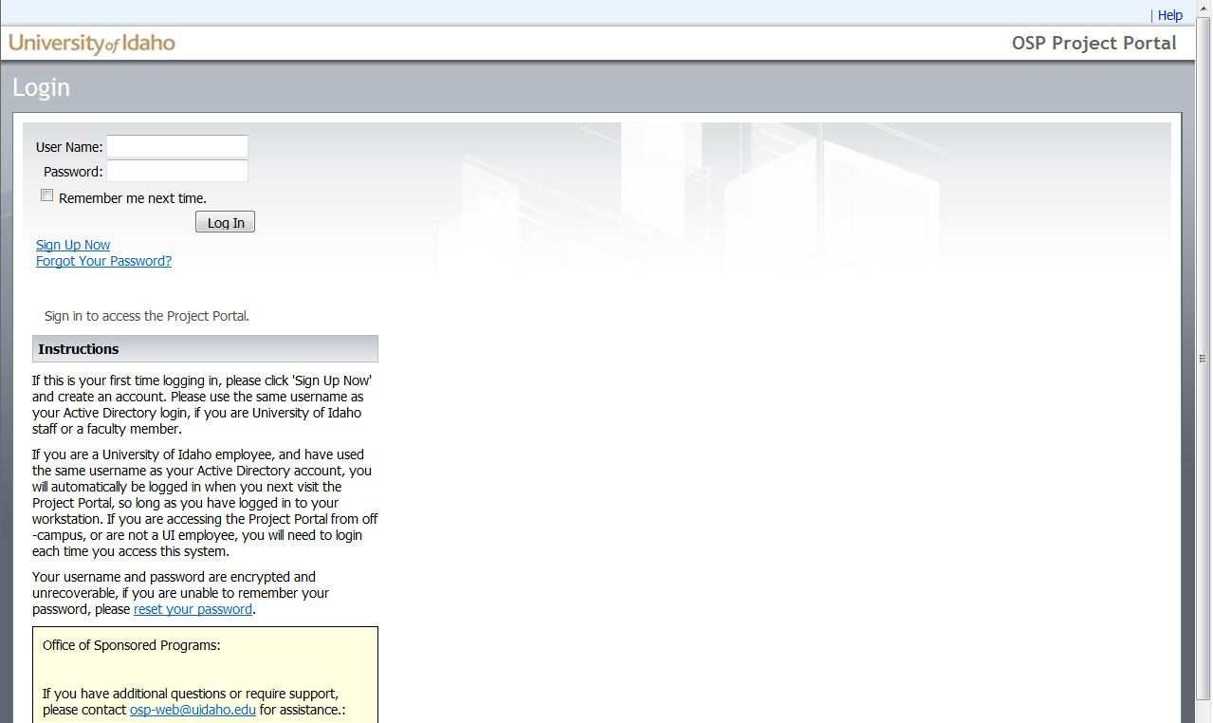

- Once you log in, click ‘Disclosures’ from the top or side navigation areas.

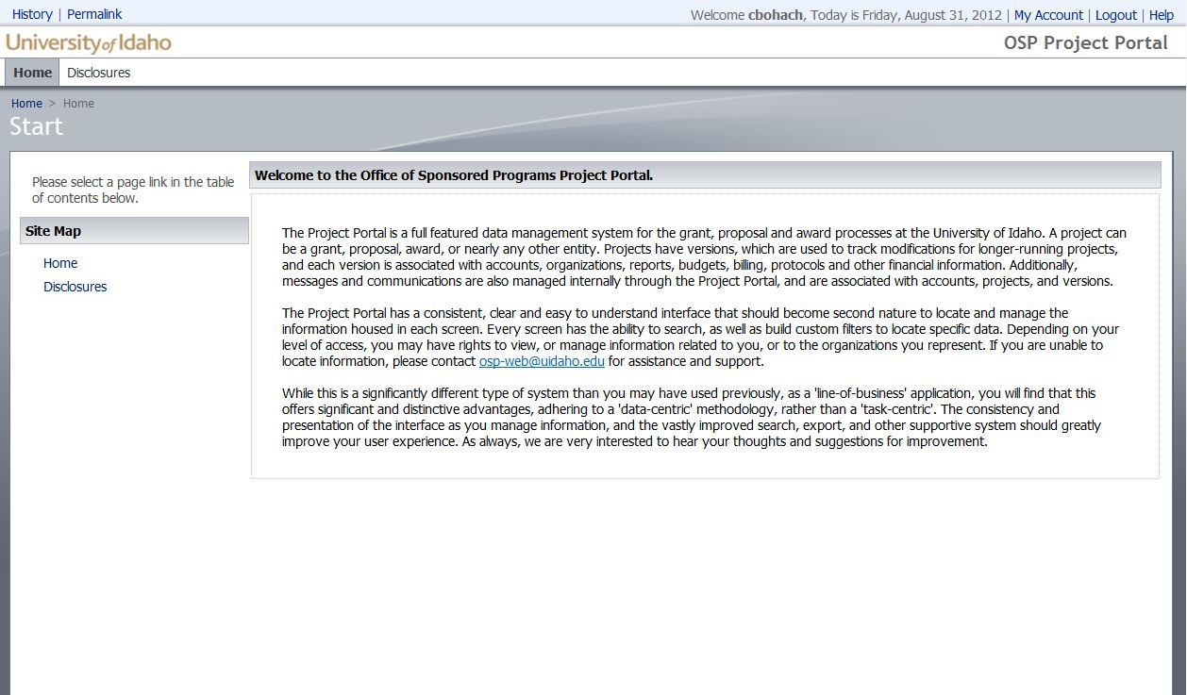

- Click ‘New Disclosures’ from the action bar at the top of the page area.

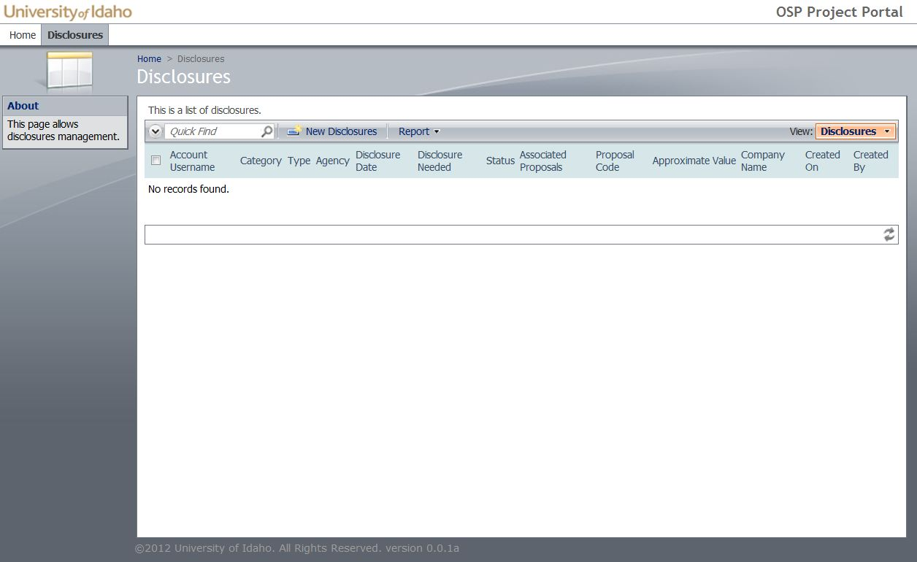

- If you have multiple PHS agency proposals, you will have multiple proposals to select from in the drop down menu. Select the proposal number that you are submitting the disclosure for.

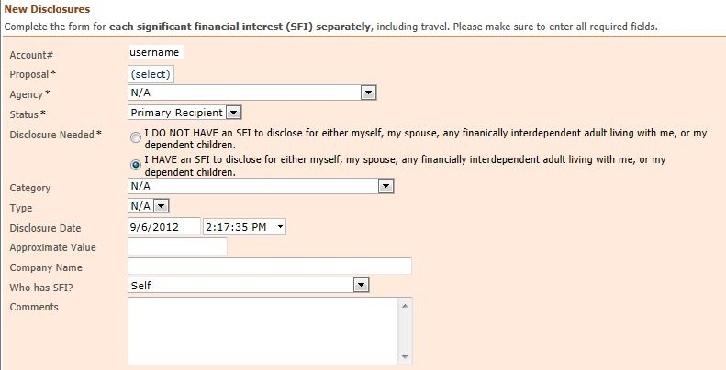

- Select the disclosure category from the “Agency’ drop-down menu. Please note the text in red regarding PHS disclosure requirements. For PHS there are two disclosure fields, “Public Health Service“ and “PHS Travel Disclosure (no minimum)”.

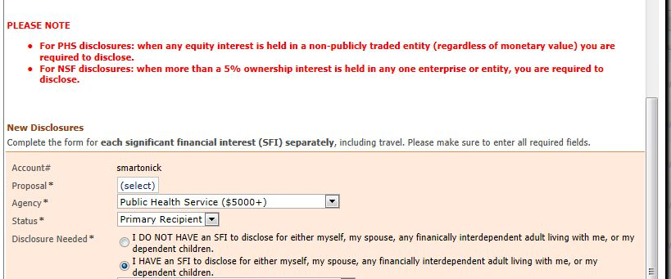

- Next select your status on the proposal. Your choices are Primary Recipient and Subrecipient. All parties external to the University of Idaho should choose ‘Subrecipient’.

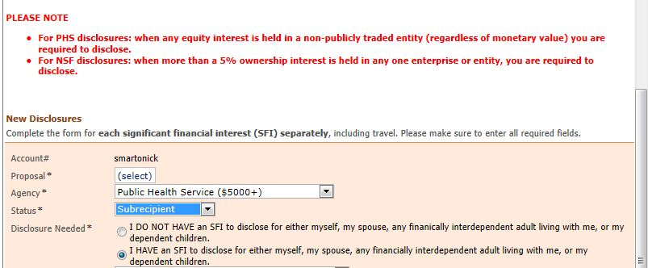

- You are required to complete the form that loads whether or not you have a significant financial interest (SFI) to disclose. Please note that the significant financial interest could be held by yourself, your spouse, any dependent children or any financially interdependent adult living with you. If you do not have an SFI to disclose select “I DO NOT HAVE an SFI…” and then click the ‘OK’ button.
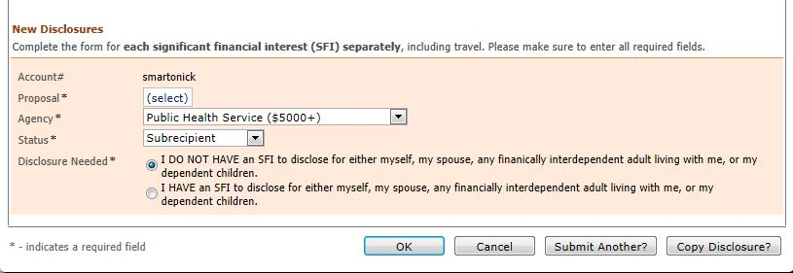

- If you have one or more SFIs to disclose select the “I HAVE an SFI to disclose…” This will open up the secondary part of the disclosure form.
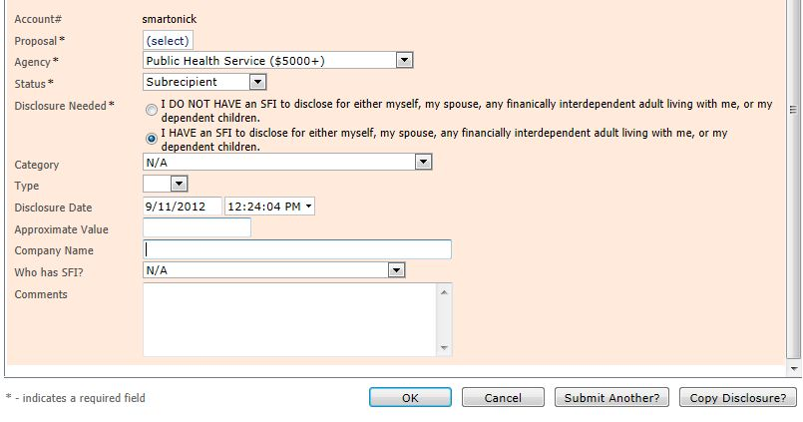

- For Each SFI that you are disclosing you will select the category (Income, Equity, Intellectual Property, Positions / Relationships – (compensated or not), and Travel) from the drop down menu.

- Next you will select the corresponding Type to further define the Category (with the exception of Travel).

- Fill in the approximate value of your SFI or travel, the company name, select the person with the SFI from the dropdown and then enter in the required information in the comments. See the UI FCOI policy and FAQs at http://www.uidaho.edu/osp/financial-conflicts-of-interest for information on the required notes to include in the comments box.

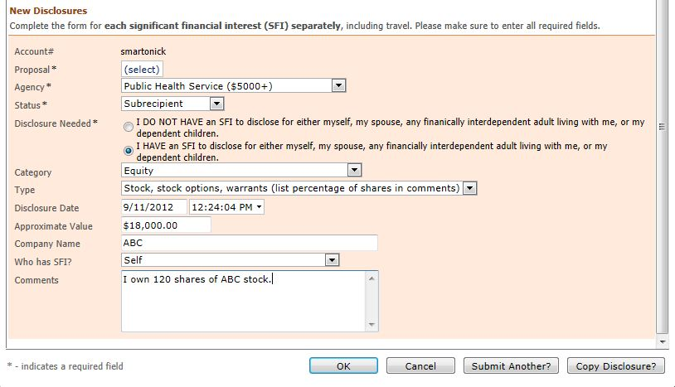

- You are required to disclose each SFI separately, including travel as defined in the University of Idaho (UI) Financial Conflict of Interest (FCOI) policy. To submit another SFI or sponsored travel disclosure click “Submit Another”.

- When you have clicked the “Submit Another” button, the following certification will appear. Please read and click “OK” to acknowledge your acceptance. Repeat steps 6-15 for each SFI or sponsored travel disclosure.

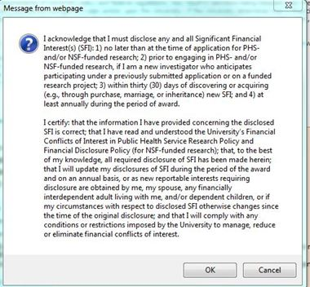

- If you have multiple PHS funded proposals you need to disclose each SFI and sponsored travel per proposal. Click the “Copy Disclosure” button. This will bring up the certification in Step 15; you will need to click ‘OK’ after reading the certification to submit the disclosure form for the proposal you were previously disclosing for.
- The disclosure form will remain on the screen but will have saved for the previous proposal. To submit this disclosure on a different proposal, select the proposal number in the drop down and click either ‘OK’, ‘Submit Another’, or ‘Copy Disclosure’. Clicking one of these three buttons will bring up the certification in Step 15. Clicking ‘OK’ on the certification will save the financial disclosure form. If you click ‘Submit Another’ or ‘Copy Disclosure’ please see steps 15 and 16.

- When you have finished disclosing all SFIs and sponsored travel for each PHS funded proposal, click ‘OK’ on the financial disclosure form and the certification in Step 15 to complete the process.

- To print your disclosure(s) see the following steps:
  - Click on “Disclosures”
  - This will bring up a list of your disclosures that looks similar to the screenshot below:
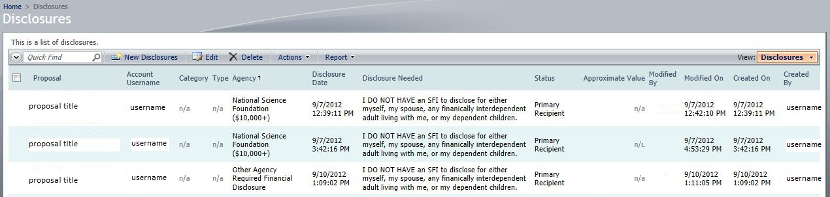
  - Click the report button and then “PDF Document” to create a PDF that you can save and print for your records.

Please contact UIFCOI@uidaho.edu or call 208-885-6651 with any questions.

