- To submit an existing financial disclosure for a new proposal or an annual renewal of an existing disclosure with no changes please visit the following URL http://www.sites.uidaho.edu/osp-portal using Google Chrome as your web browser.

- If you are using an on-campus networked machine (such as your office work-station) you will see a pop-up similar to the following screen. Type your University of Idaho username with ‘AD\’ preceding it and your UI password and click ‘OK’ to log in.
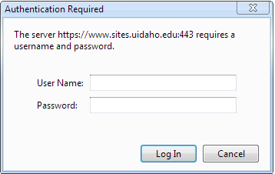
- If you are not at an on-campus networked machine (such as a laptop or home computer) you will see the following screen and will use your University of Idaho username and assigned external password or, if you have logged in and set your OSP Portal password previously, you will use that password. If you cannot remember the external password that you set, click “Forgot Your Password” and a temporary external password will be emailed to you (if you are able to answer or have set your security question and answer).
If you need to change your password after you log in, you can do so by selecting ‘My Account’ from the top right corner of the screen. Please also review and change your security question and answer as needed via the ‘My Account’ screen.
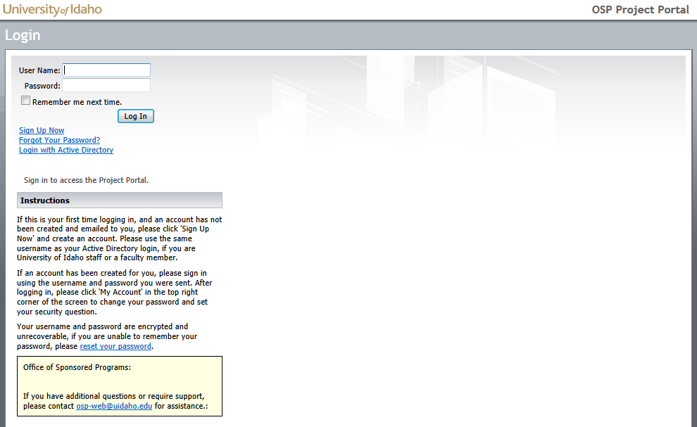

- After you successfully log in you will see the following screen; select ‘Disclosures’ from either the side menu or drop-down menu to continue with submission of an existing disclosure for a new proposal or submission of your annual renewal of a disclosure that was submitted previously and has not changed.

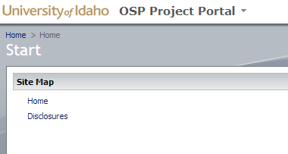

- A list of your disclosures will appear and you will need to click ‘resubmit’ in order to select the disclosure you would like to submit for annual renewal OR for a new proposal. Please note that disclosures are submitted for each proposal therefore if you have a new proposal requiring disclosure you must ‘resubmit’ an existing disclosure for that proposal per the following steps.
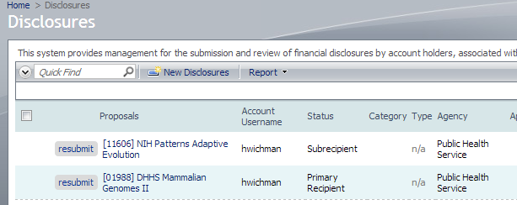
Title

jvandal
jvandal

- After you click on ‘resubmit’ the following screen will appear. You will need to either change the checkbox in the proposal section to reflect your new proposal number (if this is a submission for a new proposal) or select each proposal # that this disclosure relates to and then click ‘save’ to submit a single disclosure or ‘submit another’ if you would like to submit another disclosure.
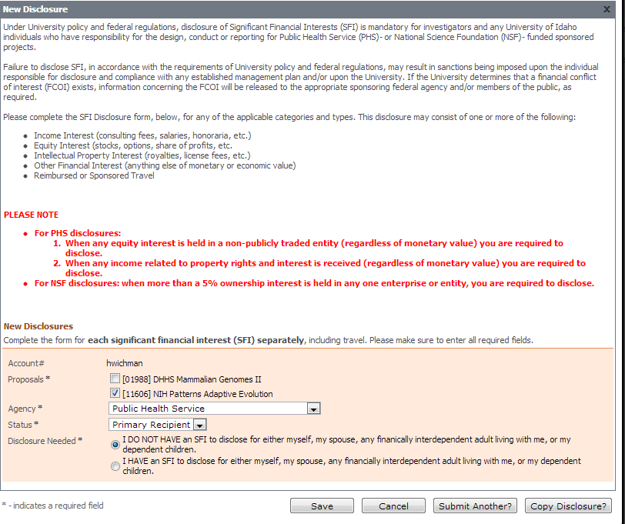
- If you have any questions please contact uifcoi@uidaho.edu or Sarah Martonick at 208-885-6651.

