How to attach a revised Application to a new IRB Amendment – Protocol Modification.

Use the My Workspaces drop down menu to select “Study Assistant”.
Scroll down to IRB Studies.
Find the study you want to modify and then select “Forms”.
Select “Start a new Submission” next to “IRB Amendment – Protocol Modification”.
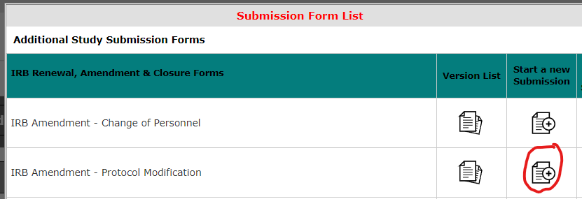

In Section 1.1 check the appropriate boxes. Then select “Save and Continue to Next Section”.
In Section 2.1 describe the modifications. Then select “Save and Continue to Next Section”.
In Section 3.1 select “Click here to attach the application”. Then check the radio button under “Select” which will be the most recent version of the application that is in VERAS. Select “Save Attachment”.
The most recent version of the application is now attached to your IRB Amendment – Protocol Modification. You now need to edit it.
Select the pencil and paper icon under “Edit/View”.
Begin making your edits. As you update each page, select “Save and Continue to Next Section”. On the left hand side of the page will be a “Section view of the Application”. Update each section that you need to change. Select “Save and Continue to Next Section” until you have completed all of the updates.
You will be returned to the IRB Amendment – Protocol Modification when you have finished the updates to the application.
In Section 3.2 and 3.2 add new consent or other documents if needed. When finished, select “Save and Continue to Next Section”.
Select “Signoff and Submit”.
If you are the PI you will be directed to the IRB Principal investigator Agreement for approval and a final sign off. If you are not the PI, please notify the PI that it is ready for their final signoff.

