RE: DGA Roundtable Agenda
April 28, 2022 1:30- 2:45 pm via zoom

Zoom Join form PC, Mac Linux. iOS or Android https://uidaho.zoom.us/j/86028305542
Meeting ID: 860 2830 5542
Passcode: 2145
See calendar invite for additional details on zoom access, including call-in information.

Reminder: Zoom meeting protocol –
Please keep your microphones muted during the presentation and wait until the end for questions unless the presenter has indicated otherwise.

During the DGA Roundtable Discussion portion of the meeting, please wait for the person currently speaking to finish before asking any questions.
You can use the ‘raise hand’ function or you may also put your questions on chat.

Thank you all for all that you do!

Announcements –

Heather Clark –
- Introduce New Grant Compliance Accountants, Shannon and Iman
- Cost Share Report Update - Adding new filters: active, inactive, college, or org (dept) PDF and Excel
- Cost Share Posting and ECodes
- Year end
- External Audit – R&D

Content – Heather Taff and Heather Clark
- Items Excluded from Indirect Costs and Indirect Cost Base – Heather Taff
- Closeout Process – Heather Clark

Content Notes:
Year End Deadlines
Labor Redistributions last day to submit June 27, 2022
Cost Transfer/Journals due July 8, 2022
External Audit- R&D Interim field work will begin June 6, 2022

F&A – Everything you want to know
F&A is recapturing of cost that the University already paid
Indirect Cost Components: Facilities (is not capped) & Administrative
Direct Cost: this is cost directly charged to specific project
Indirect Cost: cost that cannot be identified to specific project
Unallowable Cost: Found on uniform guidance 2 CFR 200
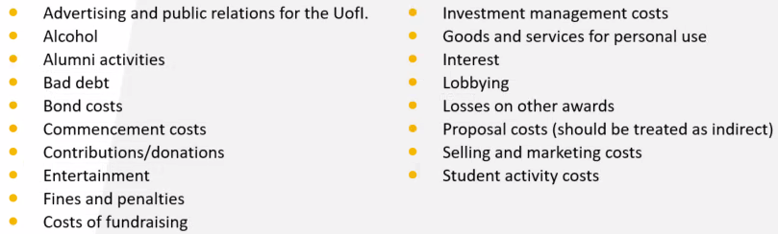
Allowable under Certain Circumstances:
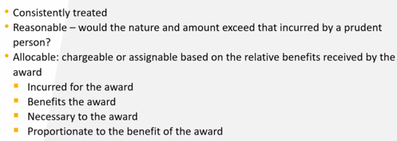

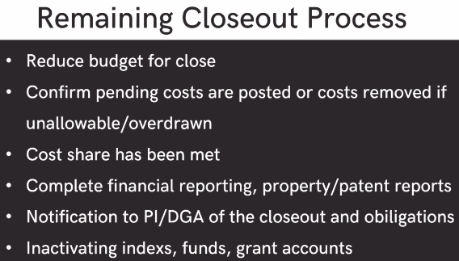
Grant Closeout Process
Preparing with 30-60-90 report
Review of expenditures posted last 30 days
DGA will prepare LR or CT if grant is overdrawn
Review balance

General Questions/Concerns: as time allows
(Tracy Kanikkeberg)
Question on Per diem:
-If an individual gets 50%, but takes a dinner, how should this be entered?
--If we take out the meal then they end up in the negative.
-Should we go by what’s in writing or what software will allow?
-Also, if they get 50%, if we take out a meal, does the meal come out at 100% or 50%?
Resolution: This is something that will need more information from General Accounting and AP

(Nancy Morrison)
Question on review of exp at end of grant:
Grant was approved around mid-March, however, ends mid-June. This looks like expenditures (computer equipment) is being purchased towards end of grant, however it is due to short window for the project. (Question is for allowability)
Resolution: Need to review what the purchase is being used for to determine allowability. Handled on case-by-case basis

(Melanie Christensen)
Question on closeout process:
When it says 90-day closeout, when is it started?
Resolution: 30 days prior to the close of grant, then 30 days before the date we are going to finalize closeout then OSP will continue to reach out. OSP is playing catch up, so you might be seeing emails now for grants that are already in closeout.

