MAIN REPORTS IDENTIFIED:
FWRITEM – Current Argos report = Operating Statement Reporting/TDR (Example)

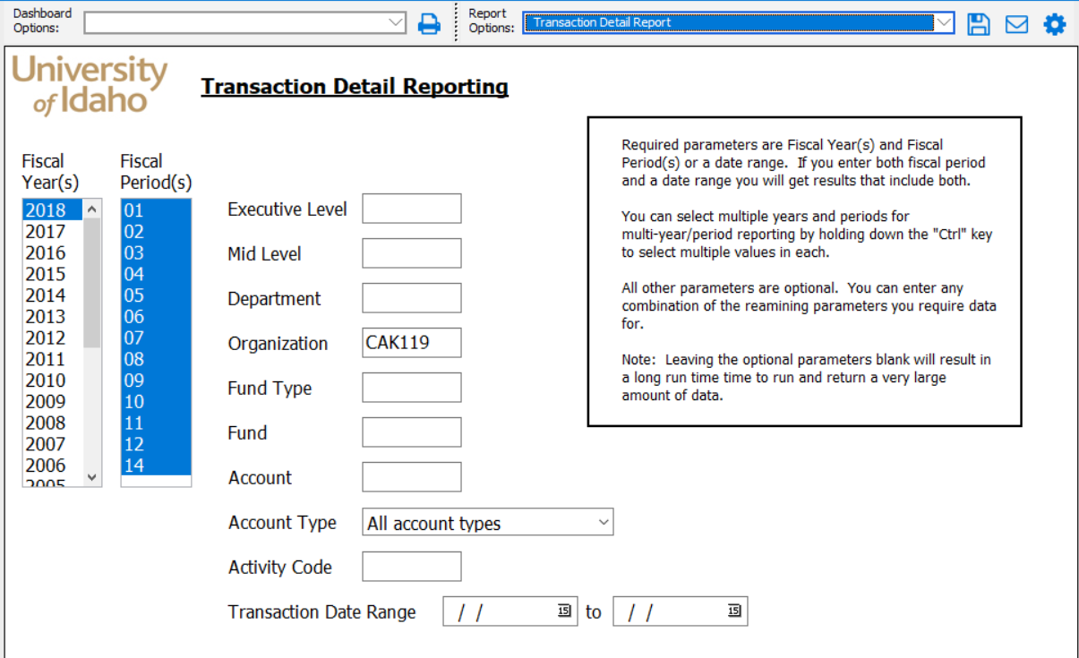
Changes identified:
- Add Banded reporting functionality
- Write macro for formatting and pivot table for csv version

FWRDOAR – Current Argos report = Transaction Detail Report (Example)
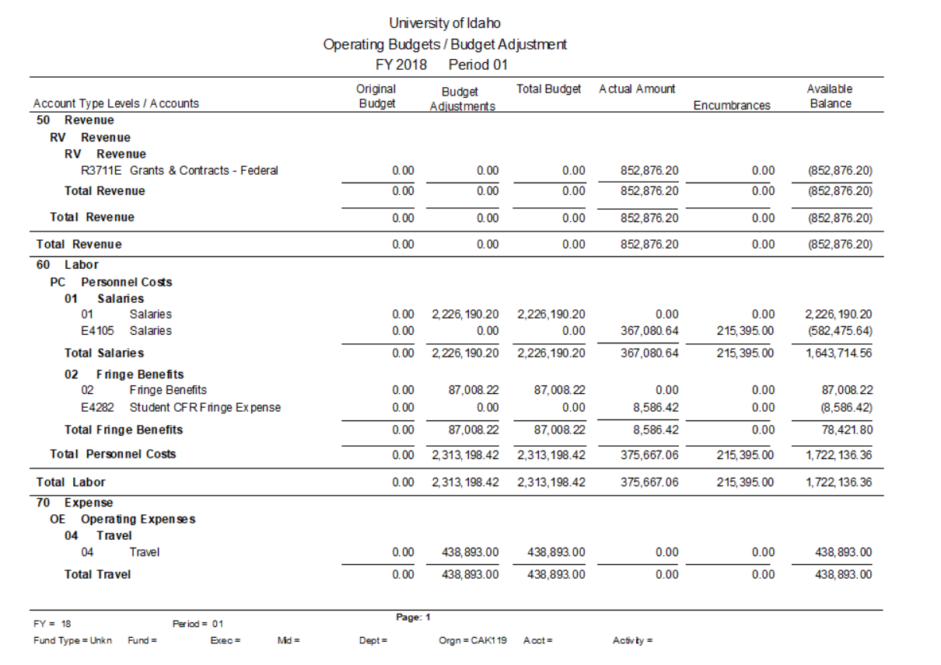

NWRPREX – Current Argos report = Detailed Payroll Reporting (Example)
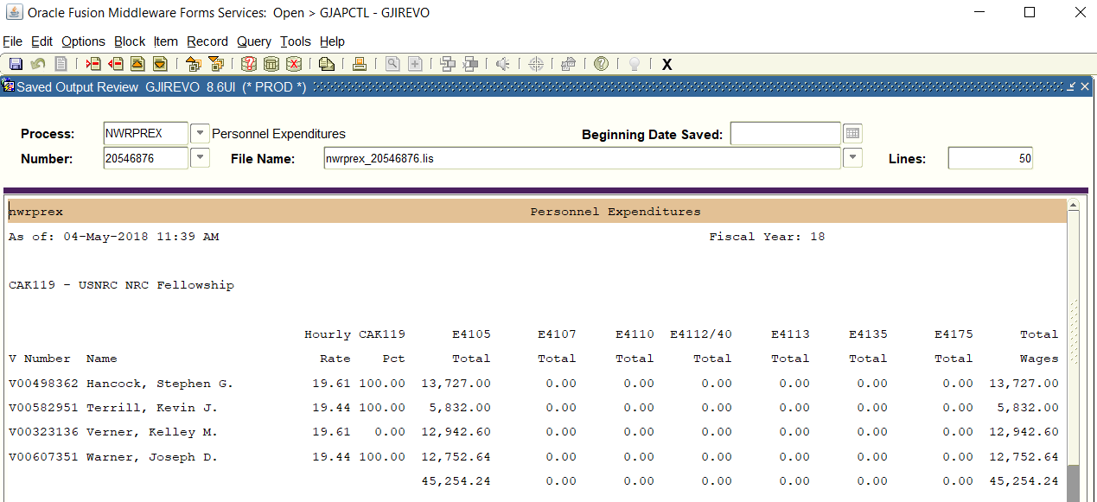
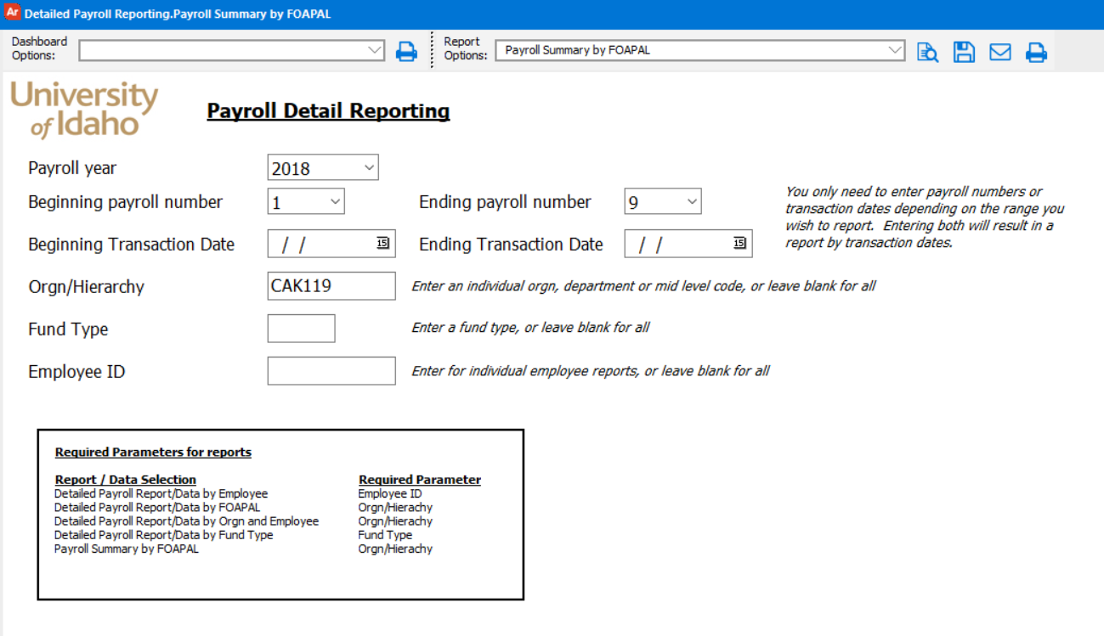

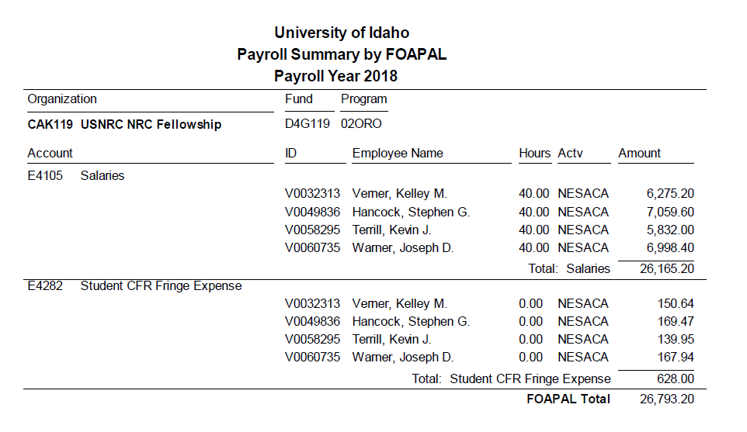
Changes identified:
- Add hourly rate field
- Add ability to include multiple fiscal years in the parameters

FGIBAVL – Current Argos report = Operating Drill-down Dashboard (no pending docs)
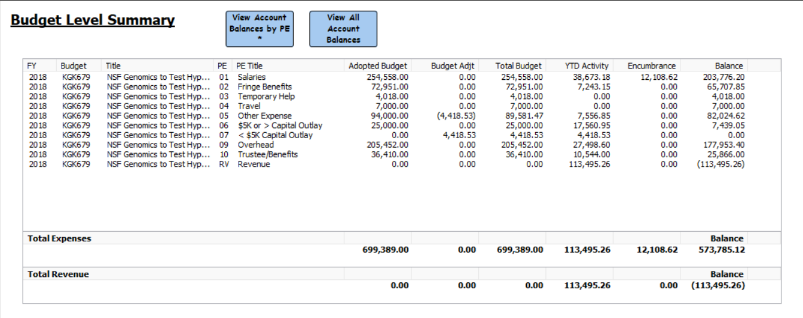
Changes identified:
- Add column for pending docs
- Add Banded reporting functionality

