PIVOT TABLE BASICS

- Run Transaction Detail Report in Argos (See Argos Reports Instructions)
- Save file as xlsx.
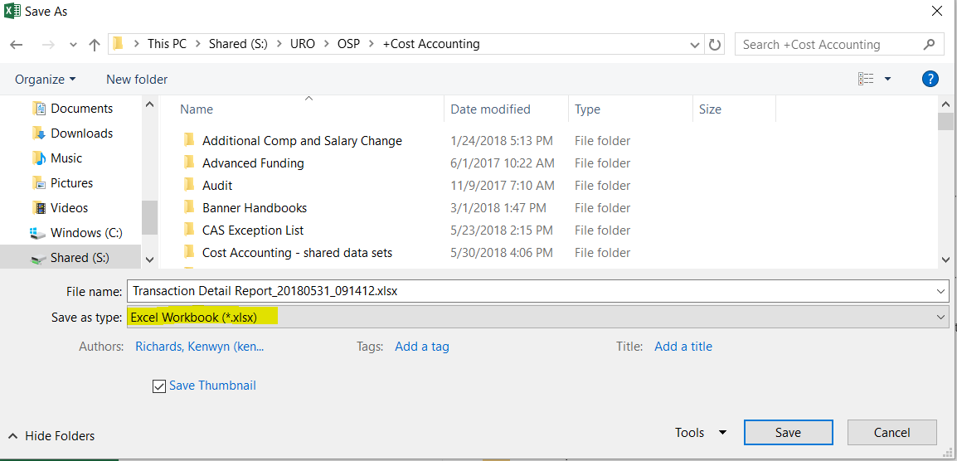
- Click anywhere within the data set – Insert Table (Inserting a Table allows you to add more data easily).
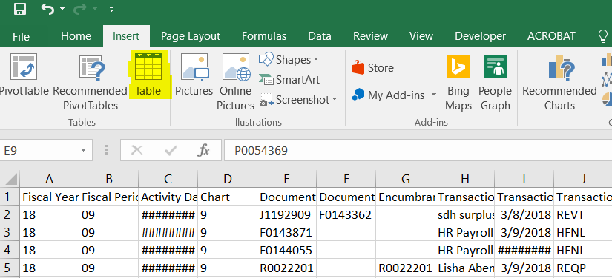
- Click OK
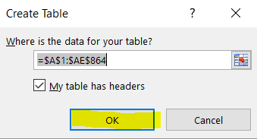
- Once you have the Table, click anywhere within the data set – Insert PivotTable
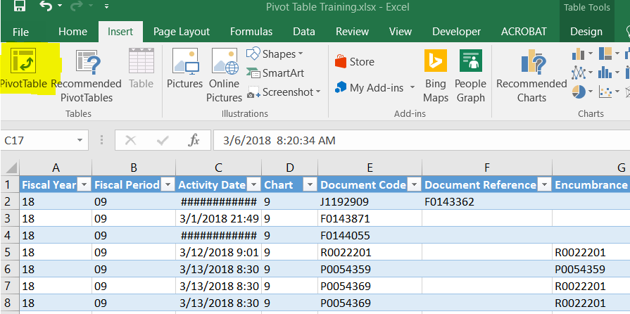
- A box titled “Create PivotTable” will appear. The default settings of “Select a table or range” and “New Worksheet” are good to use -- Click OK
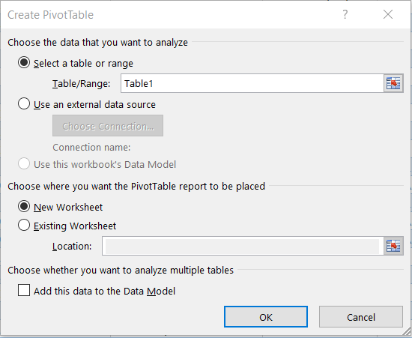

- A new sheet will appear with “PivotTable Fields” on the far right of the sheet. To choose the fields of data that you would like to see, simply click and drag the title to the box below.

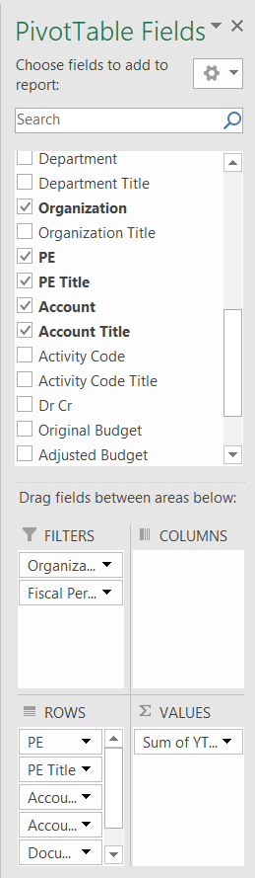
- For detailed analysis similar to the DOAR report, we recommend the following:
  - Filters = Organization (Index in Chart V) and Fiscal Period
  - Rows = PE, PE Title, Account, Account Title, Document Code, and Transaction Description
  - Values = YTD
  - Columns = blank
Note: To see budget information within the pivot table, drag “original budget”, “adjusted budget”, and “encumbrance” to the “Values” box.
Also, the order in which items are listed in the boxes effects how they show up in the pivot table.

- Once you have the data identified, we can make it look more user-friendly. Click “Design” in the ribbon. Click “Blank Rows” – choose “Remove Blank Line After Each Item” – Click “Report Layout – choose “Show in Tabular Form” – Click “Subtotals” – choose “Do Not Show Sub Totals” -- Finally, choose a color scheme that appeals to you by clicking the drop down arrow in the lower right of the “PivotTable Styles” section.
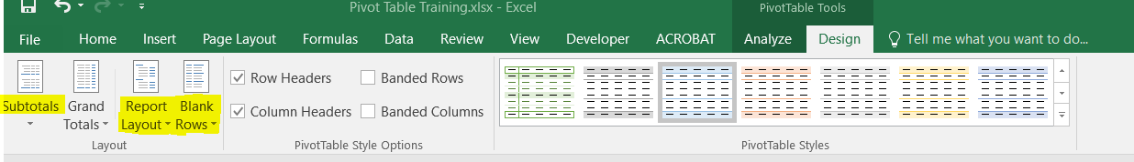

- For final finishing touches, adjust column widths and format the YTD column for currency.
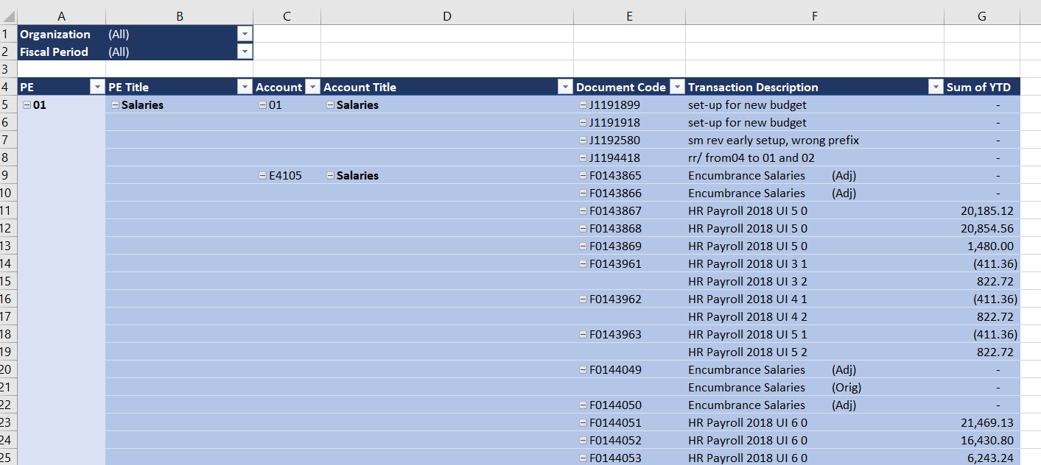
- The data is now ready to be analyzed. The good news is you will only need to go through this level of creation once. After the initial period, you can simply add data to the table and refresh the pivot table as shown below (See how to add additional periods below).
Note: The view shown above is all detail. If you wish to see less information at any given time, right click within the PE Title field and choose expand/collapse – collapse entire field. This will roll up the data into a summary view.
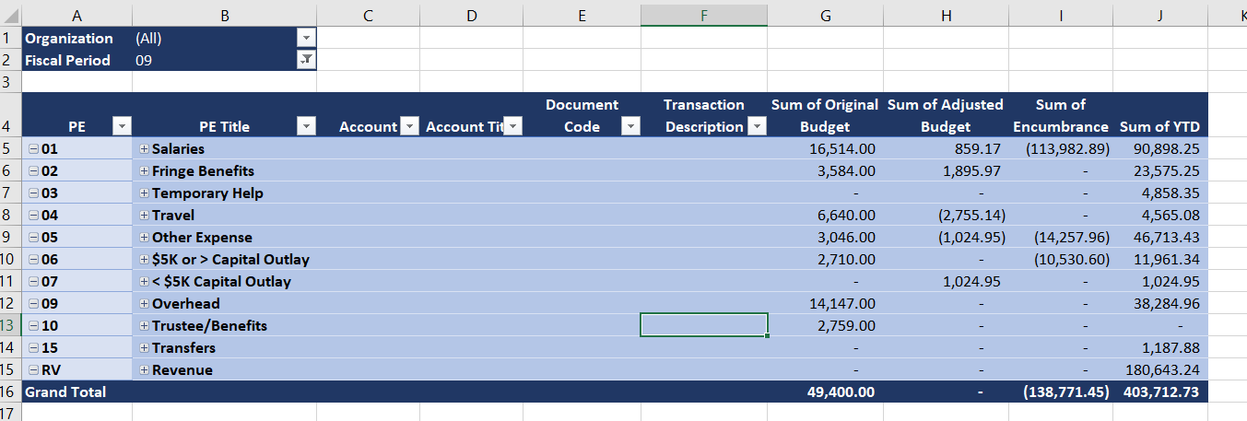

How to add additional fiscal periods to an existing pivot table
- Run new fiscal period in Argos (See Argos Reports Instructions).
- Copy rows from new report (Do not include headers in row 1) and insert copied cells between row 1 and 2 of the data sheet within the workbook that contains the pivot table.
- Click on the pivot table tab and right click anywhere in the data and choose refresh. The new data is now in the pivot table.

