Argos Reports

- Open Argos
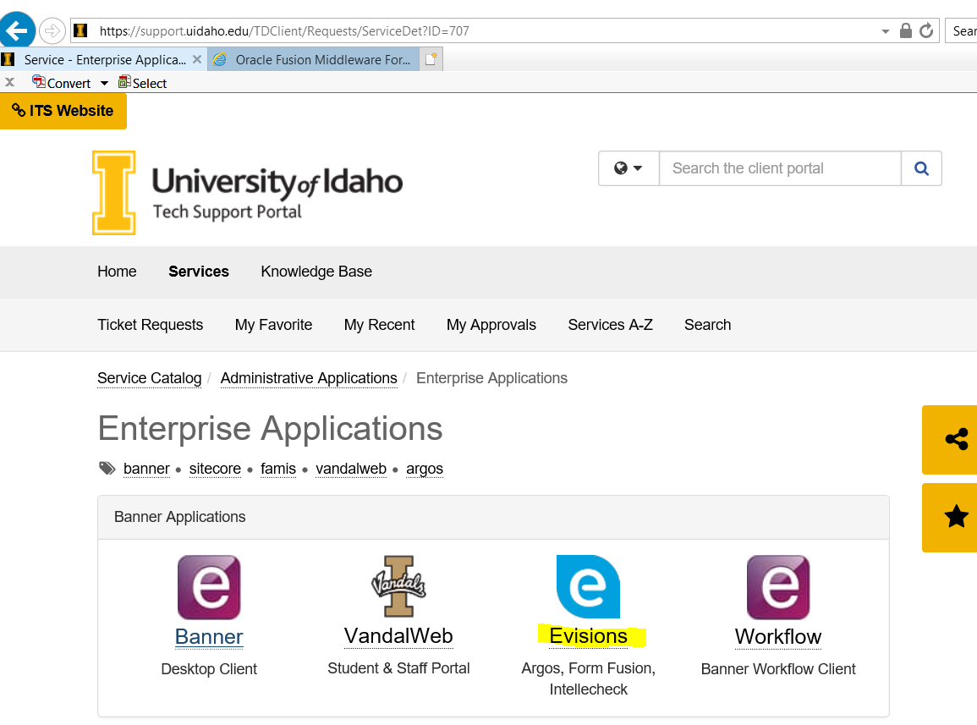
- Log in using your vandal ID
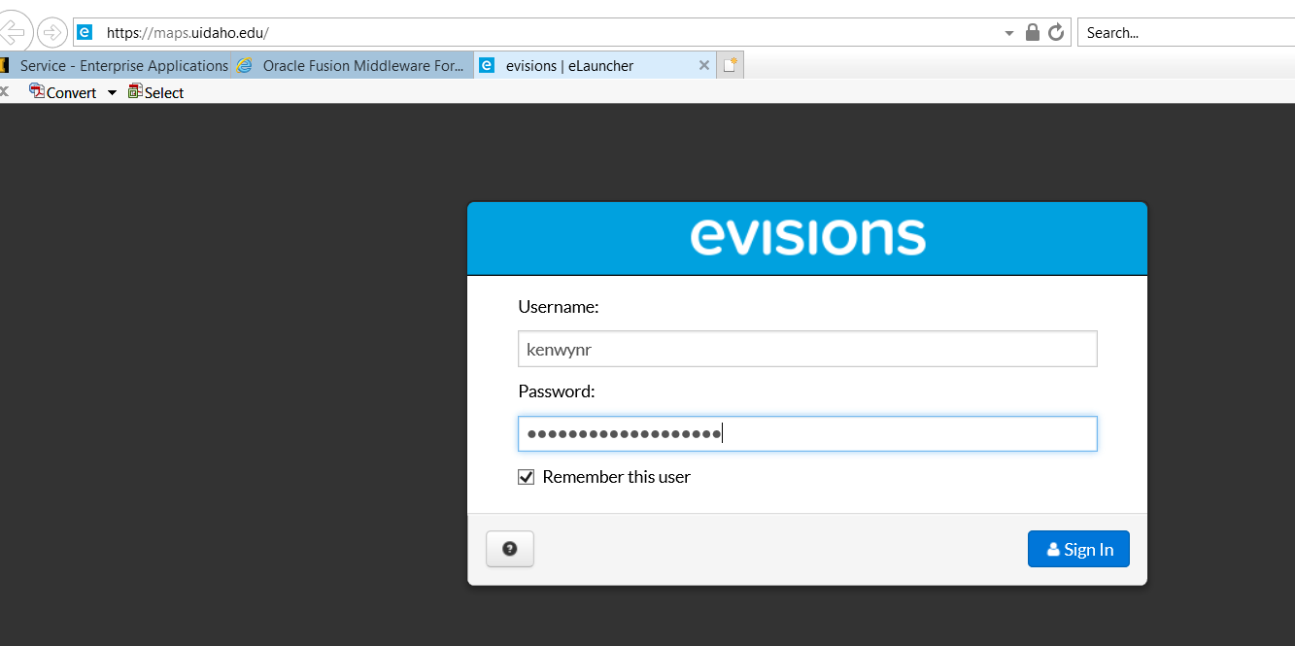
Note: Some users may be asked to update Java and install Evisions. If these pop up, please allow and install.
- Choose the desktop version. If the desktop version does not work with your system, use the Web Viewer version.
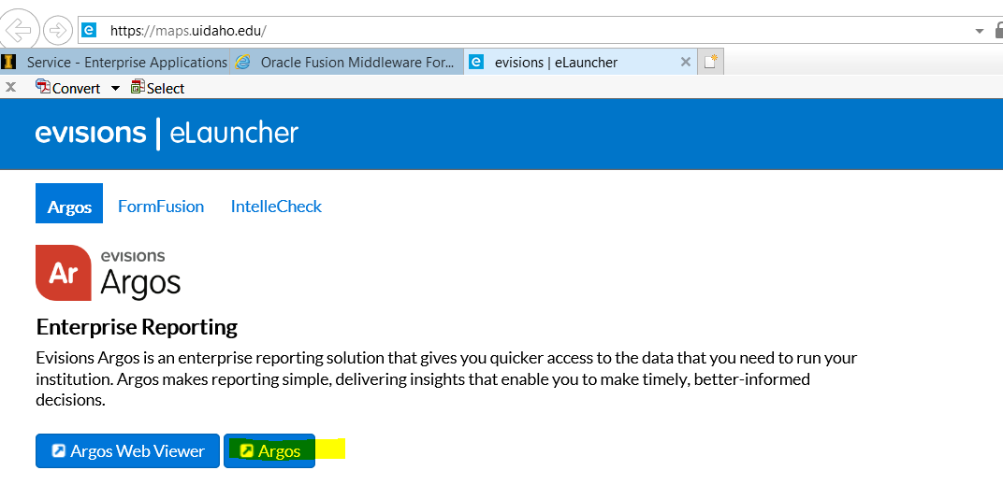
- Once in Argos, click the Finance drop down, then Production, then Departmental Financial Reporting
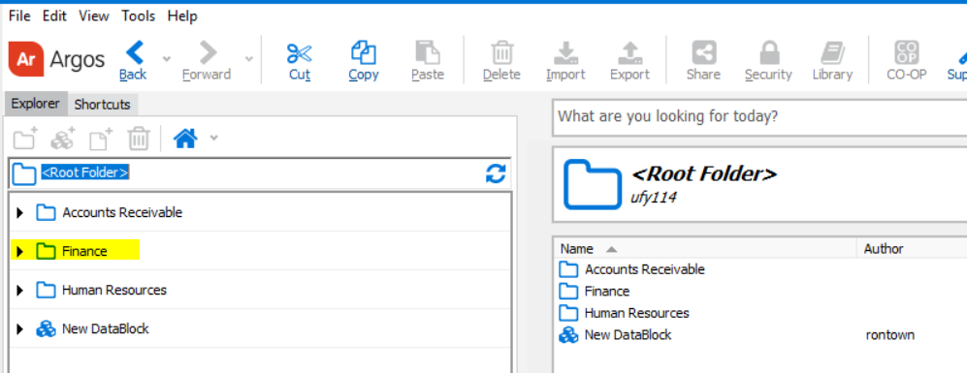
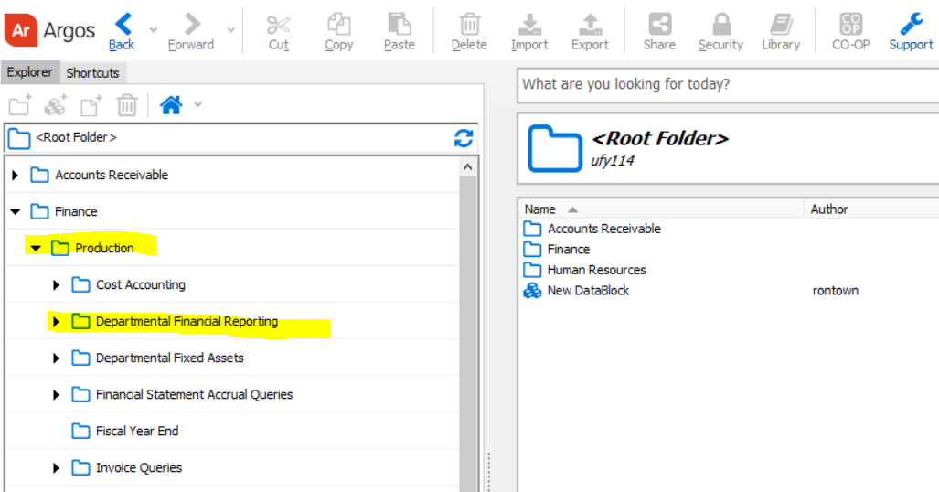
- Choose Transaction Detail Reports
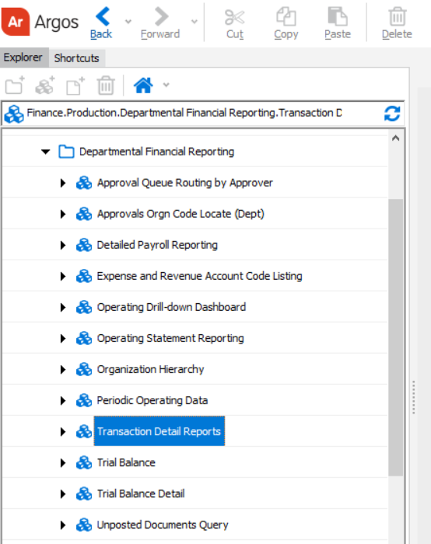

- Click Run Dashboard
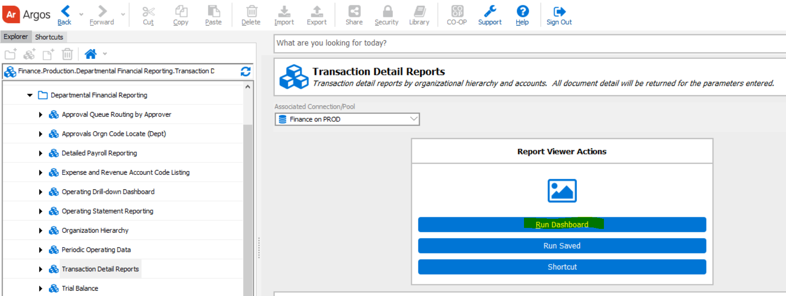

- Query on the information you would like to view. In this example, this query will return all transactions for department 004 for period 09 of FY 2018.
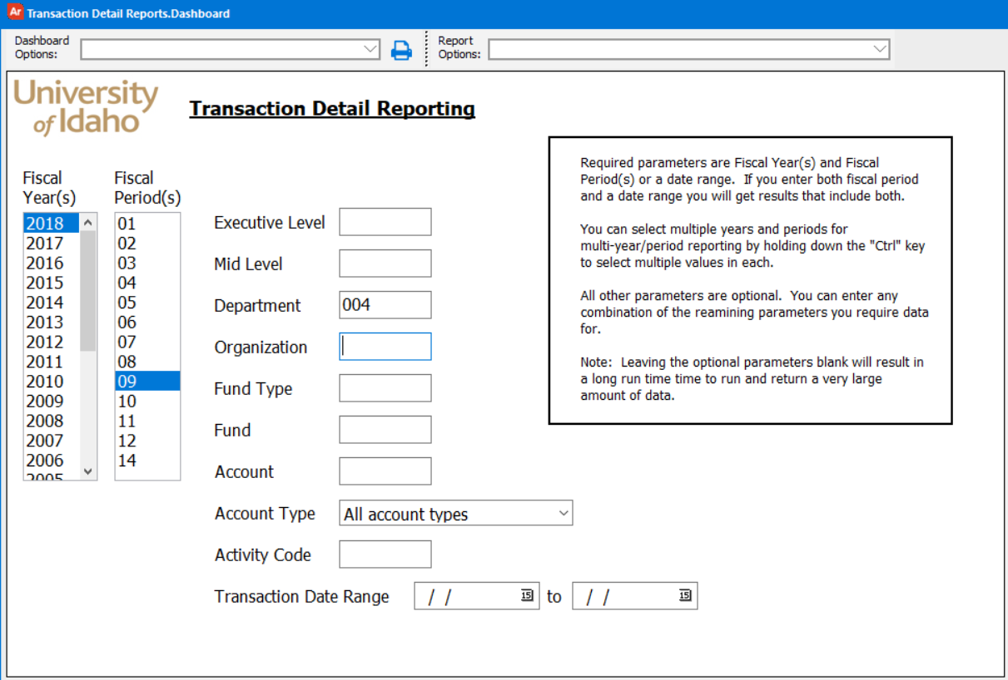

- Click on Transaction Detail Report under Report Options. Then either save the file or you can email it. In this example, we are using the gear icon to save and open the file.
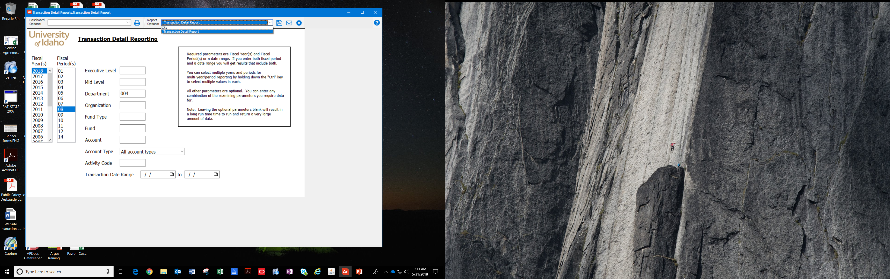
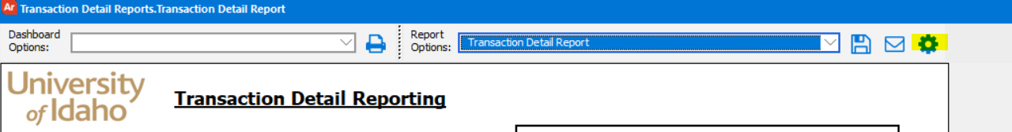

- Save the file in a folder of your choice.
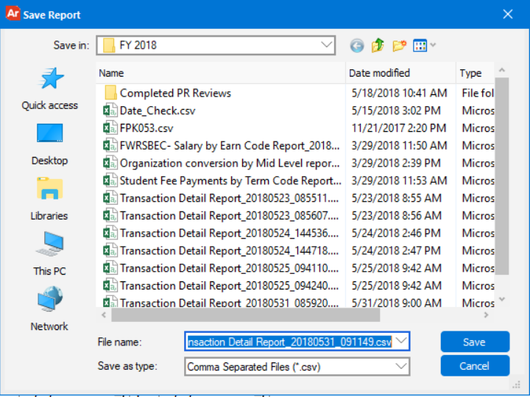

- The file will open in Excel as a CSV file (unless the “save as type” is changed) and display information as shown below.
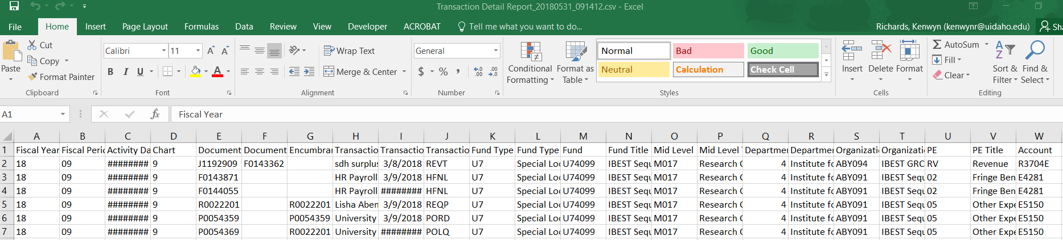

- Now go to the Pivot Table Basics document.

