Idaho 4-H Shooting Sports Risk Management Plan Template
County: Club Name:

Date Created/Revised:

The Idaho 4-H Youth Development program is dedicated to providing a safe, supportive environment that empowers youth to reach their full potential through working and learning in partnership with caring adults. Recognizing potential risks associated with 4-H Shooting Sports projects, the following provisions have been set forth to best safeguard all program participants.

Staffing / Supervision
In accordance with Idaho 4-H Policies and Procedures, all 4-H Shooting Sports trainings (classes, camps, field days, etc.) where firearms or archery equipment is handled and/or operation of live-fire ranges must be operated under the direct supervision of a Level 1 or Level 2 4-H Shooting Sports instructor who has received official state or national certification in the respective discipline being taught. Instructors must be at least 21 years of age.
Furthermore, instructors must have been screened, trained and appointed as a current 4-H volunteer through their county extension office before conducting local 4-H Shooting Sports programs.
It is strongly encouraged to have at least one additional adult (preferably screened) besides the instructor present at all meetings and activities.

{Insert club policy regarding adult/youth ratios, especially as related to live-fire activities}

Insurance
All youth participants must be currently enrolled in the 4-H Shooting Sports discipline(s), prior to participating in respective discipline trainings and/or activities. This enrollment process insures that the appropriate member waivers have been completed, required parental permissions granted (pistol/ handguns require an additional form – see Equipment section), and health history recorded.
Youth from our county participate in and are covered under the 4-H $1/Year accident insurance program (insert Policy # - get from local extension office); adult instructors are encouraged to secure this supplemental coverage. {If county doesn’t participate, indicate what options are offered – if any – for accident insurance coverage for youth & instructors here. Also, do you plan to provide coverage for spectators or other adults assisting the primary instructor(s)?}
The University of Idaho does extend liability coverage to certified 4-H Shooting Sports instructors, provided they operated within the course of their job description and training specifications.
Idaho law requires owners of motor vehicles to provide liability insurance coverage on their vehicles. Members are not permitted to transport other persons (youth or adult) during a 4-H event.
If the facilities we use require proof of insurance, we will request/secure a “Certificate of Financial Responsibility” from the University of Idaho, through our local extension office.
As our club does not own any 4-H Shooting Sports equipment, no equipment insurance is needed. {If your club does own 4-H Shooting Sports equipment, replace the previous sentence and describe how those items are insured. Attach an inventory of the club-owned equipment.}

Accidents / Emergencies
To address minor accidents (cuts, scrapes, abrasions), a basic first-aid kit will be present at all activities. The certified instructor (or their designee) will periodically check on supplies and restock as needed. The appropriate parent or guardian will be notified of any accident in a timely manner.
If incident is more serious, assess and determine level of medical attention needed (if parent or guardian is present, they will be engaged in this determination) – if in doubt, 911 will be called by the instructor (or their appointed designee). In cases resulting in serious injury, law enforcement and/or potential litigation, the following Emergency Procedures will be observed:
- Provide immediate care for injured person; work to stabilize the situation
- Call 911, police and/or ambulance, as appropriate
- Instructor (or their designee) shall immediately contact parent or guardian (if not present) of injured person and inform them of the situation.
- Contact local extension 4-H personnel and State 4-H Shooting Sports Coordinator ASAP
- Provide statements only to police and medical responders, as appropriate. Refer any media requests to local or state 4-H personnel.
- Immediately complete an accident/incident report (based on factual details) and submit this to local and state 4-H personnel {Note: form is attached to this file.}

Emergency Contacts
Ambulance: 911 {insert other number if not in 911 district}
Fire: 911 {insert other number if not in 911 district}
Police or Sheriff: 911 or {insert secondary number(s), based on facility location}
Local Extension 4-H Personnel: {insert name & phone number(s), one per line, for each person}

State 4-H Shooting Sports Coordinator: Jim Wilson (office) 208-292-1401 / (cell) 208-651-7984
State 4-H Director: Jim Lindstrom (office) 208-885-7276 / (secretary) 208-885-6321

Physical Addresses
Recognizing that having the physical address of 4-H Shooting Sports facilities being utilized is crucial for emergency responders, this lists the name and full physical street address of each site we use:

Ex. Project Meetings:
John Doe residence, 1539 W Buck Rd, Cloverdale, ID 12345 208-555-1234
Live-fire Ranges:
John Doe residence, 1539 W Buck Rd, Cloverdale, ID 12345 208-555-1234
XYZ Gun Club, 2174 E Shotshell Ave. Cloverdale, ID 12345 208-555-5012

Hospital / Medical Care Facility
In the event of an emergency, the closest constantly staffed medical facility is:

Cloverdale Medical Center, 714 N Neuro Way, Cloverdale, ID 12345 208-555-4321

At least one adult present at club 4-H Shooting Sports activities, capable of transporting an injured person, will know how to get to this facility.

Minimizing Lead Exposure
Individuals involved in firearm activities are to wash their hands before eating or drinking. If water is not available, anti-bacterial moist hand towels, waterless soap or similar products will be provided for cleaning hands during and/or upon completion of shooting activities.

Equipment
Eye protection will be worn by all participants, instructors and observers whenever live-fire activities are being conducted. When live-fire activities involved muzzleloaders, small-bore pistols, small-bore rifles and/or shotguns, ear protection is also required for all participants, instructors and observers.
All club-owned equipment will be inspected at least annually by a qualified individual to insure that equipment is in good working order. A spot inspection will be done prior to use at any meeting. All equipment brought by members will also be subject to inspection each session, prior to use; an annual inspection by a qualified individual is also recommended for member-owned equipment. Any piece found to be defective will be clearly tagged and immediately removed from use until fully repaired.
Participants and instructors will adhere to M.A.T. (Muzzle, Action, Trigger) rules at all times. Firearms may only be loaded and arrows nocked while at the firing line and only with the permission of the Range Officer. Insertion of CBI’s (clear bore indicators) is expected when rifles and pistols are not in use.
All participants and instructors are to observe safe handling practices for their respective equipment not only at meetings, but also when transporting items to and from meetings. Use of appropriately designed cases is strongly encouraged. Equipment and ammunition is to be securely stored separate from one another when not in use.
Youth participating in the current small-bore pistol/handgun, or emerging Western Heritage projects are required to have a parental permission form in their possession or on file with their discipline instructor in accordance with the Youth Safety Handgun Act (as included in the Gun Control Act of 1968). {Note: form is attached to this file}

Facilities
A thorough inspection of any proposed 4-H Shooting Sports facilities will be conducted at the beginning of the year, with additional inspections occurring before the start of each meeting to insure safety. Any defects will be immediately brought to the facility manager’s attention for repair.
Appropriate signage, berms and backstops will be in place; plus safety zones and lines will be clearly marked before any live-fire activities.
If any facilities we use require proof of insurance, we will follow the procedures as set forth in the Insurance section above.
Should a lease or contract be required for use of facilities, a copy of that document is to be submitted through our local extension office to the University for legal review.

Additional Club-Specific Requirements

{Insert any additional safety or risk management expectations, not covered above}

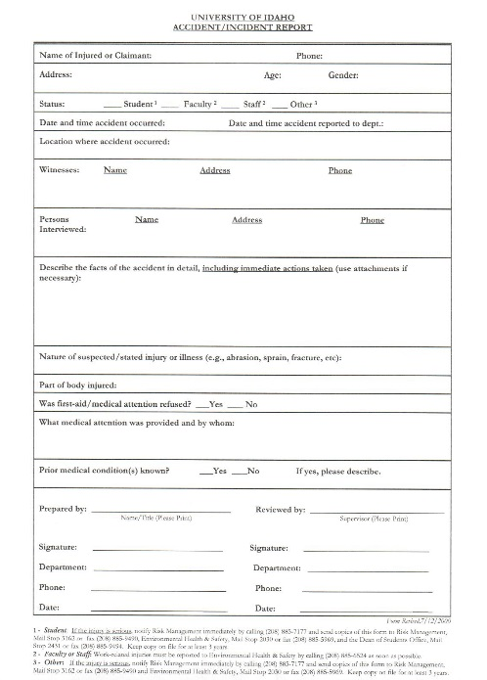

Idaho 4-H Shooting Sports Program
Youth Handgun* Permission Form

The Youth Handgun Safety Act (https://www.atf.gov/file/58806/download ) as included in the Gun Control Act of 1968 puts restrictions on the use and possession of handguns by youth under 18 years of age. Youth participating in Idaho 4-H Shooting Sports projects/disciplines where handguns are used must, at all times, follow all provisions of this Act. Therefore, Idaho 4-H Shooting Sports instructors will require “prior written consent of the juvenile’s parent or guardian who is not prohibited by Federal, State, or local law from possessing a firearm” in any setting where a handgun(s) is to be used. This written permission must be in possession of the youth or on file with the applicable instructor – even if a parent/guardian is present.

Please fill out the form below with the name of the youth, a parent’s name, address, as well as their signature, and that of a witness and dates. If participating with another club or 4-H shooting sports event, the 4-H member can provide a copy of this form to that respective, certified 4-H shooting sports instructor. Failure to have this document will require instructors/officials to disqualify the shooter from participation to avoid violation of federal law.

I/we (print name) _________________________________________________, parent/guardians of (print shooter’s

name) __________________________________________________, grant permission to participate with a handgun in Idaho 4-H Shooting Sports projects and events sponsored by County, State, and National 4-H organizations as per The Youth Safety Handgun Act.

Member/Shooter Signature: _______________________________________________ Date: ____/_____/______

Parent/Guardian Signature: _______________________________________________ Date: ____/_____/______

Address: _____________________________________________________________________________________

City: ________________________________________________ State: __________ Zip: _________________

Phone: (________) __________________ Email: ___________________________________________________

Witness Name (print): ____________________________________________________________________________

Witness Signature: ______________________________________________________ Date: ____/_____/______

* This form is required for any rim-fire or center-fire handgun, and strongly encouraged for pellet handguns. Current Idaho 4-H Shooting Sports projects where handgun use is permissible include Handgun/Pistol & Western Heritage.

Revised: December 12, 2016

