12/21/2021

Name Position Title:

V#

Supervisor V#
Evaluation Type: __ Annual __ 3-Month Probation __ 6-Month Probation Reporting Period: From To

Performance Level: (Check only one)

__ Needs Improvement __ Meets/Exceeds Requirements

(Refer to FSH 3340, section A-10 for definitions of these ratings: https://www.webpages.uidaho.edu/fsh/3340.html )
Note: If an employee is to be considered for merit increase, the comment section should clearly substantiate any meritorious effort from the year and does not mean a merit increase would be given. Second Level review and signature must be completed prior to discussion or distribution to employee for ratings of Needs Improvement. Check with your unit leadership for specific unit processes and supervisory signature authority.

University Emphasis:

Compliance Training Completed: __ YES __ NO

Safety — Consistently performs assigned work in a safe manner, remains current on safety training requirements, and actively supports the campus safety culture. __ YES __ NO

(Any University emphasis item checked as “NO” should be addressed in one of the comment boxes below.)

General Comments (including comments that support Meets/Exceeds Requirements):

Comments Supporting “Needs Improvement” Performance Level:

Future Expectations/Goals: (Required for all)

Second Level Supervisory Review (Must be in the supervisory chain) – For rating of Need Improvement. This is generally the next level supervisor but check with your unit leadership for specific unit processes and supervisory signature authority. This is to be completed prior to discussion or distribution with employee.

Reviewer Name

(Employee response/signature continued on next page)
Employee Comments

Name Position Title:

V#

As the employee you are not required to provide additional comments to the evaluation though you may choose to do so. You may choose to add comments now or later. If you add comments now, they will be submitted as part of the evaluation. If you add comments later, they will be attached to evaluation at that time, though there will be a period of time in between when the evaluation was a matter of record in your personnel file without your additional comments. Your comments become a permanent part of the review document.

__ No comments at this time.
__ Please see the comment below.

Employee Comments:

Employee signature indicates receipt of the performance review document. It does not indicate agreement or disagreement with the content of the review.

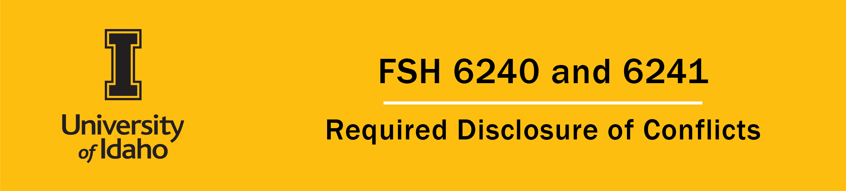

This Conflicts of Interest Disclosure form is to be signed by the employee and his/her supervisor after reviewing information on conflicts of interest and nepotism in the Faculty Staff Handbook 6240 and 6241. For each new employee, the signed Conflicts of Interest Disclosure form is to be returned to Human Resources for inclusion in the employee’s file prior to the first week of work at the University. Each continuing University employee must complete this disclosure annually with his or her performance evaluation.

If you have a conflict to disclose, then you also will need to complete Form FSH 6240A. Likewise, if there is any change in your circumstance that may give rise to potential conflicts or eliminate potential conflicts previously disclosed, then you will need to complete Form FSH 6240A within 30 days of the change. University of Idaho FSH Policy 6240 Conflicts of Interest or Commitment is available at http://www.webpages.uidaho.edu/fsh/6240.html If you have any questions about the form or about specific potential or actual conflicts of interest, please contact your unit administrator or the Chair of the university’s Ethical Guidance and Oversight Committee uifcoi@uidaho.edu. Disclose outside employment for compensation of more than 20 hours/week by completing FORM 6240 B – Disclosure of Outside Employment or Consulting for Compensation.
Please check one:

__ I have reviewed FSH 6240 and DO NOT have any conflicts of interest, conflicts of commitment or apparent conflicts to report.

__ I have reviewed FSH 6240 and DO have conflicts of interest, conflicts of commitment or apparent conflicts to report. Please submit a completed form FSH 6240A to your unit administrator, along with separate pages describing a plan to manage each conflict or apparent conflict.

Your signature below certifies that:

- you have reviewed FSH 6240 regarding disclosure of conflicts
- the information that you provide in this form regarding your disclosure of any conflict is accurate to
the best of your knowledge as of the date of this document, and
- you commit to providing an update if a material change occurs in the information you have provided.

Please print (Last, First, MI): Vandal #:

Please print (Last, First, MI): Vandal #:

